Chapter 21 - Modeling for Research and Communication

Abstract

Modeling the MISA Instructional Engineering Method
Modeling Productions, Tasks and Principles
Summary of the MISA R&D Process
Modeling Assistance for a host system
Task-based Advisors
Generic Assistance Systems
Structure of an Advisor Agent
Building Assistance for the ADISA Design Workbench
Building Assistance in TELOS
Summary of the Advisor System Research Process
Visual Modeling in Doctoral Research
A Thesis on Learners’ Self-Management
Three Thesis on Cognitive Computing and the Semantic Web
Summary of the Research Process

In this concluding chapter, we will give examples where visual modelling techniques have been used in actual research projects. Visual Modelling is particularly useful to the researcher both to organize and guide the research and to communicate its results. Our Research Centre applied this approach in numerous research projects since its creation in 1992.
We will start by showing how visual modelling has helped develop a coherent view of Instructional Engineering that led to the design of the MISA method through a number of years. Then we will present another stream of research that has also been supported by knowledge modelling: the development of assistance systems. Finally, we will conclude the chapter by presenting a method that has been used by several doctoral students, in particular by those responsible of the projects presented in section III of this book. These examples will enable us to propose a generic meta-method for research projects and doctoral work that will serve as a conclusion to this chapter.

21.1 Modeling the MISA Instructional Engineering Method
In many chapters of this book we have presented aspects of the MISA Instructional Engineering Method that make an extensive use of visual knowledge modelling for representing the content, pedagogical strategies, learning materials and delivery processes of learning environments. The reader can refer to chapter 8 for a short introduction to MISA and to the books that have been published on the subject (Paquette 2002, 2004) or to the author’s Web site at www.licef.ca/gp.
Here, we are interested in modelling the process and its products that have led to the MISA method and its various tools. Without such a process, refined through the years, it would have been impossible to keep a focused and coherent view on MISA’s Evolution and the development of its related tools.

Modelling MISA’s Productions, Tasks and Principles

Throughout these research process we asked ourselves, what is it exactly that the designer has to produce, what are the tasks that will enable him to achieve these productions, how are they related, and what are the principles that should guide designers to better quality products. These are quite general question that are present when designing a new methodology, whatever the application domain. These questions led us to build a visual model of MISA with the MOT editor that shows the interrelations between all these elements of the method. In this section, we present the MOT model of MISA 4.0. Another MISA-based model of the method for IMS-LD can be consulted at www.idld.org in the methodological aids section.
The first question was: what is it that an instructional designer supposed to produce? Our answer was: a learning system (or IT-supported environment) in all its dimensions. This led us to a general model of this concept shown on figure 21.1. A learning system is composed is produced by an instructional engineering process and is an input to the delivery of the system. It is composed of two elements: a set of specifications or “blueprint”, produced using MISA, and the “Physical” system composed of learning materials and support infrastructures.
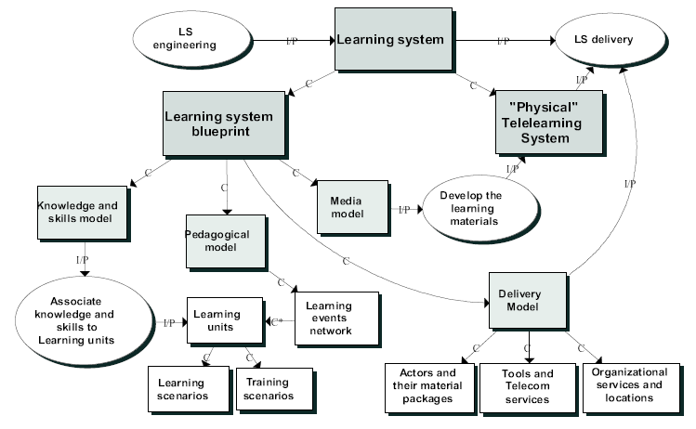
Figure 21.1: The Learning System Concept (Paquette 2001)

The role of MISA is to support the production of a blueprint or specifications of a learning system composed of a knowledge and skills model, a pedagogical model grouping learning units and their learner or teacher interrelated activities, a media model to guide the development of the learning material, and a delivery model to define the human and technical infrastructure needed to support the LS when it will be in use.
Analysing these tasks more closely and their interactions, we found out that they had to be developed progressively, as in most method, in a number of phases. We retained the following phases.
- Define the Training Problem and Customize MISA
- Define a Preliminary Solution
- Build the Learning System’s Architecture
- Design Instructional Materials
- Produce and Validate the Materials
- Prepare the Delivery of the Learning System
Finally 35 main tasks or processes and around 150 subtasks have been identifies. Each main task produces a Documentation Elements (DE) either a graphic MOT model (in bold on the figure) or a form or property table produced using predefined templates. The DEs produced by the instructional designers are distributed into folders for each phase and to each axis.

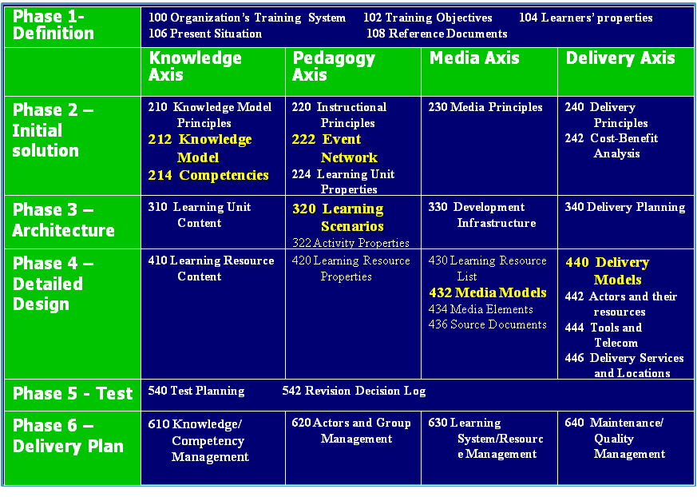
Figure 21.2 – The structure of the MISA 4.0 instructional engineering method

This bi-dimensional structure of the method and the use of MOT models provide many advantages:
- It makes the engineering process easier to understand and more consistent while facilitating communication between the learning system production team members
- In relation with his specialty and in collaboration with his teammates, each team member may be assigned to a specific DE production. The distribution of tasks and responsibilities is clearly stated so that each team member knows when and what must be done.
- Especially when designing complex LS, the information is represented and organized into a coherent system through graphic modeling and their related DE descriptions.
- All the documentation may be collated into a single report that can include phase folders, axis folders or various combinations of documentation elements (DE) selected by the designer.
- Because of the modularity of the DE system, many LS specification components created by MISA 4.0 may be easily reused from one project to the next one, representing a major saving in terms of effort, cost and resources.
- The LS Engineering Project Management may be structured by phases or by axes or by any combinations of data require to manage the development.

Now let us present the MOT model that gives its unity to the MISA method and provides a way to adapt it and navigate through the different tasks and products. Figure 21.3 shows the three possible ways to progress in the method and related principles to guide the design tasks.
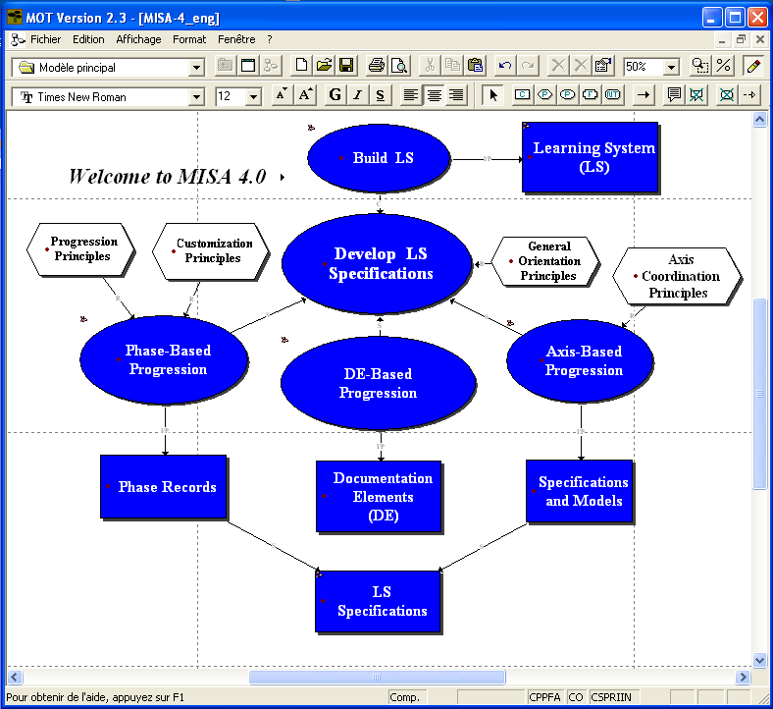

Figure 21.3: MISA 4.0 Main model

This model has three sub-models to navigate further depending if the design team wants to navigate through phases, axis or DE elements. The Phase-based Progression sub-model presents a sequence of phases. If phase 2 is selected, the sub-model on figure 21.4 is presented, emphasizing that each of MISA's phases may be divided into steps. Each step equates a task that produces a DE or a section of a DE. The DEs produced during a phase can be grouped in the corresponding folder of the phase. It is the method's user who determines which DEs or which DE sections will be included in each folder.
For example, figure 21.4 shows the context of phase 2: it is preceded on phase 1 products and will be followed by phase 3. It also shows its content for the four axis: definition of the LS's Instructional, Material Development and Delivery Orientation Principles, development of the Knowledge Model and the Learning Event Network (LEN). Then, these products will support the analysis of costs, benefits and impacts. The DEs produced during this Phase are grouped in the "Preliminary Solution" folder. Upon client approval of the Preliminary Solution, Phase 3 can be started on this basis.

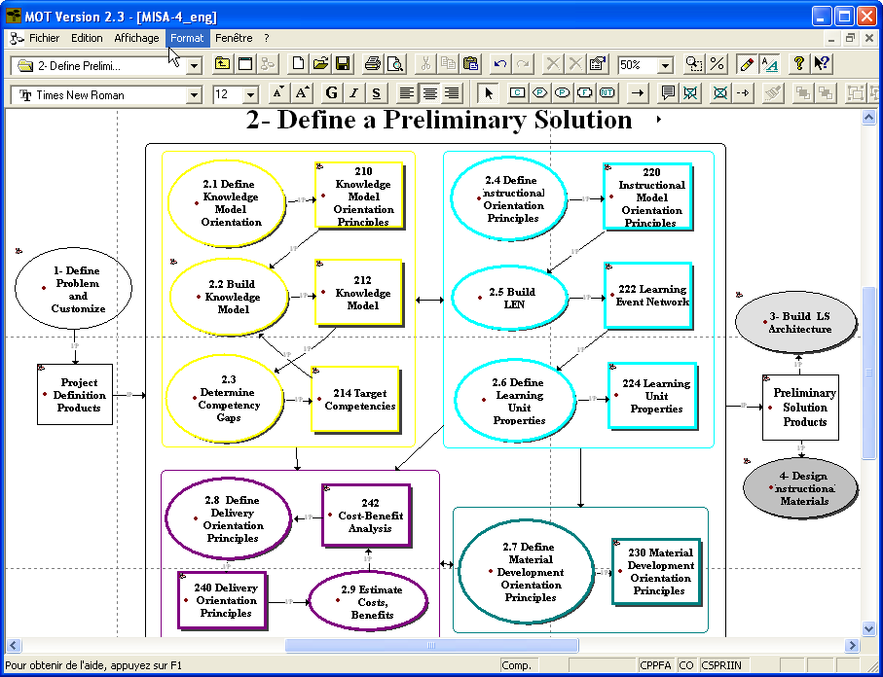
Figure 21.4 - Phase 2 main tasks and DE produced

Going back to figure 21.3, the designer can also develop the LS specifications axis by axis or by selecting a DE progression mode. A sub-model for the progression through axis groups all the tasks and DEs into 4 sub-models, one for each axis, showing when products from other axis are needed as input for some of the tasks. Axis coordination principles guide the exchange and reuse of information between products in different axis.
A sub-model for the progression through the products (DEs) presents a bi-dimensional table similar to figure 21.1 in order to select one of the products or DE. Such a selection for DE 212, in this table, or in a phase view such as 21.4, will open the sub-model shown on figure 21.5. This model presents, organized around the DE 212 product, the designer’s task to produce it, together with the previous products that influence its design, and the following ones that will be influenced by it.
To complete a documentation element (DE), the designer must use some source data that can originate from different DE’s. Once some data has been collected and processed in a DE, they can be useful to different “destination” DE’s in which they will be examined in a new perspective.
In the MISA method model, each of the 35 DE's has such a contextual model that helps the designer to make a coherent and efficient LS development.
In this contextual model, the left side indicates the incoming DE’s that act as a data “source” useful to build the Knowledge model (DE 212) and the right side of the model shows the destination DE’s where the data defined in the Knowledge model can be used or applied. If a designer clicks on one of these products, for example “320 Instructional Scenarios” produced by task 3.3, he will open a new contextual sub-model for this design element. It is then possible to navigate in MOT from DE to DE until the end of the process.

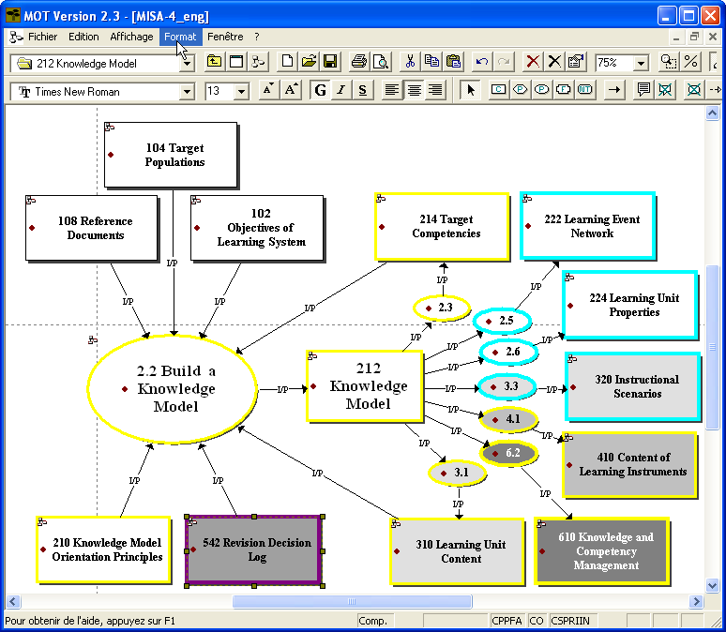

Figure 21.5: A contextual model for Design Element (DE) 212

These contextual models are particularly interesting when some validations, tests or LS maintenance management require some data changes in a DE. The designer and the manager can then more easily evaluate the impact on the others DE in the method and the cost of the LS modification.
Organizing a method by building a visual knowledge model ensures the consistency of its various operations. The types of links joining the 35 main instructional design tasks are clearly identified and advice is given to help ensure consistency of the Method's different products. In addition, the Method's general orientation, customization and phase progression principles as well as its axis coordination principles are there to guide LS designers through the process. The model shows clearly for what design tasks these principles are to be applied.

Summary of the MISA R&D Process

As we can see on figure 21.6, the development of MISA has been a long process based on three interrelated streams of research: Design methods, Visual Modelling Tools and eLearning delivery systems. Table 21.1 presents the timeline of these research streams from the point of view of the development of the MISA method.

Figure 21.6 – Interaction between research projects at LICEF

1987 | Beginning of research (at Télé-université) on knowledge-based systems.
1991 | Design of a first knowledge-based environment generator (LOUTI).
1992 | A Télé-université course on instructional design integrating knowledge modeling.
1992 to 1994 | Development of an educational engineering workbench (AGD – Atelier de Génie Didactique) ; Version 1 of MISA and a first Visual Modeling Tool are embedded in AGD
1995 | Doctoral thesis on MISA (Françoise Crevier). Trial and validation of MISA version 2.0 and the AGD by some nine organisations and companies.
1995 to 1996 | Creation of a first autonomous MOT editor based on the optimization of typed-object modeling techniques developed within the AGD workbench.
1996 à 1997 | Production of version 2.0 of the MISA Method using previous trials results. Trial of MISA 2.0 by six instructional design teams at Télé-université.
1998 to 1999 | Production of MISA 3.0. This was accomplished in conjunction with the development of the MOT+ editor and of a set of form-based tools to support MISA 3.0. A set of 17 typologies of learning system components or aspects were developed.
1999 to 2001 | Development of a Web-based distributed workbench for engineering learning systems (ADISA) in conjunction with Version 4.0 of the MISA Method that integrated the typologies.
2001 to 2003 | Multiple applications of MISA and MOT+: Hydro-Québec, Bank of Montreal, Professional Corporations, courses with the Explor@ LCMS, etc.
2003 to 2006 | Specialisation of MOT+ to MOT+LD and MOT+OWL. Additional modelling and instructional engineering projects
2006 to 2009 | Adaptation of MISA to the IMS-LD specification, development of the IDLD learning design repository, integration of MOT+ and ADISAconcepts into TELOS

Table 21.1 – Time line of the research on MISA and related R&D

As shown in table 21.1, the whole process started in 1992 on the basis of previous projects on knowledge-based educational environment. A first version of the MISA method (Instructional engineering Method for Learning Systems) was produced in 1994, embedded in a computerized support system for designers called AGD (Paquette, Aubin and Crevier 97; 99). The initial vision was to apply knowledge elicitation methods to model the products, processes and principles that instructional designers produce or apply as they design learning environments or systems.
The method was thereafter validated with instructional designers and content experts in nine organizations and was rebuilt, yielding MISA 2.0, based on results and observations gathered during these validations. In parallel, we extracted and rebuilt a tool for knowledge modelling (MOT) to support central aspects of the method.
After another round of validation, our attention focused on learning object typologies. We defined seventeen typologies on concepts such as knowledge models, skills, learning scenarios, learning materials, delivery models and so on. The MOT models made it easier for the designer to communicate his ideas through a documented model. The MISA Method was devised and entirely modelled using MOT, providing a clear visualization of MISA's various processes. In 1998, this effort led to MISA 3.0 in which these typologies and method models were used to present numerous alternatives to the designer on which to build viable design decisions.
Starting with the goal to build a new Instructional Design Web-based tool (ADISA), MISA evolved to MISA 4.0 during year 2000. This version has been built in coordination with the ADISA support workbench for instructional engineering (Paquette, Rosca, De la Teja, Léonard and Lundgren-Cayrol 2001), which combined the method MISA and the MOT software in a web-based application. The XML files, the results tables in HTML format and the MOT models defined in the workbench could be saved and reused from a computer database grouping the successive versions.
In recent years, we have been focusing on applications, increasing the usability of the method and the tools, adapting them to new eLearning standards such as the LOM and IMS-LD. MOT+ has become totally Web-based with new import/export facilities to standards, within the TELOS framework presented in chapter 15 where it provides scenarios for designers.

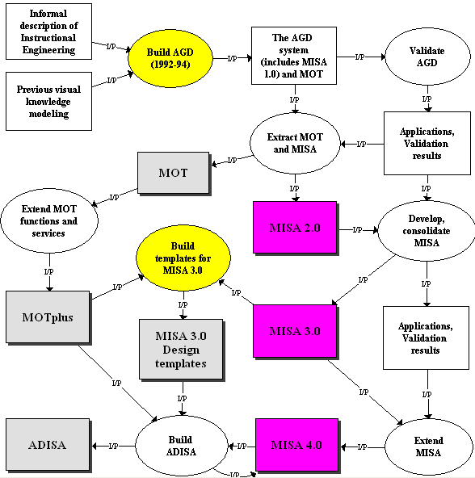

Figure 21.7: The interaction of R&D activities in the MISA Research Process

Figure 21.7 presents the MISA research process model. It shows the close interaction between the progressive elaboration of the method and the development of the ICT tools supporting its use and operation. At first, the goal of constructing a support system like AGD favoured a close scrutiny of the design products and the tasks that needed to be supported. We had to be very precise and systematic; otherwise the AGD system could not be operated or would be of no use to designers. In fact, any elaborated computer system needs to be defined first by an information model. In our case, this information model took the form of MOT models. This led us to a first informal version of the method.
On the tool side, within AGD, a module was needed to model the knowledge and the learning scenarios. Such a tool was constructed, closely integrated with the other tools of AGD. Only later did we decide to extract the modelling editor and make it an autonomous tool. This opened up a large spectrum of applications that is still expanding today.
Then, outside AGD, we began to concentrate on the method behind the tool, through a number of applications and tests with partner organizations. This led us to new versions of the method that in turn, had a great influence on the evolution of the tool set.
Another important aspect of MISA research is the testing of the method through the tools. Testing a method is possible without a tool to represent it, but it is difficult to analyse the way the users undergo with the processes. When a method is embodied in a tool, the interaction of users with the tools can be observed directly.

21.2 Modeling Assistance for a host system
Advising plays a central role in Decision support systems and Intelligent Tutoring Systems. Based on a diagnosis of the activity of a user within an application (called the host system), an advisor system compiles some useful advices or explanations, and delivers this assistance to a user.
In this section we summarize a stream of research that has started with the authors doctoral thesis in 1989. In 1992 it was decided to build a companion advisor system for the AGD system intended for designers (Paquette, Pachet, Giroux & Girard 1996). The EpiTalk approach was used to build this first advisor system. It was generic enough to support also learners. In the first case, the host system was a design environment (AGD). In the second case the host system was an eLearning environment such as those produced by a designer using AGD. This led us to integrate advisor capabilities into Explor@ (Girard, Paquette, Miara and Lundgren-Cayrol 1999),, an on-line learning delivery system. In a third step, the concept of advisor system was adapted to the ADISA instructional engineering system, in order to integrate some “intelligence” in its operations (Paquette, Rosca, De la Teja, Léonard & Lundgren-Cayrol 2001). More recently, work started to introduce generic assistance capabilities into the TELOS system presented in chapter 15, to support users, whatever their role in the system.

Task-based Advisors
We present now the research results of the first EpiTalk project. ÉpiTalk is a generic tool designed to facilitate the development of advisor systems based on a process model, an activity scenario built with MOT (Paquette and Tchounikine 1999).
Imagine a designer who wants to build an advisor for a given task to be achieved using software like a common spreadsheet. This task can be modeled by an activity scenario such as the ones presented in many chapters of this book. The designer will need to consider the tools provided by the computer environment: table and graph definition, sorting capabilities, database operations. Assistance may focus on one or many subtasks of the scenario. Pieces of advice may be given on the use of the application; they can also address the tasks to be achieved by using the application; or they could address the state of knowledge and competencies required or demonstrated by achieving these tasks. Each point of view gives rise to a distinct advisor.

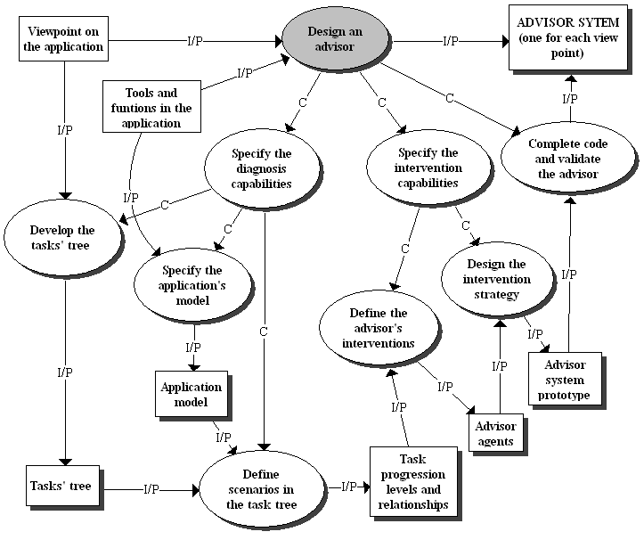
Figure 21.8 – A first method to design an advisor system

As shown in the MOT model of figure 21.8, the designer first chooses a viewpoint on the application. An advisor on a budget analysis task will be quite different from one to support the planning of a project. In both cases, a spreadsheet is used as the host system. Some spreadsheet functions will be useful for the budget task, but not necessarily for the project planning operations. Then, when the viewpoint is chosen, the designer should consider different user scenarios on how to proceed with the task. These are the main inputs to the process, the output being an advisor system for each chosen viewpoint and scenario.
When the designer starts to formalize the advisor, his first steps will be to build a tasks’ tree and an activity scenario linking the tasks. The task tree groups the main task and his subtasks on a number of levels down to terminal tasks. It is the backbone of the design of an advisor. Once the designer has completed such a task tree, he should identify in the host system which tools, which documents and what kind of interaction with the host system are relevant to the task. These are the elements that have to be diagnosed upon by the advisor.
This second phase leads first to a model of the interesting part of the application for the task and for the advisor system on the task: the application model. Then, to each sub-task, the designer can add a context that describes progress levels within the task. For a given task, there is an on-going activity necessary to perform the task from the beginning to its completion. Progress levels decompose this activity into ordered stages. Each of these progress levels is an abstraction of a diagnosis condition. These conditions refer to the state of the application but mostly to the user's productions. At any time, the user is modeled by the set of its progress level within each task of the task tree.
Then the intervention of the system will rest on an expertise that has to be identified and formalized from the concepts, procedures and problem solving strategies of the task domain or problem type. Some of this expertise can focus on the progress that has been made in a task; that is progress levels associated to each task in the user’s model. Another part can evaluate the coherence of the results obtained by the learner by comparing it to some coherence norm. The formalization of this expertise can take the form of a set of individual advices, each with a pattern detection part combining diagnosis conditions and an action part (presenting a message, displaying a tool, etc.) to be performed when a certain pattern is detected.

A Generic Assistance System
Instructional Engineering is not an easy task and it seemed evident right from the start of the AGD/MISA project that the designers using it, or in fact using any instructional design method or tool, would need to be supported by a companion tool that would give them appropriate advice at a right time
Figure 21.9 present an application of the Epitalk approach to the AGD system. This MOT+ model involves two knowledge domains. On the left, we have the tasks’ tree, the tasks being achieved using the tools provided by the hosting AGD system. On the right, we see part of a corresponding advisors’ tree.

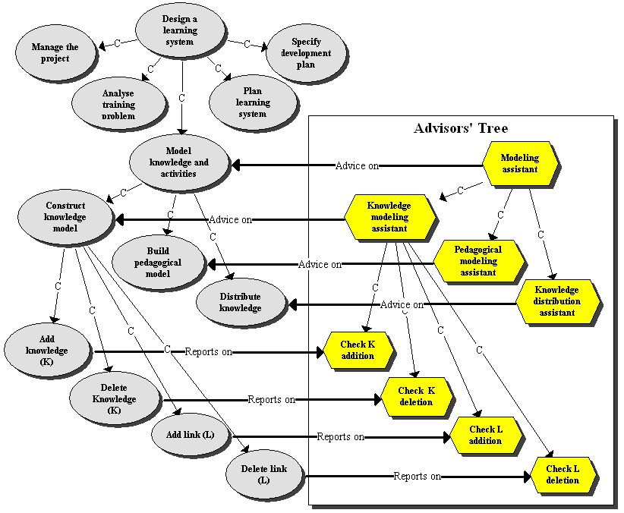

Figure 21.9 – An example of a tasks’ tree and a corresponding advisor’s tree

The links between the two models are co-domain links that can be read as follows: an advisor agent gives advice on a task, and conversely, some task report to an advisor agent on some user actions while accomplishing the task.
The upper part of Figure 21.9 shows parts of the AGD task graph. The main task, “Design a learning system” is decomposed into a number of levels containing a total of 168 sub-tasks, including the task “model knowledge and activities” which is further decomposed into sub-tasks on the figure( such as “distribute knowledge (into courses, modules and activities of the pedagogical structure)”. These tasks are structured together by the model of MISA presented in the first section of this chapter. Tasks like “add or delete knowledge or a links in the model” are terminal tasks, corresponding to direct user actions or set of actions in the host system, here AGD.
To this tasks’ tree correspond on the right an advisor’s tree that has a similar form. These advisor agents are represented by MOT principles that contribute externally (in an “Epitalk” way) to the control of a corresponding task by giving assistance to the actors responsible for that task (in this case, using a modeling tool).
Conversely the advisor system needs input from actor’s action in the host system while enacting a task such as adding a knowledge unit or deleting a link. These inputs are provided by the “spying agents” defined on terminal tasks (insertion points) of the advisor system. This information enables EpiTalk to build a structured memory of the user’s actions and progress levels pertaining to the task. Using as an example the “construct knowledge model” task, table 21.2 shows an ordered list of such progress levels in the first column. The second column gives the definition of each level; in the implementation of EpiTalk, this definition is coded and a program inspects the data produced by the user as it manipulates the system.
“Construct knowledge model” and its progress levels
Progress level | Condition | Associated pieces of advice  (if user is further than that level)
Not started | Default value at start | "Please start using the model editor....."
Model started | "Knowledge unit list in the user defined model is not empty " | "Try to complete an initial model containing at least 10 knowledge units"  "Specify the learning needs for all client groups before starting to build the model"
Initial model sufficient | "The model has at least 10 knowledge units for which the learning needs have been specified for all the client groups" | "The following knowledge units are not linked to the rest of model: ....”  "The model is not well balanced for this reason:........."  "There are not enough knowledge units because you have too many (courses, modules or learning activities)......."
Model completed and well-balanced | Model contains enough knowledge units (a number sufficient to “cover” each course, module or learning activity already defined)  &  Model is well balanced, that is relative % of knowledge units that are facts, concepts, procedures and principles is in accordance to the learning needs of the client groups  &  All the knowledge units in the model are linked to at least another knowledge unit. | "This task is completed for now, you should turn to the development of the pedagogical structure and add some course, module or learning activities"
Mainly achieved | Always false until the user quits the task
Table 21.2 - Progress levels and pieces of advice for “construct knowledge model” task in AGD

The third column gives the general meaning of the possible assistance messages when the corresponding conditions are met. Each piece of advice will be given if the user is at or further than the corresponding progress level, but has not reached the next level.
Notice that the second and third progress levels in table 21.2 refer to another task “specify learning needs” that is a prerequisite to “construct knowledge model”. This is an example of a progression relationship between two different tasks. The present task with its level “initial model sufficient” should be preceded by the task “specify learning needs” at the progress level where it is “Mainly achieved”, that is learning needs are specified for all the knowledge units.

Structure of an advisor agent
Each advisor agent on a task is informed by data of the user model used by its assistance rules. This memory component stores the progress level that the user has reached and also the values of his related productions. Table 21.3 gives an example of the state of an advisor when the initial model is completed but the model is not yet completed and well balanced. This is when a rule such as "The model is not well balanced for this reason:........." is ready to fire.
PROGRESS LEVEL IN THE TASK:
“Initial model completed” < = USER < “Model completed and well balanced”
USER PRODUCTIONS:
USER has produced learning needs that are at the SENSIBILIZATION level
USER actual knowledge model contains: Facts = 10%; Concepts = 30%; Procedures 35%; Principles = 30%.
EXAMPLE FROM THE ADVISOR’S RULE BASE:
Advice name: “Model-05“
- Advice: “Increase the proportion of facts and concepts in your knowledge model by adding new facts or concepts or deleting some procedures or principles”.
- Additional explanation: “Usually, learning needs at the SENSIBILIZATION level entail mainly factual (more than 30%) or conceptual (more than 40%) knowledge units”.
- Progress position: between “initial model completed” and “model complete and well balanced” levels
- Additional condition: Maximum target for learning needs < = 2.5 and (Facts% < 30 or Concepts% < 40)
Table 21.3 - State of some components of an advisor

If we go a step higher in the hierarchy, the advices on the “model knowledge and activities” task will become more abstract in nature. As shown in table 21.4, the progress levels of this task are defined in terms of progress levels of its sub-tasks, and pieces of advice are focused on the general progress in task achievement.
“Model knowledge and activities” task
Progress  level | Condition | Associated piece of advice  (if user is further than that level)
Not started | Default value at start | Distr-01  “Start building an initial model and create a first learning event”
Distribute-knowledge ready to start | Knowledge model started &  Build pedagogical model started | Distr -02  "Start developing sub-events of the main learning event and distribute knowledge units in these events....”
Distribute-knowledge started | Knowledge model started &  Distribute knowledge started | Distr -03  "The knowledge model is inadequate for some of first-level sub-events ...”
Distribute-knowledge completed on first level | Knowledge model completed and well-balanced &  Pedagogical model completed on first level &  Distribute knowledge completed first on level | Distr -04  "Due to the number of knowledge units in your model, you should consider developing a second-level layer of sub-events"
Distribute-knowledge adequate | Knowledge model completed and well-balanced &  Pedagogical model completed &  Distribute knowledge completed | Distr -05  "You should proceed with the “state learning objectives” task.
Mainly achieved | Always false until the user terminates the task
Table 21.4 - Progress levels and pieces of advice on the “model and distribute” task in AGD

Building Assistance in the Explor@ LCMS
After completing a companion editor for AGD using the EpiTalk approach, we applied it successfully to another situation. This time the actor being advised was not a designer but a learner interacting with a spreadsheet-based environment where he had to induce simple laws in physics using data tables. This proved the general applicability of the Epitalk approach.
In the meanwhile, in 1999, we had built a platform for distance learning delivery called Explor@. Such systems were to be called later “Learning Content Management System (LCMS)”. Explor@ aimed to support a Virtual Learning Centre (VLC) model where five actors were interacting: learner, trainer, designer, content expert and manager. We decided to add a generic advising system to Explor@ based on the EpiTalk approach, in order to support these actors in Web-based environments (Girard, Paquette, Miara and Lundgren-Cayrol 1999).
In this project, we mainly focused on the learner as being the actor to be advised. The host system was any learning environment produced using the Explor@ LCMS. In Explor@, the task tree and an activity scenario are provided by a hierarchical activity structure (AS) build using one of the main tools in Explor@. Another tree, the knowledge structure (KS) could also be built by a similar tool, in order to describe a hierarchy of the concepts to be acquired during the learning activities.
Explor@ also contained an Advice Editor that enabled designers to define conditional principles that will update the user model, display an advice or engage a dialogue with the user (Lundgren-Cayrol, Paquette, Miara, Bergeron, Rivard and Rosca 2001).
The advisor system evaluates the user’s actions in the host system and assigns, for each activity in the AS or each knowledge unit in the KS, an estimated progress level considered to be done or acquired by the user, called his belief, and a targeted progress level called his goal. The user model at a certain time is simply the set of all beliefs and goals assigned at this time to each activity and knowledge unit.
This user model is updated essentially in three ways: by the designer’s predefined rules, by querying the user at run time and by some action the user can take to modify the model. The designer’s predefined rules state that if certain conditions are met, the model will be updated to some belief or goal level for a certain activity or knowledge unit. A second way to update the model is when the user is queried. Upon certain answers, other questions can be asked, until the end of a predefined decision tree. Then, depending on the path of the user’s answers, the system will be able to update the model or to trigger an action according to the designer’s definition in such a case.
The Advice Editor has evolved from being a rather complicated interface to an easy “fill-in-the-form” format intended for the designer. The course designer is asked to enter the instructional tree structure consisting of nodes (e.g., course modules), sub-nodes (e.g., activity level) and leafs (e.g., terminal task level such as use a resource). Nodes and leafs can be added, deleted or edited at any point. For each node the course designer enters the title of the node, the abbreviation, the URL, the weight of importance (%) and the type of progression within the node (sequential, optional, modular, parallel). The designer then decides whether s/he wants to insert a contextual advice, At the leaf level, the designer enters the above parameters plus information on the level of self-monitoring by the learner.
When the designer has finished entering the static and dynamic advice, the editor can be put in a validation mode, which is the simulation of what the learner will experience once the course is online. The designer can switch from validation to editing mode in order to modify and verify the advisory system, until he is satisfied. This feature has proven very helpful to course designers to determine, before the course is online, whether advice really are inserted at the right place and whether there are enough or too many advice.
When this work is completed by the designer and the learning environment is run, the advisor will manifest itself in the user’s interface in three ways:
- By displaying diagnosis questions and pop-up advice at certains times to the learner while he is navigating in the course site;
- By making available contextual advice that can be consulted at any time in the Resource Navigator;
- By displaying progress bars for each activity and knowledge elements.

Building Assistance for the ADISA Design Workbench
In 2002, we have started another project to provide the ADISA design workbench with an assistance system extending the possibilities of the EpiTalk approach. This goal led to a new generic model of an assistance system (Basque, Dufresne, Paquette, Léonard, Lundgren-Cayrol and Prom Tep 2003) that presents refinements of the previous EpiTalk approach
This model takes the form of a MOT conceptual model presented on figure 21.10. The figure shows only the upper layer of the model. Sub-models have been developed, but they will only be described textually below and some examples will be given to illustrate an application to the ADISA instructional engineering workbench.
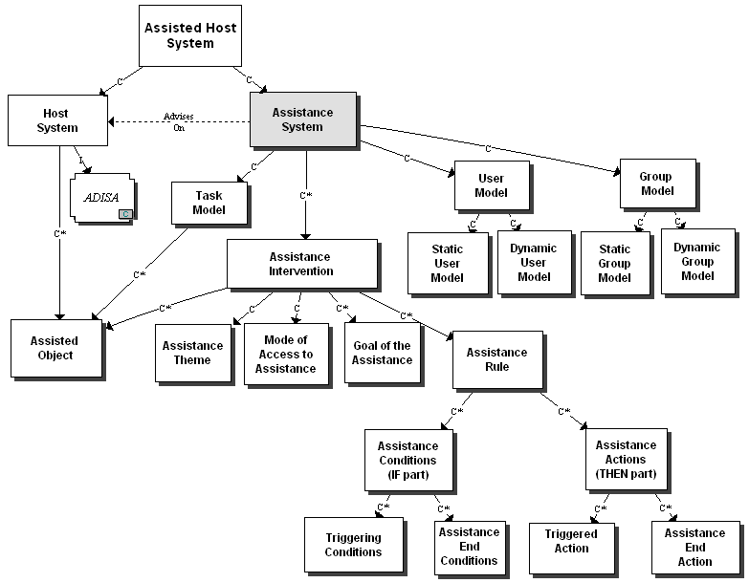

Figure 21.10 – Generic model of an assistance system

As we can see on the model, we have kept the general EpiTalk approach where the assistance system is defined in relation to a host system and a task model. The host system is an environment like ADISA grouping activities and resources to support users and group achieving a relatively complex task: designing a learning system or environment.
The task model groups a subset of all the activities that can be done using the host system. It is the part of the assistance systems that relates to the host system by a task/tool-function association. The task model is basically a hierarchical list of tasks and sub-tasks achieved using the host system. In a similar way to the Explor@ advisor system, the task model can also contain:
- a progress model within each task: sequential, parallel, modular or optional;
- a weights model of the task showing the relative importance of sub-tasks within the task, for example, what percentage of the task a given sub-task represents;
- a time-table model where the duration of each sub-task is specified,.
To be able to adapt to users, the assistance system contains a user and a group model constructed on the basis of the traces of user interactions with the host system. The static user model contains general user properties such as its background, learning styles and preferences or to its role in a task. The dynamic user model contains traces of user activities that will be used by the conditions that trigger the assistance, for example the number time consulting a resource or accessing assistance. The static and dynamic group models contain aggregated results from its individual member’s models and also traces of group activities and interactions between group members. It enables a comparison between each user and the other users in a group.
The assistance interventions are based on these models. They are composed of an assisted object, an assistance theme, a mode of access to assistance, the goals of the assistance and the assistance rules.
- The assisted object is an element of the task model, supported by the host system. It can be a resource, an activity or a knowledge element defined in the host system.
- The assistance theme is a way to group the interventions by similarity of goal, in order to facilitate the access to indexed assistance or to build specialized assistance modules on themes like the operation of the host system, task execution, quality of the production (consistence, completeness, pertinence,…), collaboration between users or users’ self-management.
- The mode of access to assistance determines if the assistance is static or adaptive. Static assistance is not based on the user model. It is always the same, whatever the users actions in the host system. There are two modalities: contextual assistance that provide pieces of advice or information on the task and resources that the user is actually using, or general indexed assistance such as the help files provides by generic software tools. On the contrary, adaptive assistance is founded on the user model. It can also be given in context or in a general indexed way. In those two cases, the assistance will be different depending on the user’s previous actions.
- Seven types of assistance goals have been identified: presentation, explanation, recall, guidance, motivation, verification, feedback.
The assistance rules are the central part of an assistance system. Each assistance intervention is define by one or more assistance rules, each composed of one or more assistance conditions (IF part) and a sequence of assistance action (THEN part).
The assistance actions either give the assistance or end the assistance. The actions can produce:
- Adaptation of the user interface. Such an adaptation can be a modification in the interface of the host system (e.g. the number of choices in a menu is reduced according to the user model); a change in the user model (e.g. the number of times a user access a resource in the host system); information given about the group model (e.g. a bar graph presents the results of a test for each member and an average for the group); the interface of the assistance system (e.g. a progress bar increases to show the progress of a user in a task ).
- Display of an assistance message. The message is textual or audio-visual and it varies according to the goal of the assistance.
- Display/launch of an element in the host system. For example, in ADISA, the action opens a MISA design element in the ADISA interface.
- Display/launch an external element: an application, a document, or a notification to other actors of the host system.
- The ending assistance actions depend on the type of assistance. If it is a message, it is simply closed; if it is a host system element, the assistance system has to close that element to return to the preceding state.
The assistance conditions of a rule either trigger the assistance or end it. A triggering event (e.g. a user starts a task, produces a document, etc.) is part of the condition. Only if the triggering event happens will the other conditions in a rule be evaluated to decide if the rule will be triggered. Here are the main triggering conditions that can be integrated in assistance rules.
- Task related conditions. (e.g an intervention assistance is scheduled at a certain date after the beginning of a task).
- Conditions on the static user model. These conditions are based on general properties of the user (e.g. the user prefers a certain access mode to assistance).
- Conditions on the dynamic user model. These conditions are based on the previous actions of the user in the host or the assistance system (e.g. an action can be triggered when the user select, start or complete a task element, passes a long time on a task element or annotates a resource).
- Conditions on the group model. These conditions are similar to those on a user model, except they are based on the aggregation of the individuals’ models or group properties and previous actions of the group (e.g. all members have declared a low competence for a task (static model); at least two members have participated in a forum (dynamic model).
- Conditions on the comparison of the user model and the task model. These conditions evaluate the gap between the user model and the task model (e.g. a user is late on a time table, or tries to complete a task before a prerequisite is completed).
- Conditions on the comparison of the group model and the task model: (e.g. conditions where the whole group is late according to the time table and the progression model for the task).
- Conditions on the comparison of a user model and the group model. These conditions evaluate the gap between the user model and the group model (e.g. an intervention is needed when a user is late compared to the progress of the group or if s/he intervenes rarely in group activities compared to other members of the group).
- Conditions to close assistance. The user can be offered to close the assistance or the assistance system car retrieve the intervention after a certain period of time.

Building Assistance in TELOS
At the moment of writing this chapter, we have started to apply the EpiTalk approach to build assistance into the TELOS system. In TELOS, host systems are provided by activity scenarios that also provide a task model. In the case of TELOS, the task model (or the scenario) can be more elaborated than in our previous projects because TELOS is based on the concept of a multi-actor process or workflow. These scenarios can also be intended for any level of the TELOS cascade, for engineers who aim to extend the services given by the system, for technologists who design platforms, for designers who built courses or work scenarios and for the final users who interact in these scenarios.
As explained in chapter 15, it is possible to embed actors called software agents into TELOS scenarios. We will define here a special class of software agents called advisor agents. They will be inserted in scenarios to show at what insertion point the assistance will be provided. An insertion point is a TELOS function symbol, as shown on figure 21.11, or a terminal activity.

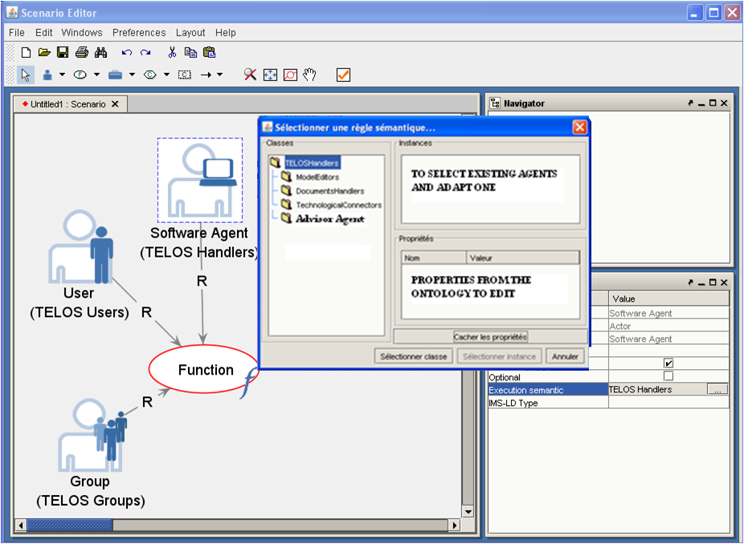
Figure 21.11 – Insertion of an advisor agent in a TELOS scenario

But stating that assistance will be given at a certain function or activity is not enough since there can be many actors that intervene in that task. The TELOS ontology (and the IMS-LD model) defines actors categories that are “explorers” such as learners or knowledge workers, and facilitators such as coaches, tutors, or technical support staff, in other words, users of the scenario. As a first step, we aim to give the assistance only to actors that are explorers at the exclusion of composers (designers will be assisted in their own scenarios) or administrators that control scenario instances. In the situation of figure 21.11, assistance could be given to the user and/or to the Group.
Each advisor is defined essentially by its assistance rules. Rule conditions can check on user preferences (initiator of the assistance, learning style, socio-cultural indicators,…), on previous actions in the TELOS scenario (tasks achieved or progress bars, asked and received assistance,…), on competencies stored in the user model, on a portfolio that provided evidence on a user’s competencies, on group collaboration or affective indicators. When conditions are met, the action part of the rules can provide messages to the user, modifications to the user model, advice to facilitators or modification to the scenario.
Figure 21.12 proposes an extension of the TELOS technical ontology presented in chapter 15 to provide a definition of Advisor agents, which are special classes of TELOS handlers (services). It states that an Advisor agent gives assistance to exactly one insertion point in a scenario: a function, a multi-activity or an activity, each representing tasks or groups of tasks. This insertion point has at least one advised explorer-actor (one or more individuals or groups) and possibly other actors that the designer of the assistance has chosen not to advice.

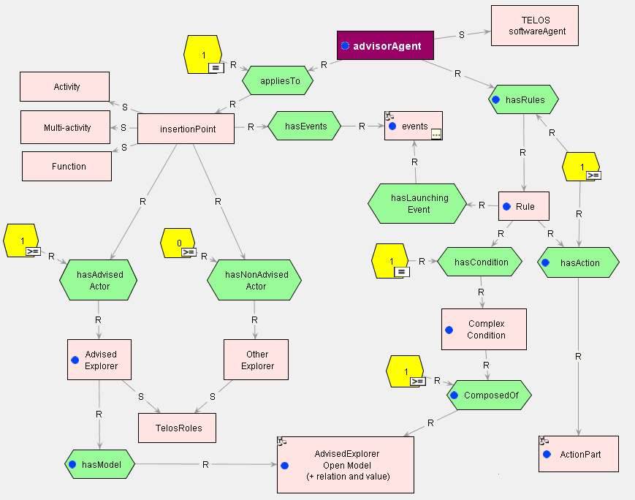
Figure 21.12 – Ontological definition of an advisor agent.

An Advisor agent has rules composed of at least a condition and at least an action, the condition being composed of explorer’s properties that can be consulted in his user model. Sub-models of this main ontology models defines properties that can be used in conditions, based on the generic model of assistance presented on figure 21.10 and a competency-based user model based on the one presented at the end of chapter 9.

Summary of the Advisor System Research Process
Let us summarize this research process. The initial phase, involved a process to construct advisor system presented in figure 21.8. This process has been embodied in the EpiTalk generic advisor editor. Using this editor, two applications have been made, one for designers using AGD, another one for learners using a physics law induction environment.
After this first phase, a tool to define advising components has been built into the Explor@ LCMS. This new advisor editor refined the initial EpiTalk orientation in order to provide a more accessible tool, but that had a reduced set of functionalities. Advisors for a Job Search environment and advisors for some of Télé-université courses have been built with it.
A third phase began with a three-year research project that resulted in a model of an assistance system partly shown on figure 21.10. This model was applied to build an advisor system for the ADISA instructional engineering workbench.
Finally, a fourth phase has started where the previous model of an assistance system has been transformed in an ontology that extends the TELOS technical ontology. The advisors agents are visual objects, clearly related to their context in an activity scenario.
Again in this research process, we see the interaction between a method and its tools and the role that visual knowledge modeling plays in the process. The model of the method provides the specification for the tools and the tools can be seen as interactive method objects. With them, you can apply a method and discover ways to refine it. Finally, in the latest development, the method ontology becomes part of the tool in an ontology-driven system like TELOS.

21.3 Visual modeling IN Doctoral Research
The interplay between methods and tools, guided by visual modeling has been applied many times in the doctoral research of students directed by the author. We have mentioned earlier that a prize-winning thesis was produced by Françoise Crevier (1996) on the subject of the MISA method presented in the first section.
Other theses have applied similar approaches, despite the differences between their subjects. We will present here some of these doctoral work, to underline the similarity of the research methodology.

A Thesis on Learners’ Self-Management
Another successful Ph. D thesis in Education was accomplished by Diane Ruelland (2000) on the subject of learner self-management. After a number of studies of self-management processes in telelearning environments, she elaborated a model a learner self-management. The upper part of this model is shown on figure 21.13.
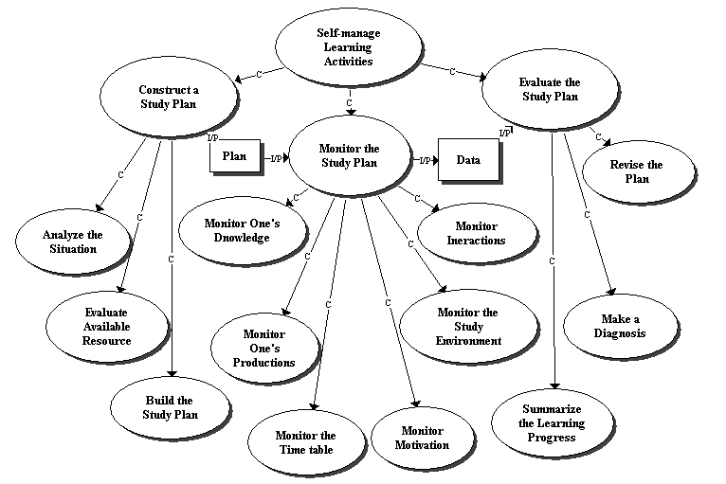
Figure 21.13 – A learner’s self-management process (Adapted from Ruelland, 2000)
The analysis of the learning context in distance learning environments has shown that a learner has to master a number of self-management tasks to succeed. These tasks are complex because of the need to organize interactions and collaboration at using a variety of ICT technologies. On figure 21.13 the general process of learning self-management is subdivided in three large sub-processes: construct a study plan, monitor the plan and evaluate the plan.
The first sub-process is normally done at the beginning of course. It encourages a preliminary reflexive activity on how to address the learning activities. In the second process, the learning plan is monitored by the learner on six dimensions: progress in knowledge acquisition, quality of the productions (homework, tests, etc.), time management, state of motivation, mastery of the learning environments and quality of the learner’s interaction with peer learners and facilitators. This process is enacted during learning and produces data that will serve to evaluate the plan and the learning progress. Enacted at certain predefined moments (end of a module or a difficult production), this third process favors meta-cognition (Noël 1991), an activity where the learner reflect on his situation and can decide to re-plan a new set of activities, thus starting a new plan-monitor-evaluate cycle.
The model of the self-management process on figure 21.13 has been used to identify a number of tools to support the process. Some of them have been implemented in the Explor@ and Concept@ tele-learning delivery systems at Télé-université. Figure 21.14 presents some of these tools related to components of the self-management process.
The guided tour of a course or learning environment is a necessary starting point to analyze the learning situation, in particular to identify the knowledge and competency objectives, and the activities, resources and participants that are available to attain the course’s objectives. Then the learner uses the personal profile tool to present himself to the other participants. He also uses the competency self-diagnosis tool to evaluate its strengths and weaknesses with regards to the target competencies; such a tool has been presented in the preceding chapter.

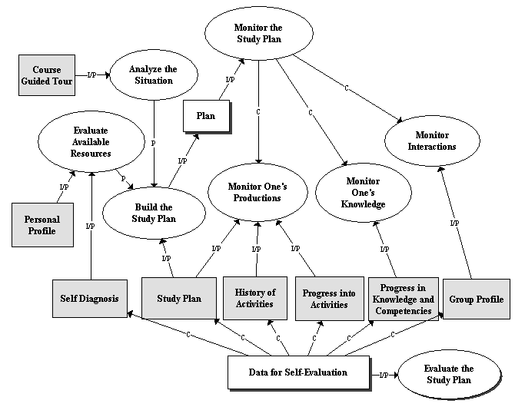

Figure 21.14 – Identification of self-management tools
The study plan plays a central role in the integration of all three sub-processes of learning self-management. It results from the preceding activities and consists in building a timetable integrating individual and collaborative activities and evaluating the amount of work required to achieve them. The study plan provides a basis to help monitor and guide the global learning process.
The four other tools presented on figure 21.14 serve mainly to help monitor the learning process by presenting to the learner data to evaluate its progress. The history tool provides a trace to the learner, displaying the dates where his activities have been realized. The progress tool presents the activity structure of the course together with a progress bar of its achievement. The knowledge and competency progress tool presents a synthesis of the evaluation of the learner’s production. Finally, the group profile tool enables each participant to see the personal profile of each participant in the group and to compare his results with those of the group, It also provide a global view of the group and the individuals progress in the course to the facilitator in order to orient their assistance to the right persons and on the right subjects.

Three Thesis on Cognitive Computing and the Semantic Web
The two above-mentioned thesis are very good examples of the application of Knowledge Modeling to Educational Research. We will now summarize three theses on Cognitive Computing and the Semantic Web. These doctoral research works have been presented in detail in section III of this book, on the subjects of ontology evolution, software components aggregation and ontology modeling.
The doctoral work of Délia Rogozan presented in chapter 11 has started by building a process model. This visual model, presented on figure 11.4, has been built using the MOT representation language in order to elaborate a unified model of ontology evolution. It helped identify the delicate operations where support should be given to the ontologists responsible for ontology change. After a further analysis of the ontology evolution process, the conclusion was that there is a lack of tools to support important steps of the ontology evolution model. From the evolution process model, needs have been identified a) for a tool that provides a uniform and consistent logging of elementary and complex changes as well as the causality relations that exist among them; b) for a tool that can analyse change effects on resources that are semantically referenced by concepts should be made available; c) for a tool that preserves the access to and the interpretation of resources via the new ontology version.
To resolve these problems, a framework was proposed that led to the identification of two tools: the Change History Builder (CHB) and the Semantic Annotation Modifier (SAM). The integration of these tools in the process of ontology evolution has been presented in figure 11.13. Basically, CHB logs the changes in a useful way when the ontology is modified, and SAM uses this information to present referencing adaptations for the ontologist to decide. Essentially, this framework is an advisor system that helps ontologists maintain a sound referencing of resources through ontology evolution.
The doctoral work by Anis Masmoudi presented in chapter 13 has followed a similar path, though with a different subject: the aggregation of software components. On figure 13.1, a software component aggregation process (SOCAP) has been presented. This aggregation process is based on a software component ontology that provides metadata describing each software component. This metadata helped define a first tool, the SOCOM manager that enables the construction of a software component repository where components can be stored and retrieved according to their metadata. Then other tools have been built into a framework to support the aggregation process. This framework contains an aggregation advisor that uses the ontology and the metadata to evaluate if two or more components are compatible for aggregation and if not, make recommendations on how to adapt them.
The doctoral work of Michel Héon, presented in chapter 14, focused on an ontology engineering process based on the transformation of semi-formal models into ontologies. This process is presented on figure 14.8, and the three sub-processes, design a semi-formal model, formalize in a domain ontology, and validate the domain ontology, are presented in figures 14.9, 14.10 and 14.11. Based on this process, a meta-modeling technique is used to help disambiguate the semi-formal model in terms of a reference ontology, with the goal to produce a domain ontology that respects the semantics of the original model. This leads again to an advisor system that uses transformation rules to suggest automatic transformation to the semi-formal model, or propose choices to the ontologist on alternative possibilities.

Conclusion to Chapter 21
In this chapter, we have presented a variety of research project that have been conducted using visual modeling. Despite the variety of subjects, there are three constants: the interplay between method modeling and tool definition; the use of visual modeling to represent the method as a process and situate the context of use of the tools; and the use of visual modeling to describe the software framework and the tools themselves. Table 21.5 synthesizes the main elements of the research projects presented in this chapter.

Research Project | Actors and their products | Method or task process | Assistance rules | Tools and/or framework
MISA Instructional Engineering | Team of instructional engineers – specs of a learning environment | Model of the instructional engineering (IE) method | Rules to ensure coherence relations between IE products | AGD, ADISA, form-based and model support to IE
EpiTalk Advisor systems | Technologist – definition of an advisor system | Adding advisor agents to a host system and a task model | No assistance to advisor designers has been provided | Epitalk and Explor@ advice definition tools
Learner self-management | Learners - self-monitored learning process | Model of a self-management of one’s learning process | Rules in some Explor@ applications | Personal and group profile, competency self-assessment, progress tools, …
Ontology Evolution | Ontologists – revised resource semantic references | Model of the ontology evolution process | Rules to adapt resource references through ontology change | Change history builder and semantic annotation modifier
Software component aggregation | Software engineers – aggregated components | Model of the software aggregation process | Rules on component compatibility for their aggregation | Software component aggregation framework (SOCAF)
Ontology modelling | Ontology engineers – ontology models | Model of the ontology building process from a semi-formal model | Disambiguation rules for transformation from semi-formal model to ontology | OntoCASE ontology building advisor
Table 21.5 – Comparison of research projects.

Figure 21.15 captures the commonalities of these projects in a generic research process that can be applied to other research areas. We do not pretend it applies in all areas but certainly to the type of oriented research and development that characterizes the LICEF research centre and the CICE research chair.
At the beginning, there is always an actor or a set of actors that we aim to assist by providing a method and a set of tools that will help apply the method. After an inventory of the problem area, the first questions are who are the actors? what do they have to produce? Then, with answers to these initial questions, we can start decomposing the products and the main actor’s tasks, in order to build a process model or a method structuring these tasks.
The difference between a process model and a method lies in the principles that rule a method. This difference has been underlined in chapter 3. If an advisor system is the final goal, then principles must be added to the process or uncovered from the method in order to formalize some assistance rules, as we have done in some of the projects. This operation requires a more profound analysis and needs not to be done for the entire process but only for the critical tasks in the process or method.
With a set of critical tasks’ sub-models, we can start modeling the tools and/or the framework using software engineering techniques. MOT models can also be used. By integrating the tools within the tasks sub-model, we can provide precise test bed scenarios for the validation of the process/method and its tools. This validation can start another cycle of process modeling/ tool definition, as we have seen in the MISA research process.

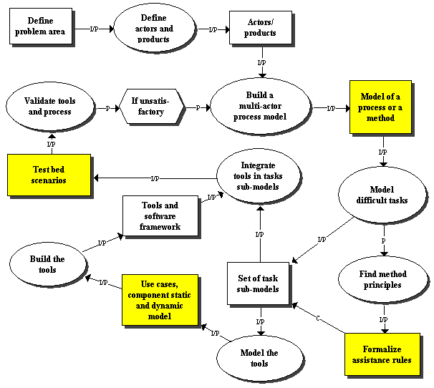
Figure 21.15 – A generic research process

References
Basque, J., Dufresne, A., Paquette, G., Léonard, M., Lundgren-Cayrol. K. and Prom Tep, S. (2003), Vers un modèle conceptuel générique de système d’assistance pour le téléapprentissage. Revue STICEF, Vol. 10, France
Crevier F. (1996) Conception et validation d’une méthode d'ingénierie didactique. Thèse de doctorat. Sciences de l’Éducation, Université de Montréal.
Girard, J., Paquette, G., Miara, A. and Lundgren-Cayrol, K (1999) Intelligent Assistance for Web-based TeleLearning. Proceedings of AI-Ed’99, in AI and Education, open learning environments, S. Lajoie et M. Vivet (Eds), IOS Press, pp 561-569
Lundgren-Cayrol, K., Paquette,G., Miara, A., Bergeron, F., Rivard, J. and Rosca, I. (2001) Explor@ Advisory Agent: Tracing the Student's Trail, WebNet'01 Conference, Orlando .
Noël, B. (1991) La métacognition. Bruxelles: De Boeck-Wesmael. 229 pp, 1991
Paquette, G., Rosca, I. , De la Teja, I., Léonard, M. and Lundgren-Cayrol, K. (2001) Web-based Support for the Instructional Engineering of E-learning Systems, WebNet’01 Conference, Orlando.
Paquette, G. (2001) Designing Virtual Learning Centers. In H. Adelsberger, B. Collis, J. Pawlowski (Eds) Handbook on Information Technologies for Education & Training, within the Springer-Verlag series "International Handbook on Information Systems", pp. 249-272
Paquette, G. (2002) L’ingénierie du télé-apprentissage, pour construire l’apprentissage en réseaux. 450 pp, Presses de l’Université du Québec.
Paquette, G. (2004) Instructional Engineering for Network-Based Learning. Pfeiffer/Wiley Publishing Co, 262 pages.
Paquette, G. and Tchounikine, P. (1999)Towards a Knowledge Engineering Method for the Construction of Advisor Systems. Proceedings of AI-Ed’99, in AI and Education, open learning environments, S. Lajoie et M. Vivet (Eds), IOS Press.
Paquette, G., Aubin, C. and Crevier, F. (1999) MISA, A Knowledge-based Method for the Engineering of Learning Systems, Journal of Courseware Engineering, vol. 2, August 1999
Paquette, G., Crevier, F. and Aubin C. (1994) ID Knowledge in a Course Design Workbench. Educational Technology, USA, volume 34, n. 9, pp. 50-57, November 1994
Paquette, G., Pachet, F., Giroux, S. and Girard. EpiTalk J. (1996) Generating Advisor Agents for Existing Information Systems. Artificial Intelligence in Education, USA.
Ruelland, D. (2000) Un modèle des processus d’autogestion de l’apprentissage. Thèse de doctorat, Université de Montréal.

A first version of this text has been prepared by Michel Léonard.

