Chapter 18 - Modeling for Learning Design Repositories

Abstract

A Learning Design Portal
Learning Design as Learning Objects
A Case Study: Producing and Reusing Patterns and Learning Designs
Description of the Reusability Process
Analysis of the process
An Ontology for Learning Design Objects
Main Ontology Model
LD Format Relationships
Reusability Categories
Aggregation Level and Delivery Model
Pedagogical Strategies
Learner Evaluation Model
Using the LD Objects Ontology

The deployment processes of a new technology or a methodology like Instructional Engineering is crucial if we want R&D results and products to reach end users with innovative products and services that produce quality and growth. These preoccupations are at the origin of the IDLD project that provides the main thread of this chapter. This project is based previous projects in the same area: R2R (Paquette, Marino, De la Teja, Lundgren-Cayrol, Léonard & Contamines, 2005) and edusource (McGreal, Anderson, Babin, Downes, Friesen, Harrigan, Hatala, M., MacLeod, Mattson, Paquette, Richards, Roberts & Schafer, 2004).
In the first section we present the IDLD portal (Figure 18.1) that contains a repository of learning design models and examples. Such a repository groups narratives (lesson plans), MOT+LD models and the corresponding XML files compliant with the IMS-LD specification. It contains also an adaptation of the MISA Learning System Engineering Method presented earlier in chapter 8. In section 2, we will present how we have adapted the Learning Object Metadata (LOM) to structure the LD repository, considering LDs as special kinds of learning objects. For this, we had to integrate two classifications schemes into the PALOMA Learning Object manager. PALOMA will be presented with more details in chapter 20. In section 3, we will present a reusability process for decomposing a course into smaller patterns and re-using some of them to compose new courses. In section 4, we will propose an ontology that can help structure learning design repositories and enable more useful queries to such repositories.

18.1. The IDLD Portal

Building LD repositories has been identified as a priority in a Valkenburg Group round table held in January 2004 (Paquette et al, 2004). In order to fulfill this need, the IDLD Web portal has been built. This IMS-LD resource center is now in operation at www.idld.org providing a free access to a repository of learning designs, a suite of tools to support the deployment of IMS-LD, methodological aids to help in its implementation and a number of background documents and related sites.
All object and information in the IDLD Portal can be reuse under a give credit/non commercial/share alike Creative Commons licence. Knowledgeable persons are invited to use the tools in the Portal and add learning designs to the repository using the PALOMA software.
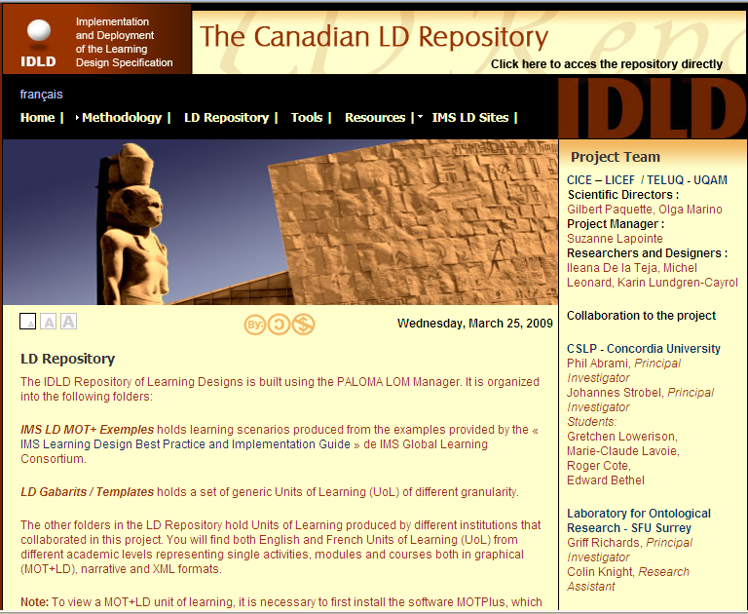
Figure 18.1 – A view of the IDLD Web Portal

Besides some basic IMS-LD documentation, the IDLD portal offers a set of methodological aids for instructional designers and educators involved in the implementation and deployment of the IMS-LD specification, such as the following:
- A methodological guide to support IMS-LD authoring, validation and execution using the portal’s tools or other alternative tools;
- A description of the classes of learning designs in the classifications we have used to provide metadata descriptors for learning designs;
- A set of best practices in the development and use of the learning design repository based on our experience in the project;
- A workflow model to help build units of learning or courses compliant with the IMS-LD specification.
To support the development and use of the LD repository, the IDLD portal presently gives access to four tools:
- the MOT+LD graphic editor (Paquette, Léonard, Lundgren-Cayrol, Mihaila and Gareau, 2006) that supports an interactive design process more friendly to designers than form-based editors, but limited to level A of the IMS-LD specification;
- the RELOAD (2006) editor (RELOAD supporting A, B and C levels in a hierarchical form-based format;
- the RELOAD player, embedding the COPPERCORE engine (Martens and Votgen, 2006), that reads IMS-LD manifests and offers a Web-based interface to deliver and execute a LD run;
- PALOMA, a learning object repository management system, extracted from the Explor@ system (Paquette, Miara, Lundgren-Cayrol and Guérette, 2004) that supports the IEEE-LOM and the IMS-DRI specification for federated search into multiple repositories.
These tools are sufficient to support the implementation process presented below; however, some limitations have appeared in the IDLD test beds, so we aim to extend this tool set with other open source tools that are being developed by us or by other groups. We are in the process to integrate in the portal the new TELOS scenario editor presented in Chapter 15. This editor covers all three levels of IMS-LD and exports the scenario models to XML. TELOS also executes such scenario. When this work is finished, the RELOAD editor can still be used for packaging and the RELOAD player will provide an alternate scenario delivery tool to TELOS.
Figure 18.2 presents the main process phases (Lundgren-Cayrol & Léonard, 2006) and the tools that we have used to build and reuse the LD repository. In the first phase, our research group’s tools, documents and expertise were used by three other teams besides Télé-université, at Concordia University and at Simon Fraser Universities, and also another team at the Canada School of Public Service (see section 17.4) to build standardized learning designs. The two main standards needed for the implementation and deployment of Units of learning are the IMS Learning Design Specification (Koper 2005) and a metadata schema, in our case, the Learning Object Metadata Standard by IEEE, which is integrated into PALOMA.

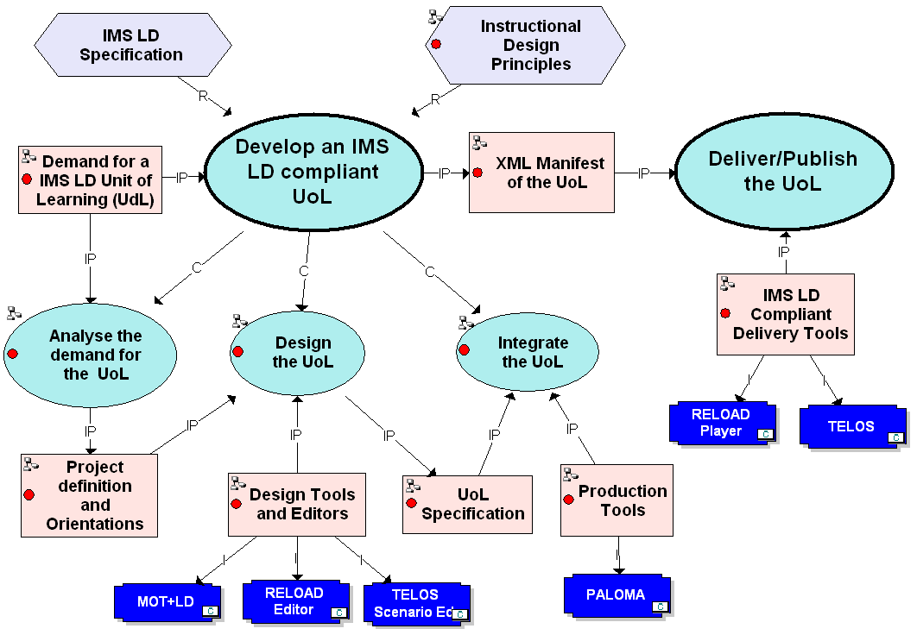

Figure 18.2 – Repository Building Main Process and tool

Using the MOT+LD visual learning design tool presented in chapter 8, the teams involved in the project have build and integrated in the PALOMA Resource Manager, a repository of around 50 learning designs. The IDLD Portal (www.idld.org) gives a direct access to this repository. In a second phase, a test bed was carried out with new instructional designers distributed all over Canada to test the use of the IDLD repository and portal for learning design operations. This test bed yielded ample information not only on implementation and deployment issues, but also on the types of reuse that are potentially viable.
Throughout this process, the instructional designers were involved in the following activities:
- Familiarization: Explanation of main IMS LD concepts and paradigms and the demonstration of MOT+LD editor.
- Planning: Clarification of the context at hand and construction of a plan on how to best implement and deploy IMS Learning Designs.
- Preparation: Analysis of existing courses to be modeled by respecting a number of principles such as :
  - Constructivist or cognitivist learning paradigms;
  - Collaborative learning strategies in a blended or online learning setting.
  - Multi-actor design, making use of content/field experts, teachers moderators etc.
  - Generic and/or easily adapted learning environment;
  - Ensure instructional quality by applying a known ID method, i.e., MISA
- Implementation: Model building supported by mentor activities and community exchanges through the following steps:
  - Face- to face workshop: Participant training, where the objective was to explain the constraints required by the IMS LD specification and to demonstrate the MOT+ LD editor tool.
  - Exemplification: Presentation of IMS LD narratives and derived units of learning models and xml files;
  - Drafting: Elaboration of a first draft of the chosen course;
  - Face-to face workshop: Validation of this first model and demonstration of advanced features of the MOT+ LD editor.
  - Modeling Support: Discussion of alternatives to the proposed solutions and continuous coaching in the modeling process.
- Validation:
  - Exportation of the MOT+LD Level A model as an xml manifest file and testing it in an IMS-LD compliant player, such as RELOAD Player.
  - Summarizing and documentation of impressions.
- Referencing:
  - Publishing the Unit of Learning and indexing them using a recognized metadata scheme such as the LOM and integrating the metadata forms in the PALOMA tool.

18.2 Learning Design as Learning Objects

The central idea in the PORTAL is to consider learning designs or scenarios, IMS-LD compliant or not, as a special kind of learning objects, which explains the use of the PALOMA Learning Object Metadata (LOM) manager. In this section we will present briefly this tool and the adaptation that was made to integrate learning designs in learning object repositories. We will also present some examples to show how the learning designs have been described using the LOM standard.
The idea behind this approach is to visualize the construction of a Unit of Learning (UoL) as an aggregation of learning objects of different kinds. A similar approach has been taken in chapter 12. As shown on figure 18.3, learning objects can be all sorts of documents that carry information using media elements, tools that help actors process information, and human or software actors that process the information in documents to produce other documents using some of the tools.
Process scenarios or learning design patterns (such as in the central part of figure 18.3) are also learning objects composed of a structure of activities, awaiting for actors (red arrows) or documents and tools (yellow arrows) to be specified. When they are at least partly specified (others can be specified only at runtime), then we have a learning design example, schematized on the right part of the figure. This schema tells us that an actor will do the first two activities and a group will do the other two activities. Also, the group will use a document produced by the actor in the second activity in the last activity.
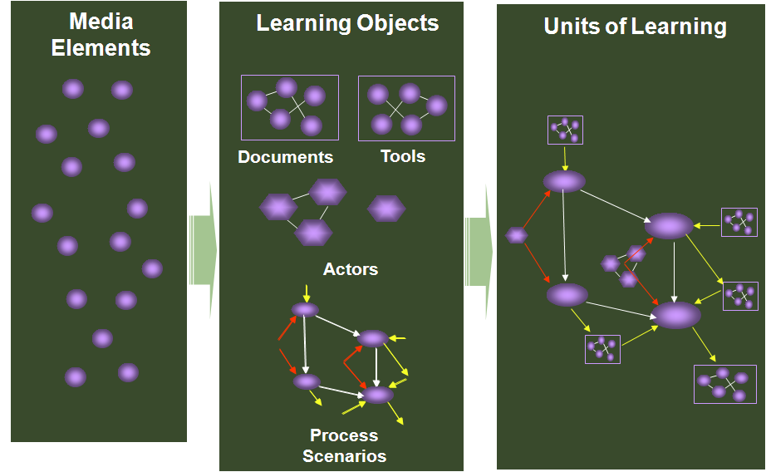
Figure 18.3 – Units of learning through learning object aggregation

The central component of the IDLD portal is the LD repository. It actually contains around 50 entries, each giving access to products of the learning design implementation process: initial narratives of learning scenarios, visual models of learning designs build with the MOT+LD editor, IMS-LD compliant XML manifests. The visual models and their corresponding XML manifests are either LD examples, where the content resources are specified as items, or LD patterns that are learning design flows without specific content.
We believe that LD patterns are more interesting that other types of learning objects because they are ready-to-adapt multi-actor processes embedding learning and teaching strategies that can be reused in different knowledge domains.
To facilitate search in learning object repositories containing learning design products we need to classify the LDs according to their main properties. Figure 18.4 shows a screen from the PALOMA learning object manager. The left part presents a list of available repositories, including the IDLD repository. Other repositories contain description of documents (text, presentations, video, images, etc). They can also contain tools or actors descriptions.
Using PALOMA, a designer car can select the components that will be aggregated to produce a unit-of-learning. The center part of the screen shows a list of designs grouped in the selected folder within the IDLD repository. The larger part of the screen provides a user interface for metadata definition based the 9 sections of the LOM standard specification. This is where people can enter and view metadata on learning objects such as authors, language, intended audience, technological or commercial constraints, etc.

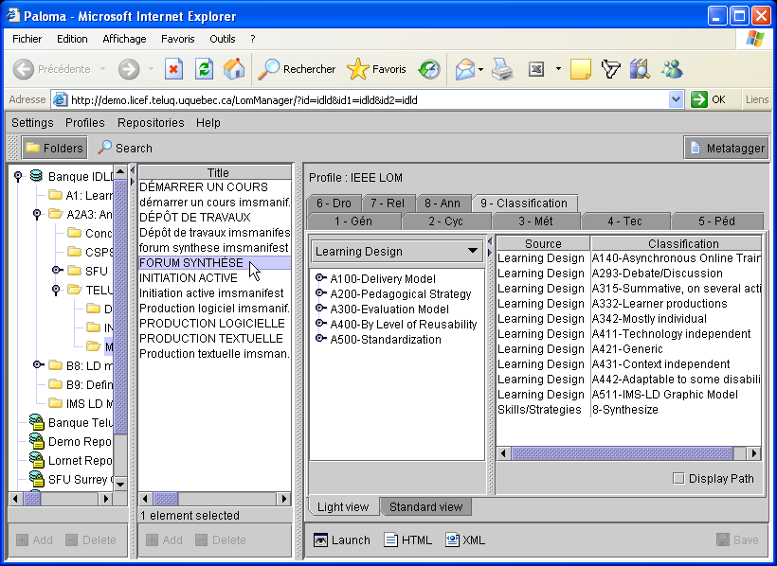
Figure 18.4 – Learning design classification and metadata association to learning designs

The object actually being referenced is a learning design for a collaborative LD pattern entitled “FORUM SYNTHÈSE”. For this LD, the user has already selected metadata from the learning design classification: the delivery model is “Asynchronous Online Training”, the pedagogical strategy is “Debate/Discussion”, and the evaluation model is “summative”, based on “learner productions” that are “mostly individual”. These three top level categories of the learning design classification are extracted directly from the MISA method presented in chapter 8. Category A400 of the classification helps specify a level of reusability of a learning design on different aspects. This category is an extension of a proposal by (Currier & Campbell, 2006). Since the LD here is a pattern, it is considered to be “technology independent”, “content generic”, “context-of-use independent” and “adaptable to certain disabilities”. Finally, category A500 describes the type of LD product, in this case an IMS-LD Graphical Model.
Other classifications can also be made available in section 9 of the LOM. In the list of classification descriptors on figure 18.4, we see that the last entry shows metadata selected from a classification on cognitive skills and strategies. This classification is also extracted from our work on MISA and has been presented in chapter 7. Here, this metadata asserts that the learners will use and develop synthesis skills.
Other LOM sections are useful to provide some semantic structure to the set of LD products in a repository. We use the 1.8 section of the LOM to specify one of four aggregation levels:
- Raw media (learning objects and services);
- Lessons (grouping level 1 objects);
- Courses (grouping level 2 objects);
- Programs (grouping level 3 objects).
Section 7 of the LOM also provides a limited set of choices for relations between learning objects LOM descriptions. Some of them were used with the following semantics:
- “is basis for /is based on” indicates the relationship between a narrative or a textual course outline (or lesson plan) and a graphical model or an LD manifest ;
- “has format/is format of” indicates the relationship between a graphic model of a UoL, an IMS-LD manifest or an executable Web site of the same UoL;
- “has part/is part of” will indicate the relationship between a LD product and its components, for example, between a level 3 (course) and a level 2 (lesson) object.
- “has version/is version of” is re-interpreted as the relationship between a pattern and its examples obtained by associating precise items to the abstract objects (environment, activity, role,…) in a LD pattern.

18.3 A Case Study: Producing and Reusing Learning Design Patterns
In this section, a reusability process using the LD repository presented in the previous section will be described. In this process an existing Télé-université course on Artificial Intelligence (AI), designed as a MOT model using the MISA method, was initially transformed into a graphic MOT+LD model. From the model, a generic pattern was obtained by erasing all the content-specific resources and terms. Then, the course was decomposed into smaller (lesson or module) learning design patterns. From these patterns, it has been possible to aggregate two new IMS-LD courses, one in the same AI domain and the other in a completely another domain.

Description of the Reusability Process
This use case will demonstrate the reusability potential of a LD repository, especially when the LDs are described by visual models that can be globally viewed and easily modified, decomposed and recomposed.

Transfer to an IMS LD generic pattern
An Artificial Intelligence course at Télé-université will serve as an example here. It was developed a few years ago using the MISA method, so a MOT model of its pedagogical structure and scenarios was already available. This model was copied in the MOT+LD specialized editor, as shown on figure 18.5. It was then necessary to redefine the object types using those particular to IMS-LD. An alternative, a little more time-consuming would have been to rebuild the graph directly in MOT+LD, which is necessary for courses that have not been modeled graphically.

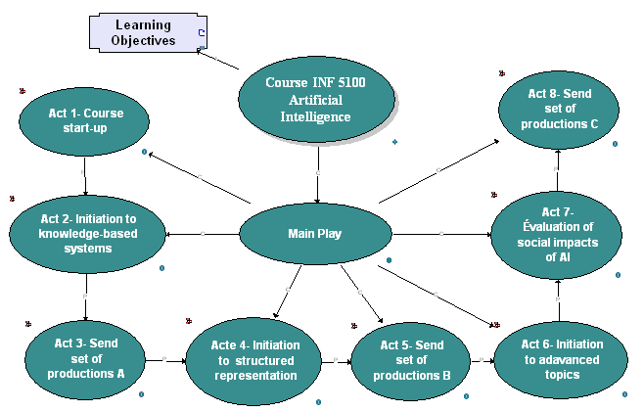
Figure 18.5 - Inf-5100 Initial Course Module

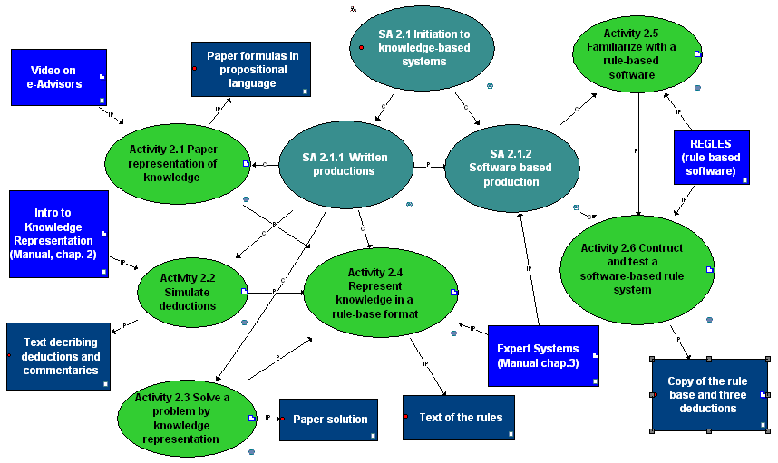

Figure 18.6 – One of the Activity Structures expressed in MOT-LD format

Figure 18.6 shows an activity structure, part of Acte2 that shows resources input or output of each activity. In the original model, the instantiated resources were associated to the activities by a direct attachment, which is a standard functionality of the MOT+ editor. In MOT+LD, to respect the format of the IMS-LD specification, it was necessary to introduce IMS-LD “item” elements associated to each resource used in to perform an activity. These item symbols contain the address of a resource. This is where the concrete learning objectives’ definitions, the instructions for activities, the texts, the videos and the software can be found and displayed at run time.
To obtain the template by eliminating the contents of the course, we just had to erase the items which carry the contents specific to the AI course. It is afterward sufficient to rename the objects in the graphic template using generic terms instead of AI Terms, so they do not carry any specific meaning. The result a template (or “pattern”) reusable in other domains.

Decomposing the Course Pattern
After analysis of the structure of the course, we noted that it could be rebuilt using five basic UoL patterns. Such basic patterns correspond to the concept of “learning nuggets”, developed by (Bailey, Mohd, Davis, Fill & Conole, 2006). One example is the activity structure in figure 18.6 that contains two basic patterns: TEXT PRODUCTION (for activities 2.1, 2.2 and 2.3) and SOFTWARE PRODUCTION (for activities 2.4, 2.5 and 2.6). Another basic pattern is used to STARTUP an online course and another one for HOMEWORK DEPOSIT. A fifth basic UoL pattern is the FORUM SYNTHESIS that was referenced using the PALOMA as shown on figure 18.4. Figure 18.7 represents the main structure of this UoL patterns with a nested model the activity structure in Act 2.

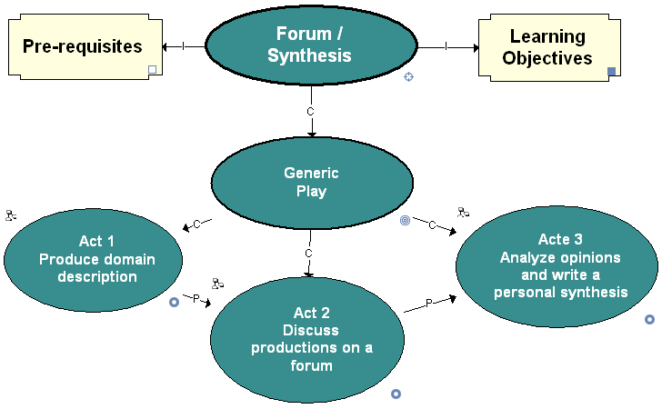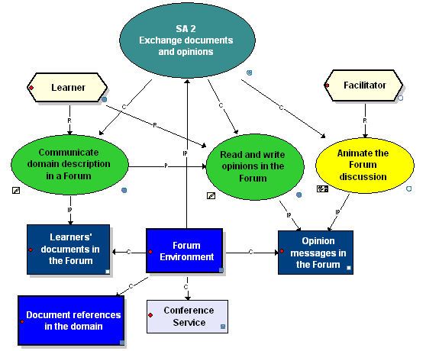
Figure 18.7 – FORUM SYNTHESIS, an IMS-LD UoL reusable pattern

Re-composing course patterns in various subject domains
By re-composing the five basic LD patterns obtained at the preceding step, it is possible to build a new course UoL corresponding exactly to the course pattern produced at step 2, or to change the course structure, re-ordering the activities. This fact confirms the reusability of such patterns. Starting from this new pattern, it is possible to integrate various resources (as IMS-LD items) and thus design a different version of the initial course or a course in a completely different domain. This is done by specifying which resources from the original course are to be used, thus obtaining another version (or a simplified play) of the initial course “Introduction to Artificial Intelligence”.
Figure 18.8 shows two instantiation of the TEXT PRODUCTION pattern, one in the original subject on artificial intelligence, and the other one in political science. If we compare the two models, we see that the differences are essentially in the items associated to activities or document. These items state each activity’s assignment, or point in a LO repository to the videos or texts needed to perform the activities. Another difference is in the names of the activities and documents that are adapted from generic terms to specialized terms in one or the other subject domain.

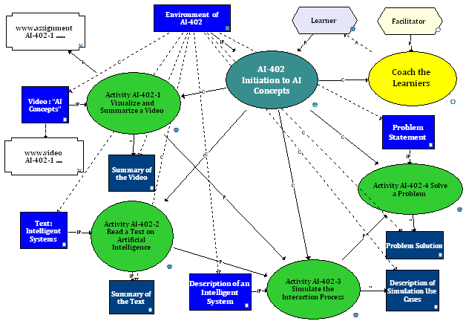

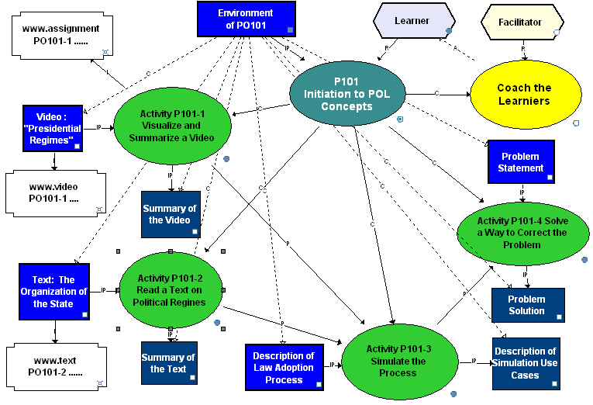

Figure 18.8 –Instantiation of a generic TEXT PRODUCTION pattern, in two different domains

Analysis of the process

During the reusability process presented above, the visual representation of LD patterns and examples offered by the MOT+LD editor was of an invaluable support. The MOT+LD editor provides an overview of the learning design that facilitates the construction and the adaptations of scenarios, especially when comparing it to form-based editors, such as RELOAD. Graphical transformations are very simple and little training is needed to make full use of MOT+LD functionalities.
- Transforming an example into an IMS-LD UoL template or vice versa, is done by simply removing item graphic symbols containing pointers to specific resources or adding them on.
- The decomposition of a UoL course template into basic UoLs can be done by simply copying (or dragging/dropping) an activity structure from one model into a new MOT+LD model.
- The reverse operations, re-compositions, are done similarly by placing the two models them side by side, selecting the desired components and copying or dragging/dropping them into the sub-model of an act or an activity structure in the model to be built.
- Once one or several of these transformations are completed, the designer just has to adjust the numbering and text of the objects in the models either to reflect their generic or specific nature, or to identify new components in the resulting model.
At each step, the model can be exported to IMS-LD XML files and both objects can be stored in the LD repository for further reuse. While populating the LD repository in this way, the graphic MOT+LD editor was found very helpful. It is easy to transform graphs, extract sub-graphs or regroup them, then add content items to create new learning designs.

18.4 An Ontology for Learning Design Objects

In order to add inference capabilities in a LD repository, providing more intelligent processing capabilities, we wanted to replace the use of classifications in section 9 of the LOM by an ontology that will be presented in this section. In the context of LOM, relations between the classifications’ terms is not possible, only global relations can be made using section 7, as presented above.
Another goal was to reduce the manual referencing of learning objects, which is time consuming with LOM metadata, and even more if the objects are learning design. We need to automate at least partly the referencing process. One way that has been explored by various researchers is to add a natural language parser to extract metadata from text or Web documents automatically or semi-automatically. For LD objects a further possibility exists to extract metadata from the regular structure of an IMS-LD manifest and by inferences on a LD objects ontology.
In this section, we will present a preliminary ontology for learning designs that provides a more powerful semantic referencing capability than the LOM. We aim to integrate this ontology for semantic referencing into a IMS-LD editor such as the TELOS scenario editor presented in chapter 15. This user interface will offer referencing and search services extending the capabilities of the PALOMA LO manager in support of the various decomposition/re-composition operations presented in section 18.3.

The Main Ontology Model
The main ontology model is presented on figure 18.9. It has been built with the MOT+OWL editor presented in chapter 10. It shows the main properties of LD objects: Format, Aggregation Level, Reusability Level, Delivery model, Pedagogical Strategy and Evaluation Model. The following figures will present nested sub-models that develop further this main model.
One of the properties of an LD Object is its Competency Attachment where an entry (prerequisite) and/or a target (objective) competency attachment can be specified using the Competency Ontology presented in chapter 10.
Since there are no cardinality axioms on the Competency Attachment, Reusibility Category and Evaluation Model classes, it is possible that some LD objects lack some of these features. On the other hand, the model tells us that a LD object must have exactly one Aggregation Level and Format and at least one Delivery Model and Pedagogical Strategy.

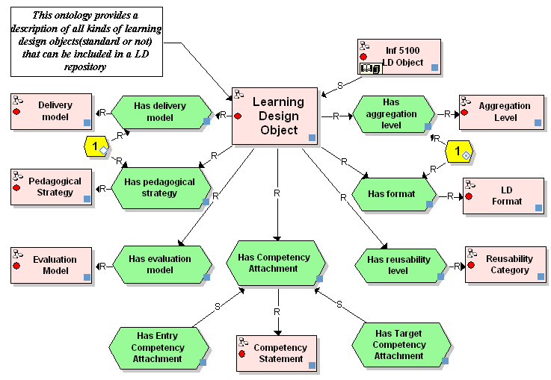
Figure 18.9 – A LD-Objects top-level ontology

LD Format Relationships
The subclasses of the “LD format” class and its main relationships are shown on figure 18.10. The main sub-classes concern non-standard descriptions and standardised ones using the IMS-LD specification or the SCORM profile.
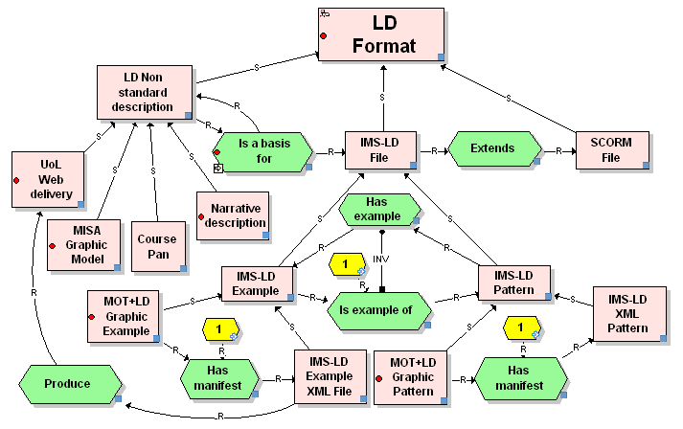

Figure 18.10 – The “Format” Part of the “LD Object” Ontology
An IMS-LD format extends a SCORM format. It can provide a basis for non-standard LD objects such as a course plan or a Web delivery version of the LD. Conversely, any non-standard LD can be transformed in IMS-LD format. One example is the MISA model of the AI course in section 18.3. The property “is-a-basis-for” is transitive as shown by the ⇒ symbol on the property symbol.
The lower part of figure 18.10 shows the relation between different kinds of IMS-LD objects, distinguishing examples from patterns. From a pattern, one can specify many LD examples by varying the items associated to the different levels of the method defining the LD. Conversely, corresponding to an example, there is only one pattern obtained by removing all the items in the example, at the condition that a controlled vocabulary is used to replace specific names of the objects in the model by generic ones.
An LD example, or a LD pattern, has a unique IMS-LD manifest, which is the XML file obtained by translating the model in terms of the standard XML schema. A LD example can be used to produce one or more (different by form and presentation) UoL Web delivery interface that can differ by the widgets used, the presentation. Amongst the possible Web delivery interfaces, there is the one we have shown for the TELOS task manager in chapter 15, which provides a user interface for a LD built with the scenario editor.

Reusability Categories
Figure 18.11 presents a taxonomy for reusability categories that extends a proposal by Currier and Campbell (2006). It specifies four sub-classes covering different aspects: reusability at the technical, content, context levels, and accessibility. These classes are not disjoint, meaning that a particular LD objects can belong to some or all of the classes since there is no restriction in the model of the ontology. But there is a maximum of 4 categories for a particular LD object, because each of the four sub-classes is further subdivided into more specialized classes that are mutually exclusive, which is expressed on the model by “Disj” links.

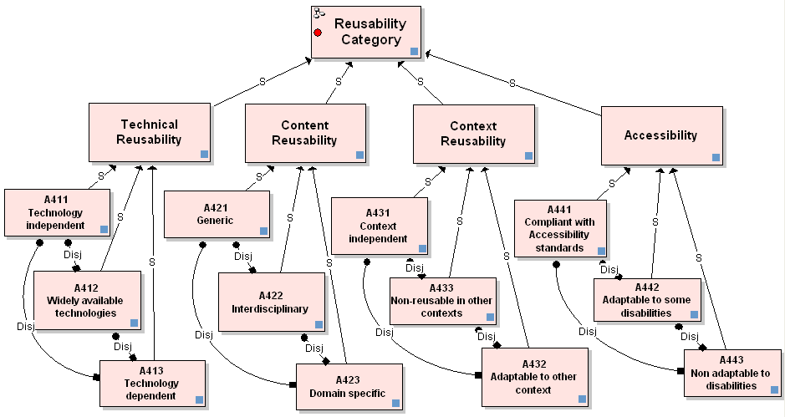

Figure 18.11 – The Reusability Categories Taxonomy

Aggregation Level and Delivery Model
Figure 18.12 shows two other parts of the LD objects Ontology. The Aggregation Level reproduces the Learning Object hierarchy in the IMS-LD information model instead of the one provided by section 1.8 of the LOM. The upper object of a Unit-of-Learning (UoL) is called a Method, irrespective if the UoL is labelled in the LOM as a program, a course, a module, a learning unit, a lesson or whatever local term is used. Methods are composed of at least one Play, Plays of at least one Act, and Acts of a least one Activity Structure. Activity Structures can be recursively nested on any number of level and finally composed of terminal Activities that are either learning activities (performed by learners) or support activities (performed by tutors or other facilitators). As shown on the model, the property Has part is transitive and has a cardinality of at least one. It has the same semantic meaning as the MOT language C link, which is not used in the MOT+OWL language.
The right hand part of figure 18.12 present five basic kinds of delivery models: Face to Face, Correspondence, Distributed Classroom, Online Delivery and Blended Learning. These classes are disjoint two by two. Some of 2-by-2 Disj links are not shown on the model to improve readability. If a LD uses more than one of these delivery modes, it is classified in the class A180 for Blended Learning. The model also present four sub-classes of Online Delivery. Those are not disjoint classes. This means that a LD object can integrate one, two, three or all four modalities. These categories have been built in the MISA 17 taxonomies of Instructional Engineering products (Paquette, Léonard, De la Teja, Dessaint, Lundgren-Cayrol, 2000)
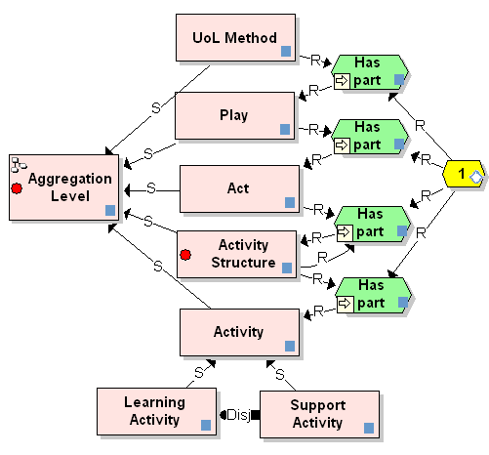 | 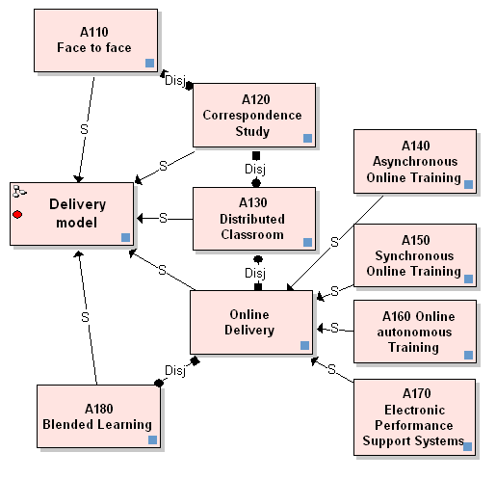
Figure 18.12 – The Aggregation Level and Delivery Model Taxonomies

Pedagogical Strategy

The pedagogical strategy taxonomy shown on figure 18.13 also stems out from MISA research. It is a visualisation of the Learning Design classification presented on figure 18.4 as a tree of possible metadata entries in PALOMA. Any combination of these classes are possible for a particular LD object.
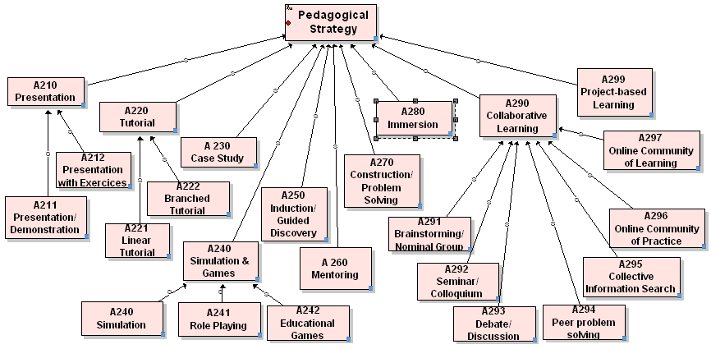

Figure 18.13 – The Pedagogical Strategy Taxonomy

Learner Evaluation Model

We present on figure 18.14 the last part of the LD objects ontology, the learner evaluation model that is also a new version based on one of the MISA taxonomy of LD objects first produced by Ileana de la Teja. The Evaluation Model has possibly one Goal, one Mode, at least one or more Evaluation Objects, one kind of Evaluation Agent and exactly one Collaboration Modality.
- The Evaluation Goal belongs to at most one of the six categories shown on the figure, which are disjoint classes (Disj links have been omitted).
- The Evaluation mode is exacly one of seven distinct categories, depending if a specific evaluation model implements different kinds of diagnostic, formative, summative or confirmative evaluation contexts. These contexts are also disjoints.
- The Evaluation Object is the set of documents or performance data produced by a learner (or a team) that will be evaluated. Theses classes are not disjoint and can be combined. For examples, an evaluation in a computer course can be made through an exam plus some software producer by the learners; an evaluation in a skating course can be based on a skating performance by the learners, plus an ePortfolio of previous achievements.
- The Collaboration Modality adds a precision on how the Evaluation Object has been built, individually, mostly individualy, mostly by team work, only by team work or in an individual/team mixed mode.
- The Evaluation Agent that performs the evaluation can be a group or individual trainer, the learner, co-learners or a combination of learners, trainers or other evaluators.

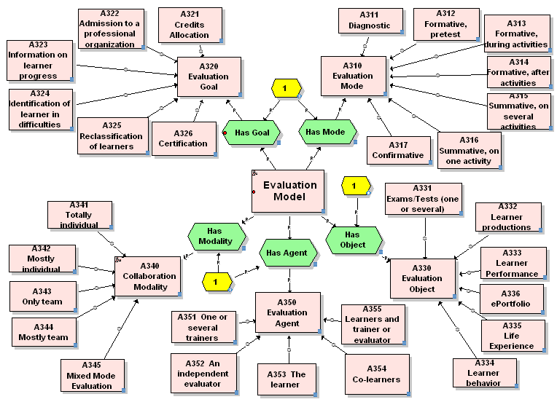

Figure 18.14 – The Evaluation Model part of the LD Objects’ Ontology

Using the LD Objects Ontology

This ontology can be used, first to reference semantically LD objects, and also to make precise queries to retrieve learning designs and learning objects that can help produce higher quality Web-based learning environments.
The upper part of figure 18.15 presents the set of LD objects produced during the case study presented in section 18.3, together with a summary of the six-steps process that has been followed. The lower part of the figure shows how the Forum Synthesis pattern is referenced in the ontology using some of its classes, by simply declaring it as an instance these classes. The metadata assigned to the LD object is the list of classes of the ontology to which it belongs, as explained in chapter 11.

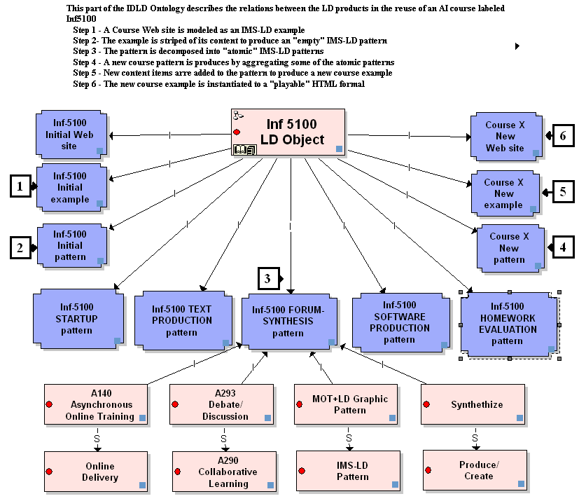

Figure 18.15 – Integration of the Case Study LD Products in the LD Objects Ontology

Using an ontology such as this one has a number of advantages. First, it provides an automatic validation mechanism. If a user tries to reference a LD objects with two disjoint classes, it will prompted with this inconsistency. Similarly, if he tries to assign two evaluation goals to the same LD object, he can be prompted to select only one.
Another advantage is the inferencing capability that the ontology provides. Not everything has to be told to the system. For example if a LD object has a class reference, it will be considered has having the class references of all the classes upward in the specialization chain. Using the properties of this class, more related classes can be found and more properties of the objects can be deduced. Similarly, a transitivity axiom on a property can be applied to find out all the related LD objects that are based on a specified LD object.
An inference engine can combine these local built-in inference capabilities. Take for example the following query: Find all LD objects containing a pattern having a target competency at the analysis skill level or higher. Such a query will follow all the links in the ontology constrained by restrictions and axioms, listing all the individual corresponding to the query. For example the above query would retrieve a Web-based course or a lesson plan based on another LD object, containing in one of its activity structure an IMS-LD pattern that has a competency attachment with a skill’s part that is analysis, repair, synthesis, evaluate or self-control. Such powerful queries are not possible if we only use the LOM.

Conclusion to Chapter 18
The work presented in this chapter shows that research in the field of Technology Enhanced Learning has progressed rapidly. On one hand, software engineering concerns such as formal specification, reusability and interoperability have made their way in this community and are here to stay. As a consequence, we are beginning to see new applications that will improve the quality of online learning.
On the other hand, the problem of designing and delivering technology enhanced learning is now widely recognized as being a complex task in which different dimensions or concepts have to be modelled separately and harmoniously integrated. Such a task implies the use of instructional engineering methods.
Either explicitly like in the MISA method or implicitly, as in the IMS specifications, researchers and practitioners are considering distinct but interrelated concepts such as learning scenarios, knowledge and competency models, learner model, media, resources or learning objects models, evaluation model, assistance model and so on. This separation of concerns has allowed for a better understanding of these dimensions and a more precise specification of technological requirements both at design and at delivery time, allowing new technologies to be effectively tested and integrated into rich learning environments.
The reusability-driven process presented in this chapter, and the ontology for Learning Design Objects is a contribution to address these concerns and facilitate the implementation and dissemination of Instructional Engineering methodology and technology.
The work presented here on learning scenario modeling, decomposition, re-composition and semantic referencing needs to be extended in many directions around the issues of learning scenario patterns and the construction of a larger well-structured LD repository. This might lead us to improve the ontology presented in this chapter. This is another illustration of the need to maintain the semantic referencing of learning objects when the ontology evolves, a question discussed in chapter 11.
Another important research and innovation direction involves partners from the GLOBE community (http://globe-info.org/en), an international effort to federate major learning object repositories around the world. We will develop this subject in Chapter 20, focusing on quality assurance strategies in Learning Object Repository practice.
These preoccupations all converge, from a software engineering point of view, with our development of adaptable ontology-driven learning platforms, such as TELOS, presented in Chapter 15.

References
Bailey, C., Mohd, T.Z., Davis, H.C., Fill, K. and Conole, G. (2006) Panning for gold: designing pedagogically inspired learning nuggets. Educational Technology and Society, 9, (1), 113-122. http://eprints.soton.ac.uk/19642/
Currier S., & Campbell, L.M. (2006) Evaluating Learning Resources for Reusability: The “Dner & Learning Objects” Study. Last retrieved February 6, 2006, from http://www.ascilite.org.au/conferences/auckland02/proceedings/papers/059.pdf
De la Teja, I., Lundgren-Cayrol, K. & Paquette, G. (2005). Transposing MISA Learning Scenarios into IMS Units of Learning. In Colin Tattersall and Rob Koper (2005). Advances in Learning Design (Special Issue). Journal of Educational Technology and Society.
IMS-LD (2006) Learning Design. Information Model, Best Practice and Implementation Guide, Binding document, Schemas. Retrieved February 4, 2006, from http://www.imsglobal.org/learningdesign/index.html
Koper, R. (2005). An Introduction to Learning Design, in R. Koper & C. Tattersall (Eds.). Learning Design - A Handbook on Modelling and Delivering Networked Education and Training, Springer Verlag, pp. 3-20
Lundgren-Cayrol, K. and Léonard, M. (2006) IDLD Modelling Technique http://www.idld.org/Methodology/tabid/174/Default.aspx
Martens, H., Votgen, H. (2006) A Reference Implementation of a Learning Design Engine, in R. Koper & C. Tattersall (Eds.). Learning Design - A Handbook on Modelling and Delivering Networked Education and Training, Springer Verlag, pp. 91-108
McGreal, R., Anderson, T., Babin, G., Downes, S., Friesen, N, Harrigan, K., Hatala, M., MacLeod, D., Mattson, M., Paquette, G., Richards, G., Roberts, R. & Schafer, S. (2004). EduSource: Canada's Learning Object Repository Network, International Journal of Instructional Technology & Distance Learning. March 2004.
Paquette, G. (1999) Meta-knowledge Representation for Learning Scenarios Engineering, in S. Lajoie et M. Vivet (Eds), Proceedings of AI-Ed’99 in AI and Education - Open learning environments, IOS Press.
Paquette, G. (2004) Instructional Engineering for Network-Based Learning. Pfeiffer/Wiley Publishing Co, 262 pages.
Paquette, G. et al. (2004) IMS-LD – The Road Ahead, Canadian Journal of Learning Technologies, Vol. 30, No. 3, Fall 2004
Paquette, G., Miara, A., Lundgren-Cayrol, K., Guérette, L. (2004) The Explor@2 Learning Object Manager, in R. McGreal (ed), Online education using learning objects, pp 254-268. London: Routledge/Falmer.
Paquette, G., De la Teja, I., Léonard, M., Lundgren-Cayrol, K., & Marino, O. (2005) An Instructional Engineering Method and Tool for the Design of Units of learning, chap 6, in Learning Design: A Handbook on Modelling and Delivering Networked Education and Training, eds. Kopper R., Tattersall C., Springer-Verlag. pp.161-184
Paquette, G., Léonard, M., de la Teja, I., Dessaint, M.P.,Lundgren-Cayrol, K. (2000) Method for Engineering Learning Systems - MISA 4.0 Description of Documentation Elements, Version 1.0. LICEF Research Center, Télé-université. October, 2000
Paquette, G., Léonard, M., Lundgren-Cayrol, K., Mihaila S. and Gareau, D. (2006) Learning Design based on Graphical Knowledge-Modeling , Journal of Educational technology and Society ET&S , Special issue on Learning Design, (in press)
Paquette, G., Marino, O., Lundgren-Cayrol, K., Léonard, M., de la Teja I. (2006) Learning Design Repositories – Structure Ontology and Processes, TenCompetence workshop, Sofia, Bulgaria, April 2006.
Paquette, G., O. Marino, De la Teja, I., Lundgren-Cayrol, K., Léonard, M. & Julien Contamines (2005). "Implementation and Deployment of the IMS Learning Design Specification." Canadian Journal of Learning and Technology. Vol 31, No 2, p: 85-104
Paquette,G., Marino, O., De la Teja, I., Léonard, M., Lundgren-Cayrol, K., (2005b). Delivery of Learning Design: the Explor@ System’s Case. In R. Koper & C. Tattersall (Eds.). Learning Design – A Handbook on Modelling and Delivering Networked Education and Training, Springer Verlag, pp. 311-326.
RELOAD (2006) Project. Retrieved February 4, 2006 from http://www.reload.ac.uk

