Collaborative Knowledge Modeling with a Graphical Knowledge Representation Tool: A Strategy to Support the Transfer of Expertise in Organizations
Josianne Basque¹, Gilbert Paquette², Beatrice Pudelko³ and Michel Leonard⁴
¹ Tele-universite, LICEF Research Center, basque.josianne@teluq.uqam.ca
² Tele-universite, LICEF Research Center, paquette.gilbert@teluq.uqam.ca
³ Tele-universite, LICEF Research Center, pudelko.beatrice@licef.teluq.uqam.ca
⁴ Tele-universite, LICEF Research Center, leonard.michel@licef.teluq.uqam.ca
Abstract: This chapter presents a strategy for collaborative knowledge modeling between experts and novices to support the transfer of expertise within organizations. We advocate the use of an object-typed knowledge modeling software tool called MOT to elaborate knowledge models in small groups composed of experienced and less experienced employees in organizations. A knowledge model is similar to a concept map except that it is based on a typology of knowledge objects and a typology of links. This technique is used to help experts externalize their knowledge about concepts, principles, procedures, and facts related to their work and to support the sharing of knowledge with novice employees. This chapter presents the rationale behind this strategy, the tool used, applications of this method, and how it can be integrated in a global knowledge management strategy within organizations.

1 Introduction
Over the last few years, economic and technological changes have brought major challenges to the workplace. To remain competitive and efficient, organizations must rely upon the competence of their human resources. Indeed, organizational know-how is often intrinsically linked to the tacit knowledge acquired by employees while working for the organization. Hence, it is lost once the employee leaves the organization (Nonaka and Takeuchi 1995; Polanyi 1966). Jacob and Pariat (2001) claim that this tacit knowledge can represent up to 70 % of the organization’s knowledge and competency assets. As almost all Western societies will soon experience substantial turnover of manpower, the issues revolving around the elicitation, representation, sharing, validation, re-use, and evolution of knowledge became particularly critical for organizations in recent years (Beazley, Boenisch, and Harden 2002; De Long 2004). Consequently, many of them began to set up knowledge management (KM) strategies supported by information and communication technologies.
According to Apostolou, Mentzas, Young, and Abecker (2000), two approaches to KM can be distinguished. The first one, called a “product-oriented approach”, focuses on creating, storing, and re-using documents. Such an approach aims to create an “institutional knowledge memory”. The second one, called a “process-oriented approach”, focuses on the social communication process and aims to transfer expertise directly among people: “in this approach, knowledge is tied to the person who developed it and is shared mainly through person-to-person contact. The main purpose of Information Technology in this approach is to help people communicate knowledge, rather than store it. This approach is also referred to as the “personalisation approach” (Apostolou et al. 2000, p. 2).
Traditional strategies used in the process-oriented approach to KM in organizations include formal training in groups, as well as informal training on a one-on-one basis. For example, an experienced worker who is about to leave the organization is asked to train his substitute during a few days or weeks. Some other strategies recently developed in organizations are job sharing between senior and newer staff members, buddy systems, mentoring, sponsorships, and communities of practice (McDermott 2001; Wenger 1998).
However, transferring one’s own knowledge to someone else is not a simple task. Knowledge-transfer aptitudes and pedagogical competencies are not innate. Moreover, those who excel in their field are not necessarily aware of the manner in which they perform their work. Tacit knowledge is difficult to externalize. Most of the time, experts use their knowledge “live” and rarely have the opportunity to consciously reflect upon what they are doing. Basically, they often find it hard to verbalize what they know or explain their “action model” (Sternberg 1999). Cognitive psychology research conducted in the “mental model” paradigm indicates that expertise consists of a highly organized structure of different types of knowledge (Chi, Feltovitch, and Glaser 1981; Ericsson and Charness 1994; Glaser 1986; Larkin, McDermott, Simon, and Simon 1980; Sternberg 1997). A mental model is activated in the context of a specific task in an economical and situated fashion; specifically, the expert activates only the knowledge necessary to perform the task. Moreover, much expert knowledge becomes “encapsulated”. Consequently, it is difficult to express it into words (Chi, Glaser, and Farr 1988; Gentner and Stevens 1983; Johnson-Laird 1983). Transferring one’s expertise thus requires that the proficient practitioners delve deeper into their knowledge and elaborate what seems clear and easy to understand to them. Many studies have shown that experts have difficulties formulating concrete and detailed explanations of a task even if they are aware that their explanations are intended for novices (Hinds, Patterson, and Pfeffer 2001). The lack of means available to deal with these cognitive and metacognitive difficulties creates somewhat of a bottleneck for organizations which aspire to address expertise transfer.
A possible solution to address this problem consists of creating situations where experts have to explicitly provide novices with a structured external representation of their knowledge of the field. This requires the integration of two aspects: (1) verbal interactions in the context of professional activity, and (2) some means to trigger the externalization of the expert’s knowledge according to the novice’s needs and knowledge level. The co-construction of graphical representations of knowledge offers great potential for this purpose. Indeed, many studies conducted in educational settings demonstrate that creating graphical representations, such as concept maps, in groups is beneficial to learning (Basque & Lavoie, 2006).
In this chapter, we present a strategy to support the transfer of expertise in organizations, which consists of having small groups of experts and novices co-construct graphical knowledge models using an object-typed knowledge modeling software tool called MOT (Paquette 2002). The strategy has some similarities with the concept mapping technique used by Coffey and his collaborators for knowledge elicitation (Coffey 2006; Coffey and Hoffman 2003). However, our strategy differs in that (1) knowledge modeling is here jointly conducted with experts and novices (not solely with experts), (2) it is done within a KM perspective that is primarily process-oriented, although it can also be integrated into a product-oriented KM strategy as discussed further on, and (3) it is completed using a semi-formal graphical representational language.
The knowledge modeling tool is described in the next section (section 2) followed by a presentation of the knowledge transfer strategy in the third section. In the fourth, we discuss the rationale behind the strategy. In the fifth section, we report first applications of the strategy in two Canadian organizations. In the sixth section, we explain how the strategy can be integrated into a more global knowledge management project into an organization. In conclusion, we identify research issues that emerge from our work.

2 The Knowledge Modeling Tool
It is often said that a picture is worth a thousand words. This can be applied to sketches, diagrams, and graphs used in various fields of knowledge. Concept maps are widely used in education to represent and clarify complex relationships between concepts (Novak and Gowin 1984). Flowcharts serve as graphical representations of procedural knowledge or algorithms. Decision trees are another form of representation used in various fields, particularly in decision-making or expert systems. All these representation methods are useful at an informal level, as thinking aids and tools for the communication of ideas, albeit with limitations. One of these is the imprecise meaning of the links represented in the model. Non-typed arrows can have many meanings, sometimes within the same graph. Another limitation is the ambiguity around the type of entities. Objects, actions performed on objects, conditions applied to actions and statements of properties about the objects are mixed-up, which would result in a missed opportunity to desencapsulate some knowledge and which makes graph interpretation imprecise and risky. Ambiguity can also arise when combining more than one representation in the same model. For example, concepts used in procedural flowcharts as entry, intermediate, or terminal objects could be given a more precise meaning by them in concept maps as sub-models of the procedure. They can also be given additional meaning by linking them with part-whole or class-subclass relationships in a submodel of the represented procedure. The same is true of procedures present in concept maps that could be developed as procedural sub-models described by flowcharts along with decision trees.
In software engineering, many graphic representation formalisms have been or are used such as entity-relationship models (Chen 1976), conceptual graphs (Sowa 1984), object modelling techniques (OMT) (Rumbaugh, Blaha, Premerlani, Eddy, and Lorensen 1991), KADS (Schreiber, Wielinga, and Breuker 1993), or Unified Modeling Language (UML) (Booch, Jacobson, and Rumbaugh 1999). These representation systems have been built for the analysis and architectural design of complex information systems. The most recent of them, such as UML-2, require the use of up to fifteen different kinds of models so that links between them rapidly become hard to follow without considerable expertise.
The initial goals of MOT developers were different. They wanted to develop a graphical representation system that was both simple enough to be used by individuals who are not computer scientists, yet general and powerful enough to let them represent knowledge in a semi-structured way.

2.1 Background in Schema Theory
The syntax and semantics of the MOT graphical modeling language are based on the notion of schema. The concept of schema is the essential idea behind the shift from behaviorism to cognitivism. Cognitivism, a dominant theory in psychology and other cognitive sciences for some years, is based on the pioneering ideas of Inhelder and Piaget (1958) and Bruner (1973). For Piaget, a schema is essentially… In the early seventies, Newell and Simon (1972) developed a rule-based representation of human problem solving activities on the same basis, while Minsky (1975) defined the concept of "frame" as the essential element to understand perception as a cognitive activity and a means of reconciling the declarative and procedural views of knowledge.
Schemata play a central role in knowledge construction and learning. They guide perception, defined as an active, constructive, and selective process. They support memorization skills seen as processes to search, retrieve, or create appropriate schemata to store new knowledge. They make understanding possible by comparing existing schemata with new information. Globally, through all these processes, learning is seen as a schema transformation enacted by higher order processes. Learning is seen as schemata construction and reconstruction through interaction with the physical, personal, or social world, instead of a simple transfer of information from one individual to another.

2.2 The Typology of Knowledge in MOT
There is a consensus in educational science to distinguish between four basic types of knowledge entities (facts, concepts, procedures, and principles), despite some differences in opinion on the terminology and associated definitions (see for example, Merrill 1994; Romizowski 1999; Tennyson and Rasch 1988; West, Farmer, and Wolff 1991). All four types of knowledge are also considered in the framework of schema theory. The distinction between conceptual and procedural schemata has been accepted for a long time in the cognitive sciences. Later, the third category, conditional or strategic schemata, was proposed (Paris, Lipson, and Wixson 1983). These schemata have a component that specifies the context and the conditions to trigger a set of actions or procedures, or to assign values to the attributes of a concept. These categories map very well onto existing consensus within educational sciences.
This categorization framework has been retained as the basis of the MOT graphical language for representing knowledge entities. Concepts (or classes of objects), procedures (or classes of actions), and principles (or classes of statements, properties, or rules) are the primitive objects of the MOT graphical language. These objects are distinguished from each other by using different geometric figures, as shown on Figure 1. Individuals from the three basic classes of knowledge objects are linked to them by an “instantiation” link (I), yielding three kinds of individuals (or facts): Examples, Traces, and Statement. Each set of individuals is obtained by giving precise values to the attributes that define a concept, a procedure, or a principle.

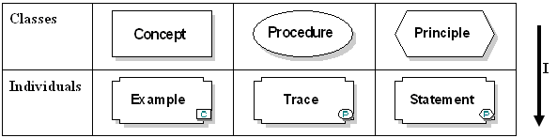
Fig. 1. Types of knowledge entities in MOT
There are various possible semantic interpretations of these graphical symbols. Concepts can be object classes (country, clothing, vehicles, etc.), types of documents (forms, booklets, images, etc.), tool categories (text editors, televisions, etc.), groups of people (doctors, Europeans, etc.), or event classes (floods, conferences, etc.). Procedures are actions or operations that are performed by humans, systems or machines (add numbers, assemble an engine, complete a report, digest food, process students’ records, etc.), Principles can state constraints on procedures (the tasks must be completed within 20 days) or represent cause/effect relationships (if it rains more than 25 days, the crop will be in jeopardy), laws (any metal sufficiently heated will stretch out), theories (the laws of the market economy), rules of decision (advising on an investment), or prescriptions (medicinal treatment, instructional design principles, etc.).

2.3 The Typology of Links in MOT
We could use graphs similar to UML object models to represent the attributes that describe a schema with different formats according to their type. However, in the MOT graphical language (Paquette 2002; 2003), we wanted to improve the readability and the user-friendliness of graphs by externalizing the internal attributes of a schema into other schemata with proper links to the original one. For example (see Figure 2), the link between the schemata “Triangle” and “Rectangle Triangle” is shown explicitly using a specialization (S) link from the later to the former concept. Links between the “Triangle” concept and its sides or angles attributes are externalized using a composition (C) link. The links from an input concept to a procedure and from a procedure to one of its products are both shown by an input/product (I/P) link. The sequencing between actions (procedures) and/or conditions (principles) in a procedure is represented by a precedence (P) link. Finally, the relation between a principle and a concept that it constrains, or between a principle and a procedure (or another principle) that it controls, will be represented by a regulation (R) link. Using these links, this simple example on the triangle concept becomes a MOT model where relations between knowledge entities are made explicit, and where the types of entities (procedural, conceptual and strategic) are combined in the same model.

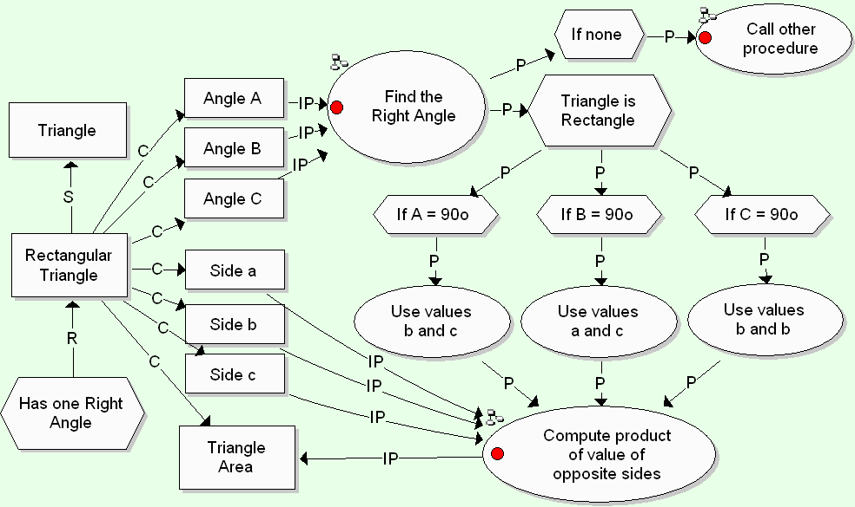

Fig. 2. A simple MOT model to provide a definition of the concept of a rectangle triangle
The objects in a MOT model such as this one includes different types of schemata whose attributes are all externalized explicitly and related to each other using six kinds of typed links constrained by the following grammar rules:
- All abstract knowledge entities or classes (concepts, procedures, principles) can be related by an instantiation (I) link to a set of facts representing individuals called examples, traces, and statements.
- All abstract knowledge entities (concepts, procedures, principles) can be specialized or generalized to other abstract knowledge using specialization (S) links.
- All abstract knowledge entities (concepts, procedures, principles) can be decomposed using the composition (C) link into other entities, generally of the same type.
- Procedures and principles can be sequenced together using the precedence (P) link.
- Concepts can be inputs to a procedure using an input/product (I/P) link to the procedure, or products of a procedure using an I/P link from the procedure.
- Principles can regulate, using a regulation (R) link, any procedure to provide an “external” control structure, to constrain a concept or a set of concepts by a relation between them, or to regulate a set of other principles (ex. to decide on conditions of their application).
The first three links are based on traditional AI distinctions between instantiation (I : “is-a”), composition (C : “is part-of”), and specialization (S : “a kind-of”) links, representing relationships between classes. The input/product (I/P) and precedence (P) links are fundamental in procedural or algorithmic representations. The first one helps in representing data flows between information sources and operations, where they serve as input or product, while the second helps in representing sequences of operations or tasks. The regulation (R) link is an innovation essential to relating principles to other types of knowledge. It is inspired by knowledge-based or expert systems where the control structure (usually conditional rules) is external to the task it controls. Typically, principles are processed by an inference engine that will apply these rules either to operations to trigger them or to objects to produce other objects.
Figure 3 summarizes the grammar rules of the MOT graphical language in the form of an abstracted graph where the nodes represent types of knowledge objects and the arrows are valid links between them. The MOT software limits the types of links that users can create between two specific types of knowledge objects. For example, because a specialization link can only be used between two objects of the same type, this link is not accessible from the menu when the user is in the process of labelling a link between two different object types. However, users can put their own label on what is called an “untyped” link. A specific shape is also provided for “untyped” objects.
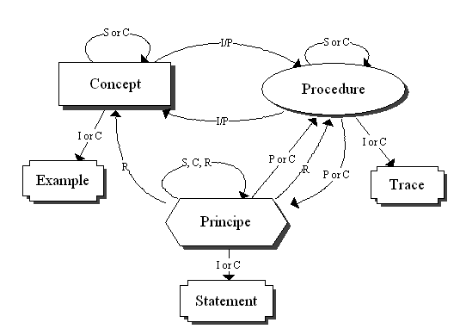
Fig. 3. The MOT metamodel
With this set of primitive graphic symbols, it has been possible to build from simple to complex representations of structured knowledge in graphical models. For example, we can build representations equivalent to concept maps but also equivalent to flowcharts (including iterative procedures), decision trees, and other types of models such as models of processes, methods, and theories. All of these types of models have been elaborated in a number of projects conducted at the LICEF Research Center (Montreal, Canada) since the publication of the first MOT editor in 1996. Here as some examples: a computerized school model (Basque, Rocheleau, Paquette, and Paquin 1998), an assistance model for distance learning (Dufresne et al. 2003), a troubleshooting model (Brisebois, Paquette, and Masmoudi 2003), a Web-based professional training model (De la Teja, Longpré, and Paquette 2000), a model of processes and methods in a virtual campus (Paquette, De la Teja, Lundgren-Cayrol, Léonard, and Ruelland 2002), a knowledge base model (Henri et al. 2006), a learning objects’ management process model (Lundgren-Cayrol, de la Teja, and Léonard 2001), skills and competencies models (Basque, Ruelland, and Lavoie 2006; Paquette 1999; Paquette, Léonard, Lundgren-Cayrol, Mihaila, and Gareau 2006), and a self-management of learning model (Ruelland 2000).
Among other functionalities of MOT, we find the possibilities for creating a sub-model of each knowledge object represented in the first-level model and for linking documents of different formats (with OLE or URL links) to each knowledge object. It is also possible to link a “comment” to a knowledge object or a link. The last version of the tool, called MOT Plus, adds functionalities for representing specific types of models (ontologies, flowcharts, learning scenarios), more exportation facilities (HTML, XML, OWL, IMS-LD, etc.), navigation improvements into sub-models with a hierarchical menu, etc. The interface of the MOT Plus tool is presented in Figure 4.

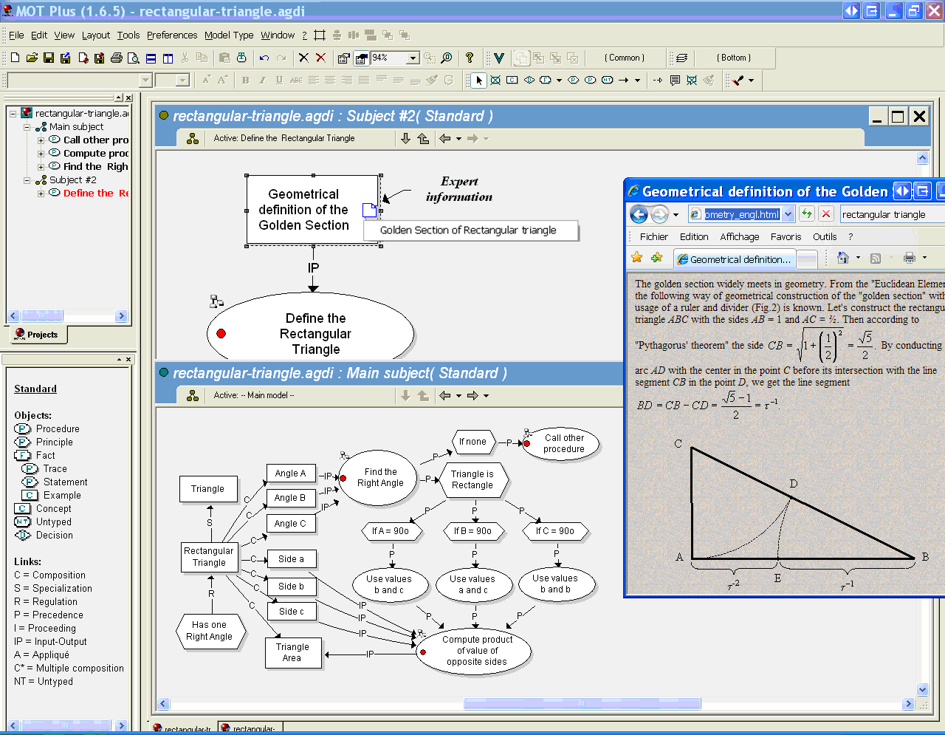
Fig. 4. The interface of the MOT Plus tool

3 The Knowledge Transfer Strategy
As already briefly defined, the knowledge transfer strategy consists essentially of having small groups of experts and novices co-construct a knowledge model related to a specific fieldwork using the MOT software. The whole procedure used to implement this strategy in organizations includes many steps, which can be operationalized differently from site to site. The main steps are the following:
- Specification of the domain to model: This decision usually stems from the head managers’ priorities, who can use a systematic methodology for identifying the “big picture” of the most critical knowledge in the organization (Ermine, Boughzala, and Tounkara 2006).
- Selection of the participants: This step consists at identifying the experts and novices who will participate in the project. The experts can be workers who will soon retire, individuals who possess rare and strategic knowledge in their specific field, or individuals recognized as experts by their peers. Novices are not necessarily new employees. They can be employees having recently changed their position within the organization or individuals who have specialized expertise in a field but do not have the “big picture” of it. In other words, the degree to which an individual is a novice in a field can vary greatly. For this reason, we prefer to call them “less expert” employees. Other criteria than degree of expertise (or of apprenticeship) in the targeted field can also be used for the selection of participants: availability, willingness to share knowledge, familiarity with graphical representations, etc.
- Training before the knowledge modeling session: Training will differ according to the role given to the experts and novices in the project. If they are to manipulate the MOT tool in order to create their own knowledge models (even if this is done with the assistance of a knowledge modeling specialist), a training to the MOT software and to its knowledge modeling language will be necessary. In this case, an initial on-site two-day session given to groups of 8-12 persons, followed by individual and group consultations with the instructor, have proven effective for basic training. If the tool will be manipulated by a knowledge modeling specialist, participants’ training to the MOT software will be minimal. Indeed, only a brief presentation of the typologies used in MOT will be necessary. We noted that participants become quite easily and naturally familiar with the knowledge modeling language simply by observing the knowledge modeling specialist manipulating the software and using the representational language.
- Collaborative knowledge-modeling sessions: The duration of the sessions can vary depending on the scope of the target field and the availability of the participants. In our case, we propose starting with an intensive two- to three-day session which allows participants to elaborate a global, relatively stable, and consensual high-level structure of the field. Additional sessions may be required in order to add details or submodels to the initial model. The sessions can take place in small groups of 2 to 4 experts and novices (or “less experts”). Two approaches can be used. In the first one, experts and novices construct the model themselves using MOT with on-demand assistance of a knowledge modeling specialist, whose role is to give feedback on the model or answer questions. In the second one, a knowledge modeling specialist questions the participants to make them elicit their knowledge while another one creates the map on the computer.
- Validation of the co-constructed knowledge model: Once the first version of the model is produced, a final validation can be performed by one or more experts having participated in the session and/or peer experts in the field. Also, the validation process can intertwine real work practices of the participants. While “instantiating” the knowledge represented in the model in actual work situations, modifications to the knowledge model can be more easily identified.
- Presentation of the models by the participants to managers and colleagues: The participants usually appreciate presenting and explaining their co-constructed knowledge model to their managers and colleagues. This acts as a means of promoting their work as well as allowing them to deepen their comprehension of the model.
- Implementation of a maintenance strategy of the knowledge model: It is important to plan for continuous improvement of the model. This task can be performed by an individual or (preferably) a group of people having good expertise in the field and being sufficiently familiar with the representational language used.

4. Rationale for the Knowledge Transfer Strategy
How does the collaborative knowledge modeling strategy by experts and novices promote the transfer of expertise to the latter? To answer this question, three aspects of the activity are examined: (1) the cartographic nature of the representational language used; (2) the semi-formal nature of this language, and (3) the collaborative dimension of the activity.

4.1 The Cartographic Nature of the Representational Language Used
The knowledge cartography strategy that we propose to support the transfer of expertise has some background in meaningful learning theory (Ausubel 1968), which is at the origins of the seminal work of Novak and Gowin (1984) on concept mapping in education. It is also based on cognitivist work on hierarchical structures of knowledge and schemata (Kintsch 1996; Rumelhart and Ortony 1977; Schank and Abelson 1977; Trabasso and van den Broek 1985).
Significant learning is defined as an assimilation process of concepts in propositional networks (Ausubel 1968). According to Novak and Gowin (1984), concept maps allow students to externalize personal knowledge in the form of significant propositional networks. Creating concept maps would then favor significant learning (Novak and Gowin 1984), allowing learners to clarify links they establish implicitly between concepts (Fisher 2000; Holley and Dansereau 1984) and involving them in deep knowledge-processing (Jonassen, Reeves, Hong, Harvey, and Peters 1997). All this would lead them to “learn how to learn’’ (Novak and Gowin 1984). Similarly, Holley and Dansereau (1984) argue that “spatial learning strategies” enhance deep knowledge-processing (Craik and Lockhart 1972), hierarchical structuring of propositional representations and schemata, and inference making (especially causal inference making) (Trabasso and van den Broek 1985).

4.2 The Semi-formal Nature of the Representational Language Used
The MOT tool could be described as a semi-formal knowledge representation tool. From an Artificial Intelligence perspective, a formal representation is defined as a representation which is machine-readable. Uschold and Gruninger (1996) describe four levels of formalization of representations: “highly informal” (expressed in natural language), “semi-informal” (expressed in an artificial, formally defined language), “semi-formal” (expressed in a restricted and structured form of natural language) and “rigorously formal” (meticulously defined terms with formal semantics, theorems, and proofs on such properties as soundness and completeness). We already mentioned that knowledge models created with MOT Plus are machine-readable to a certain degree. For example, they can be exported in XML or in a relational database.
We also use the term “semi-formal” from a cognitive perspective to express the idea that, compared to typical concept mapping tools, the MOT software imposes some additional constraints to the representational activity based on schema theory that forms the set of grammar rules defining a formal grammar of graphic symbols.
Some authors argue that a constrained or semi-formal approach to concept mapping adds more precision, exhaustiveness, and coherence to the knowledge representation, thus facilitating its interpretation and communication between humans (Gordon 2000; Moody 2000). Others warn against the danger of reducing the complexity of knowledge domains. For example, Faletti and Fisher (1996) argue that “there are advantages in systematicity and ease of net generation associated with using a parsimonious number of relations [...], but the price of parsimony is the reduction of potentially valuable distinctions. On the other hand, a tendency toward profligacy can overwhelm” (p. 201).
However, although the issue of the flexibility of expressiveness was cited by some authors as a major factor in designing concept map tools for learning (Hereen and Kommers 1992), few studies have examined the specific contribution of the constraints associated with the use of semi-formal languages implemented in domain-independent digital tools dedicated to knowledge modeling (Alpert 2004). Many hypotheses can be formulated in order to guide future research on this issue. A first hypothesis deals with the fact that typologies constitute a sort of meta-language which, if shared with the group, allows its members to work on a common representation of the field. Knowledge modeling using typologies of knowledge and of links would force participants to confront and recognize similarities and differences in their respective representation of the field, while offering the advantage of making the model eventually easier to read for other individuals who are familiar with the typology.
A second hypothesis states that knowledge modeling using a finite set of categories of types of knowledge and links would help experts make their knowledge explicit. It would guide them in representing knowledge as typical schematic structures of work situations, that is, procedural models of production and of transformation of objects using artifact-mediated actions guided by rules, heuristics, and norms.
In MOT, procedural knowledge is represented in nodes rather than in links as in other concept mapping tools, which seems an interesting solution to (1) the question of distinction between generic relations and those specific to a field and (2) the question related to the representation of procedural knowledge.
In relation to the first question, some authors are opposed to the idea of using canonical links by pretending that each field possesses its own set of relations and, therefore, it is impossible to predetermine them (Fisher 1990). However, this researcher has become more flexible after eight years of observing students creating concept maps with the SemNet software in biology (Faletti and Fisher 1996; Fisher and Moody 2000; Fisher, Wandersee, and Wideman 2000). The data collected indicates that three of the relations used in the maps counted for more than 50 % of all the relations in the field. These included “is composed of”, “is a kind of”, and “has the characteristic”. Other relations were specific to the field, or at least to a set of fields. For example, in the field of reproductive physiology, relations included “synthesizes”, “secretes”, “stimulates”, “inhibits”, etc. For this reason, Faletti and Fisher (1996) compromised by distinguishing generic relations from specific ones of a field. According to this approach, Osmundson, Chung, Herl, and Klein (1999) have included 21 predefined concepts and 14 predefined links in the menus of the concept mapping software developed for their research in the field of human biology (respiration, circulation, and digestion). Experts in the field were consulted and the links include generic links to all field (ex. “is composed of”) and links specific to the field (ex. “absorbs”, “digests”, “pumps”, etc.).
As was already mentioned, in MOT, relations which are specific to a field are represented in (procedural) nodes rather than in links. Therefore, the links in the model are only generic relations, resulting in a more economical and more parsimonious representational system.
It is noteworthy that, in MOT, the user can also use the “untyped link” in order to define a link. However, we observed that it is often the case that this link is simply another term which expresses a category of links already defined in the typology. For example, the label “has as a result” introduced by university students as an untyped link in their model in a study conducted by Basque and Pudelko (2003) corresponds to the input/product (I/P) link. Multiplying labels for the same link type could actually demonstrate that participants have difficulties structuring their own knowledge. It also makes it harder or time-consuming for others to read the map, which would be a limitation if they are to be eventually made available to other employees in the organization.
As for the second question, we propose that MOT specifically promotes the representation of procedural knowledge (although in a declarative format). Current concept mapping tools enhance essentially representations of declarative knowledge, that is, representations of knowledge on entities, including objects and their attributes (Fisher 1992; Hereen and Kommers 1992). Therefore, constructing a model using MOT offers the possibility of representing actions as “knowledge objects” which can be decomposed into sub-actions. Actions (procedures) can be linked to each other with composition (C), precedence (P), or specialization (S) links. The activity of representing knowledge can therefore be focused from the start on representing actions, objects and concepts used while performing actions, and principles guiding actions. Experts' schemata imply much procedural knowledge (the know-how), along with knowledge on explicit conditions of its applicability known as conditional or strategic knowledge (the know-when and the know-why), and object schemata which can be instantiated at will (the know-what or declarative knowledge) (Chi, Glaser, and Farr 1988; Chi, Glaser, and Rees 1982; Ericsson and Charness 1994; Glaser 1986; Schmidt and Boshuizen 1993; Sternberg 1997).
The novice and the expert then have a means for representing their field work as their own procedural model, with structures staying consistent no matter which level of the procedure is represented. This characteristic of the representational language can also bring the novice to interrogate the expert during the co-construction of the knowledge model, the objects and principles linked to procedures in the model acting as anchors for interaction.

4.3 The Collaborative Dimension of the Strategy
Finally, the strategy proposed implies that experts and novices interact during the elaboration process of the knowledge model. As mentioned previously, some studies conducted in educational settings have shown that, compared to individual concept mapping or other types of collaborative learning activities (e.g. producing an outline or a matrix representation), collaborative concept mapping is more beneficial to learning (see Basque & Lavoie, 2006, for a review). Different socio-cognitivist and socio-constructivist theories can be evoked in order to explain these results.
According to social cognitive theory (Bandura 1986), observing an expert in action promotes learning : “Learning cognitive skills can be facilitated simply by having humain models verbalize their thought strategies aloud as they engage in problem-solving activities. The covert thoughts guiding the actions are thus made observable through overt representation. “Modeling both thoughts and actions has several helpful features that contribute to its effectiveness in producing generalized, lasting improvements in cognitive skills” (Bandura 1986, p. 74). Therefore, through observation and modeling, learners would develop internal rules which help them in self-regulating their own behavior.
Other researchers, working in the vygotskian paradigm (Vygotsky 1978), emphasize the intrinsically social aspect of human cognition as well as the idea that cultural tools (symbols, rules, conventions, uses, behaviors) mediate mental activities (Bruner 1987; Cole and Engeström 1993; John-Steiner and Mahn 1996; Wertsch and Stone 1985). An internalization process takes place when competent persons offer scaffolding to less competent ones.
Based on the piagetian theory, Doise and Mugny (1984) proposethat situations which are most likely to generate sociocognitive conflicts between learners promote learning. Divergent point of views emerging during social interactions would engage individuals in an effort to coordinate their personal perspectives, in order to maintain a “cognitive equilibrium" in their own cognitive structure. Some studies show that collaborative concept mapping constitutes a situation where sociocognitive conflicts would actually occur through argumentative discussions (Osmundson, Chung, Herl, and Klein 1999; van Boxtel, van der Linden, and Kanselaar 2000).
Justifications for the use of a collaborative knowledge modeling strategy to support the transfer of expertise can also be found in symbolic interactionist theories based on Mead’s assumption that meaning is the result of a social negotiation process based on verbal interactions (Mead 1934/1974). Basically, when mental representations differ too greatly in social situations, individuals are unable to interact (Clark and Wilkes-Gibbs 1986). They need to establish a mutual understanding, also called common ground or intersubjectivity (Rogoff and Lave 1984), which is negotiated, all along the interaction. This shared understanding requires a common focus of attention and a set of common assumptions. A number of authors have emphasized the role of external representations like concept maps in supporting meaning negociation in learning contexts (Osmundson, Chung, Herl, and Klein 1999; Roth and Roychoudhury 1993). Roth and Roychoudhury (1994) use the metaphor of “social glue” to describe how concept maps can lead learners to develop a shared vision of a task and of meanings they attribute to concepts and to relations between these concepts.
Finally, in the situated learning paradigm, the legitimate peripheral participation theory (Rogoff and Lave 1984) states that novices should be given opportunities to participate regularly and actively to “communities of practice” in their field in order to promote the development of their competencies. Mentoring and apprenticeship as well as reflective discussions among practitioners would be particularly beneficial to learning (Wenger, McDermott, and Snyder 2002). Collaborative knowledge modeling could complement well these strategies. Indeed, Roth and Roychoudhury (1992 1994) have observed that collaborative concept mapping in science classes promotes the development of a “culture of scientific discourse”.

5. Applications and Research on the Knowledge Transfer Strategy
The collaborative knowledge modeling strategy was first used in 2002 at Hydro-Québec, the main producer, provider, and distributor of electricity in the province of Québec, Canada (20,000 employees). In 2004, over 150 experts and 150 novices from various departments (management, electrical engineering, civil engineering, etc.) had already participated in the pilot project initiated by this large company (Basque, Imbeault, Pudelko, and Léonard 2004). In the project, experts and novices were first trained to use the MOT software. They were then invited to construct a knowledge model in dyads or triads. Based on anecdotal data collected by local representatives, Basque et al. (2004) reported that, in general, both experts and novices tended to be quite positive towards the strategy. Many commented that it helped them organize their own knowledge. However, the authors found a number of non-partisans, especially among experts who seemed to lack time to participate in these activities due to their heavy workload. Most found the software user-friendly, although some mentioned difficulties with the process of categorizing knowledge. Some experts lamented that collaborative knowledge modeling with novices slowed down their own modeling process; however, for others, the interaction with novices was essential to externalizing what seemed obvious for them and MOT helped them capture a very large body of their knowledge in an economical fashion. Others recognized the inherent advantages of graphical representations while adding that they remained more comfortable sharing their knowledge by spelling it out in a written text or through live demonstrations. On the other hand, novices appreciated having a reference document that prevented them from constantly referring to the expert.
More recently, another public organization in Québec began to use the strategy. This time, a more rigorous research process, based on action-research methodology, is implemented. This ongoing project has the following objectives: (1) evaluate the feasibility and efficiency of the strategy for expertise transfer, (2) identify conditions that influence the efficiency of the strategy, and (3) identify how the knowledge models can be exploited in the organization in a global knowledge management perspective. A first group of four employees participated in a 3-day session of collaborative knowledge modeling with the help of two knowledge modeling facilitators, one manipulating the software and one conducting the session. The knowledge model was projected on a widescreen display. Participants included two experts and two “less expert” employees. These “novices” had already developed specific competencies in the targeted work field but had no global view of it. We videotaped the participants during the collaborative knowledge modeling session. Screen-captures of the work performed at the computer were recorded using the Windows Media Encoder software. Finally, we conducted individual interviews with each participant before and after the session. Data analysis is on-going but some preliminary results based essentially on the analysis of the model produced and the interviews data are reported very briefly here.
The first-level of a knowledge model produced during this 3-day session is reproduced on figure 5. Although the model was not completely stabilized, as illustrated by comments attached to some knowledge objects and used here as reminders, it includes more than 500 knowledge objects, which are distributed among 55 sub-models. Participants declared that they were quite satisfied with this model, considering the short time they devoted to its development. Participants suggested that the model would be useful as a complement to coaching techniques in introducing quickly a new employee to the targeted knowledge domain. It would give him an integrated overview of the activities and actors engaged in the process elicited in the model as well as the main principles that regulate the activities. It seems that the knowledge model is not a simple repetition or a collection of knowledge already documented in the organization, but a real new creation which gives them new insight on the required expertise to perform the process described in the model.
The knowledge modeling activity was evaluated very positively by participants. But they found it quite cognitively demanding. They mentioned that this activity (1) stimulated discussions and negotiation of meaning between experts and novices, (2) lead them to conceptualize simultaneously the domain in “its totality and its components” and (3) lead them to elicit knowledge that they initially judged “trivial” or “superfluous” but that they finally admitted as being central to expertise in their domain.

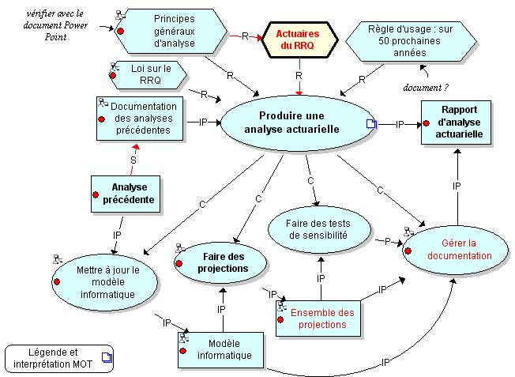

Fig. 5. A first-level of a knowledge model of the procedure “Perform an actuarial analysis”

6. A Knowledge Management Perspective
The collaborative knowledge modeling strategy described so far is primarily a process-oriented strategy of KM. However, the knowledge models produced during this process can be afterwards integrated into a product-oriented approach to KM, with aims to share expertise with a larger audience within the organization. Three types of uses can be identified in the product-oriented approach.
First, the knowledge models can be made accessible to all employees within the organization as reference documents. MOT Plus is able to export the knowledge models in HTML format which facilitates sharing on the Web. Each model serves as a kind of interface for navigation within a knowledge network to which various file formats can be attached (text, audio, video, etc.). Employees could also be asked to annotate the models, suggest additions, or discuss the models in virtual forums.
Secondly, the knowledge models can be used in the design of training sessions for employees in the organization. Indeed, the models give instructional designers a clear idea of the targeted learning content to be addressed in the training sessions. Several authors have already suggested using concept maps for instructional design (e.g. (Coffey and Canas 2003; Inglis 2003). In his book entitled Instructional Engineering in Networked Environments, Paquette (2003) proposes a method called MISA, in which the object-typed knowledge modeling technique described in this chapter is proposed in order to specify the learning content and the target competencies of learning systems. This same technique is also suggested to instructional designers to help them elaborate the pedagogical (or instructional) model − which can take the form, in e-learning systems, of IMS-LD compliant learning scenarios (Paquette, De la Teja, Léonard, Lundgren-Cayrol, and Marino 2005) −, the media model, and the delivery model of learning systems.
Finally, the knowledge models co-produced by experts and novices can serve as input in the process of developing an “intelligent” digital knowledge management system which we hope will be able to make inferences and be searched using natural language queries. We believe that having experts and novices interact during the knowledge acquisition stage of the expert system development process is an interesting alternative to classical approaches of knowledge elicitation. However, as the models co-constructed with the standard MOT are semi-formal, they cannot be interpreted by a machine. Indeed, ambiguities inherent to this level of knowledge modeling need to be removed. One way to do this is to transform the semi-formal models into ontological models. The advantage of formalizing models as ontologies, using the standard OWL-DL (W3C 2004) format for example, is to make them available for computer-based processing. The resulting OWL-DL format is an XML file for which there exists a growing number of software components that can process the file for different purposes: describing documents in databases, searching for documents according to the model’s classes, summarizing or classifying documents, etc.
In the context of the MOT representation system, ontologies, particularly OWL-DL constructs, correspond to a category of models called “theories”. Ontologies can thus be modeled graphically using the MOT syntax with some extensions (see figure 6 for an example).. A new extension of the MOT editor offers introduces new graphic symbols acting as abbreviations, such as new links that replace one or two links plus a ruling principle, or labels on knowledge object that correspond to stereotyped properties, for example stating that the relation is transitive or functional. Such an extension aims to simplify the graphic model when the goal is to build standardized models such as a learning design or an ontology.(Paquette 2006)

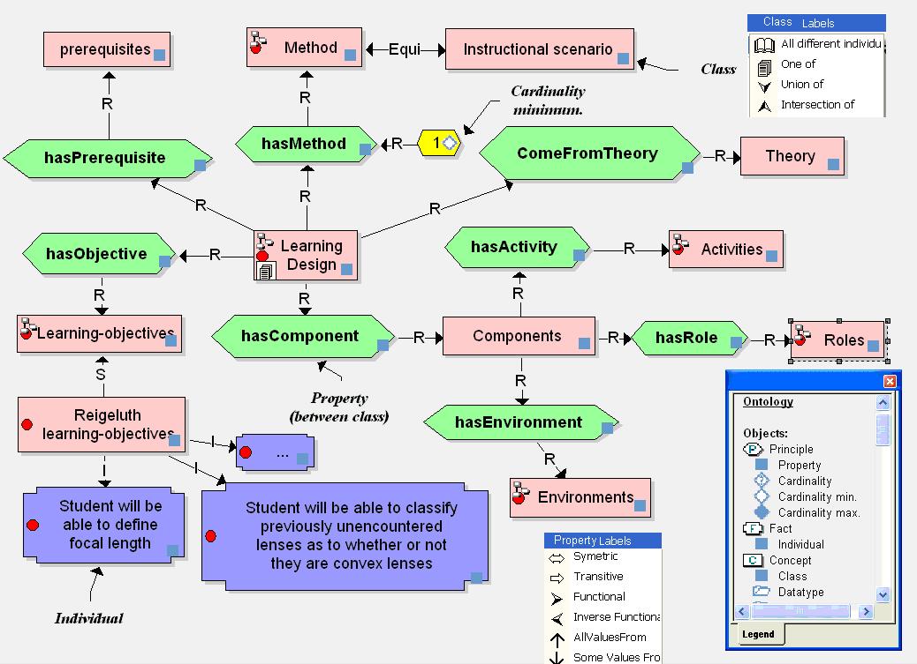
Fig. 6. First level of an ontological model representing knowledge from the Learning Design domain

7. Conclusion
The collaborative knowledge modeling strategy described in this chapter seems promising for expertise transfer within organizations. However, it brings up many questions which need to be addressed with rigorous research. The first question is obvious: Is this strategy efficient? Does it result in transfer of expertise?
Another concern involves the factors which are likely to influence the efficiency of the strategy. We report briefly some of the factors that need to be investigated in our view.
First, there are a series of factors which are related to the individuals involved. We wonder, for example, how individual variables, such as an experts’ level of motivation to share their knowledge, the individual’s spatial or verbal skills, or their cognitive style affect the efficiency of such an activity. The few studies that investigated these topics were conducted in school settings (Okebukola and Jegede 1988; Oughton and Reed 1999 2000; Reed and Oughton 1998; Stensvold and Wilson 1990). It would be valuable to conduct such research with adult participants in professional settings. For example, Stensvold and Wilson (1990) have shown, in a study conducted with Grade 9 participants, that creating concept maps was more beneficial to students with low verbal skills than to those with high verbal skills. We may thus hypothesize that concept maps aimed to represent knowledge would be particularly effective for certain types of employees (e.g. manual workers).
Second, there are some factors which are linked to the organization of the co-modeling situations. For example:
- The active contribution of each participant involved in the activity. A setting where the participants are involved in the creation process together would be more effective than a situation where only the results of the activity are shared (Stoyanova and Kommers 2002). It would be helpful to know more about the nature and types of interactions that are correlated with successful expertise transfer. Also, sharing tacit knowledge can possibly detract the expert from his status as an expert. If tacit knowledge is at the heart of the expertise, individuals may wish to keep the knowledge tacit. Indeed, as soon as tacit knowledge becomes explicit and coded, it is no longer a source of individual differences and, consequently, no longer presents a competitive advantage for the individual (Sternberg 1999).
- The level of asymmetry of the partners’ expertise paired up for the activity. A gap that is too severe could be detrimental. According to various studies conducted in adult-children dyads, asymmetric relations tend to trigger relational regulation, rather than sociocognitive regulation of the conflicts. Hence, for the interaction to be effective, problem-solving activities must be conducted on a sociocognitive level and not on a social level (Doise and Mugny 1984; Mugny, Perret-Clermont, and Doise 1981). Moreover, once aware of this asymmetry, the participants’ representations of the relationship constitute a factor which can affect their partnership. Hence, participants with low self-esteem will tend to overestimate the competency of their partners, thus influencing their interactions.
- The knowledge modeling training method. Research conducted in the field of concept mapping provides little indication as to the most efficient method to train people for this type of activity. To what extent and how should people involved in collaborative knowledge modeling in a professional setting be trained in a knowledge modeling language in order to minimize the cognitive load of such an activity? How can we help them make links among knowledge in the most significant and useful manner, an activity considered very difficult by many researchers (Basque and Pudelko 2003; Faletti and Fisher 1996; Fisher 1990; Novak and Gowin 1984; Roth and Roychoudhury 1992)? Are there any aspects of collaboration that should be the target of specific training?
- The representation language and the representation tool used. Is the representation system suggested by the tool appropriate for all fields and sectors? Does it allow the representation of a variety of knowledge structures that can be organized into temporal script, in causal diagrams, procedural models, etc.? Is it best to impose the use of knowledge and link typologies? If strategic knowledge is at the heart of expertise, can we say that expertise is mostly represented in the “principles” included in a model? How do we promote expression of this heuristic and often idiosyncratic knowledge? How can we guarantee sufficient freedom of expression to allow the representation of different knowledge structure to suits the needs of the knowledge modellers? How can we guarantee the convergence between the experts saying and doing since they can distort their knowledge representations when verbally explaining them? In other words, the externalized representation of actions may not reflect what actually occurs (Wilson and Schooler 1991). It is difficult to separate tacit from explicit knowledge because these two types of knowledge are often tightly intertwined. An expert can be able to describe rules which guide his action (explicit knowledge) without being able to describe which specific aspects of the situation triggered the application of the rules. However, he will be able to use the rule appropriately in context (tacit knowledge). How can constraints imposed by the representational language promote the elicitation of such situated strategic knowledge?
Third, there are factors related to the global organizational environment. Among those, we find, for example, the level of competition (between individuals or between various groups) that exists within the organization, the level of hierarchy present in the organization, the feelings of confidence and safety that employees have towards the organization, the manner in which knowledge is shared within the organization, the existence of incentives associated with expertise transfer (tokens of recognition, rewards, release time), etc.
We hope that the study we will be conducting in the next year will shed some light on the involvement of any, or all, of these factors. We also hope to determine the efficiency of the collaborative knowledge modeling strategy using a graphical representational tool such as MOT to support the transfer of expertise within an organization.

References
Alpert, S. (2004). Flexibility of Expressiveness: State of the Practice. In P. Kommers (Ed.), Cognitive Support for Learning: Imagining the Unknown (pp. 253-268). Amsterdam: IOS Press.
Apostolou, D., Mentzas, G., Young, R., and Abecker, A. (2000). Consolidating the product versus process approaches in knowledge management: The Know-net approach. Paper presented at the Conference Practical Application of Knowledge Management (PAKeM 2000) - April 12-14 2000, Manchester, UK.
Ausubel, D. (1968). Educational Psychology: A Cognitive View. New York: Rhinehart and Winston.
Bandura, A. (1986). Social foundations of thought and action: A social cognitive theory. Englewood Cliffs, NJ: Prentice-Hall.
Basque, J., Imbeault, C., Pudelko, B., and Léonard, M. (2004). Collaborative knowledge modeling between experts and novices: A strategy to support transfer of expertise in an organization. In A. J. Canas, J. D. Novak and F. M. Gonzalez (Eds.), Proceedings of the First International Conference on Concept Mapping (CMC 2004), Pamplona, September 14-17, vol. 1 (pp. 75-81). Pamplona: Universidad Publica de Navarra.
Basque, J. and Lavoie, M.-C. (2006). Collaborative Concept Mapping in Education: Major Research Trends. In A. J. Canas and J. D. Novak (Eds.), Concept Maps: Theory, Methodology, Technology - Proceedings of the Second International Conference on Concept Mapping (Vol. 1, pp. 79-86). San Jose, Costa Rica: Universidad de Costa Rica.
Basque, J. and Pudelko, B. (2003). Using a concept mapping software as a knowledge construction tool in a graduate online course. In D. Lassner and C. McNaught (Eds.), Proceedings of ED-MEDIA 2003, Wold Conference on Educational Multimedia, Hypermedia and Telecommunications, Honolulu, June 23-28 2003 (pp. 2268-2264). Norfolk, VA: AACE.
Basque, J., Rocheleau, J., Paquette, G., and Paquin, C. (1998). An Object-Oriented Model of a Computer-Enriched High School. In T. Ottmann and I. Tomek (Eds.), Proceedings of ED-MEDIA/ED-TELECOM 98. Charlottesville, VA: Association for the Advancement of Computing in Education.
Basque, J., Ruelland, D., and Lavoie, M.-C. (2006). Un outil informatisé d'autodiagnostic des compétences informationnelles destiné aux étudiants universitaires. In Actes du XXIIIème Congrès de l’Association Internationale de Pédagogie Universitaire : Innovation, Formation et Recherche en Pédagogie Universitaire, Monastir, Tunisie, 15-18 mai 2006.
Beazley, H., Boenisch, J., and Harden, D. (2002). Continuity Management: Preserving Corporate Knowledge When Employees Leave. Hoboken, NJ: Wiley.
Booch, G., Jacobson, J., and Rumbaugh, J. (1999). The Unified Modeling Language User Guide. Reading, Mass.: Addison-Wesley.
Brisebois, A., Paquette, G., and Masmoudi, A. (2003). Affective Attributes in a Distributed Learning Environments. In 9th International Conference on User Modeling. University of Pittsburgh.
Bruner, J. S. (1973). Beyond the Information Given. New York: Norton.
Bruner, J. S. (1987). Le développement de l'enfant: Savoir faire, savoir dire (2 ed.). Paris: Presses Universitaires de France.
Chen, P. P.-S. (1976). The Entity-Relationship Model: Toward a Unified View of Data. ACM Transactions on Database Systems, 1(1), 9-36.
Chi, M. T. H., Feltovitch, P. J., and Glaser, R. (1981). Categorisation and representation of physics problems by experts and novices. Cognitive Science, 5, 121-152.
Chi, M. T. H., Glaser, R., and Farr, M. J. (1988). The Nature of Expertise. Hillsdale, NJ: Lawrence Erlbaum Associates.
Chi, M. T. H., Glaser, R., and Rees, E. (1982). Expertise in problem solving. In R. Sternberg (Ed.), Advances in the psychology of human intelligence (pp. 7-75). Hillsdale, NJ: Lawrence Erlbaum Associates.
Clark, H. H., and Wilkes-Gibbs, D. (1986). Referring as a collaborative process. Cognition, 22, 1-39.
Coffey, J. (2006). In the Heat of the Moment... Strategies, Tactics, and Lessons Learned Regarding Interactive Knowledge Modeling with Concept Maps. In A. J. Canas and J. D. Novak (Eds.), Concept Maps: Theory, Methodology, Technology (pp. 263-271). San Jose, Costa Rica: University of Costa Rica.
Coffey, J. W. and Canas, A. (2003). An Internet-based Meta-cognitive Tool for Courseware Development. In A. Rossett (Ed.), Proceedings of E-Learn 2003, November 7-11, Phoenix, Arizona (pp. 909-912). Norfolk, VA: AACE.
Coffey, J. W. and Hoffman, R. R. (2003). Knowledge modeling for the preservation of institutional memory. Journal of Knowledge Management, 7(3), 38-52.
Cole, E., and Engeström, Y. (1993). A cultural-historical approach to distributed cognition. In G. Salomon (Ed.), Distributed Cognitions: Psychological and Educational Considerations (pp. 1-46). Cambridge, UK: Cambridge University Press.
Craik, F. I. M. and Lockhart, R. S. (1972). Levels of processing: A framework for memory research. Journal of Verbal Learning and Verbal Behavior, 11, 671-684.
De la Teja, I., Longpré, A., and Paquette, G. (2000). Designing Adaptable Learning Environments for the Web: A Case Study. In Proceedings of the ED-MEDIA Conference. Montreal.
De Long, D. W. (2004). Lost knowledge : Confronting the threat of an aging workforce. New York: Oxford University Press.
Doise, W. and Mugny, G. (1984). The social development of the intellect. Oxford: Pergamon Press.
Dufresne, A., Basque, J., Paquette, G., Léonard, M., Lundgren-Cayrol, K., and Prom Tep, S. (2003). Vers un modèle générique d'assistance aux acteurs du téléapprentissage. Sciences et Technologies de l´Information et de la Communication pour l´Éducation et la Formation, Numéro spécial: Technologies et formation à distance, 10(3).
Ericsson, K. A. and Charness, N. (1994). Expert Performance: Its Structure and Acquisition. American Psychologist, 49(3), 725-747.
Ermine, J.-L., Boughzala, I., and Tounkara, T. (2006). Critical Knowledge Map as a Decision tool for Knowledge Transfer Actions. The Electronic Journal of Knowledge Management, 4(2), 128-140.
Esiobu, G. O. and Soyibo, K. (1995). Effects of Concept and Vee Mappings under Three Learning Modes on Students' Cognitive Achievement in Ecology and Genetics. Journal of Research in Science Teaching, 32(9), 971-995.
Faletti, J. and Fisher, K. M. (1996). The information in relations in biology, or the unexamined relation is not worth having. In K. M. Fisher and M. R. Kibby (Eds.), Knowledge acquisition, organization, and use in biology (pp. 182-205). Berlin: Springer.
Fisher, K. (1992). SemNet: A tool for personal knowledge construction. In P. Kommers, D. H. Jonassen and J. T. Mayes (Eds.), Cognitive Tools for Learning (Vol. NATO ASI Series, vol. 81, pp. 63-75). Berlin: Springer-Verlag.
Fisher, K. and Moody, D. E. (2000). Student misconceptions in biology. In K. Fisher, J. Wandersee and D. E. Moody (Eds.), Mapping Biology Knowledge (pp. 55-75). Dordrecht: Kluwer.
Fisher, K., Wandersee, J., and Wideman, G. (2000, February 17-22 2000). Enhancing cognitive skills for meaningful understanding of domain specific knowledge. Paper presented at the American Association for the Advancement of Science, Annual Meeting,, Washington, DC,.
Fisher, K. M. (1990). Semantic networking : The new kid on the block. Journal of Research in Science Teaching, 27(10), 1001-1018.
Fisher, K. M. (2000). Overview of Knowledge mapping. In K. M. Fisher, J. H. Wandersee and D. E. Moody (Eds.), Mapping biology knowledge (pp. 5-23). Dordrecht: Kluwer Academic Publishers.
Gentner, D. and Stevens, A. (1983). Mental Models. Hillsdale, N.J.: Erlbaum.
Glaser, R. (1986). On the Nature of Expertise. In H. Hagendorf (Ed.), Human Memory and Cognitive Capabilitis: Mechanisms and Performances (pp. 915-928). North Holland: Elsevier Science.
Gordon, J. L. (2000). Creating Knowledge Maps by Exploiting Dependent Relationships. In Applications and Innovations in Intelligent Systems (pp. 63-78): Springer.
Henri, F., Gagné, P., Maina, M., Gargouri, Y., Bourdeau, J., and Paquette, G. (2006). Development of a Knowledge Base as a Tool for Contextualized Learning. AI and Society 20(3), 271-287.
Hereen, E. and Kommers, P. A. M. (1992). Flexibility of expressiveness: A critical factor in the design of concept mapping tools for learning. In P. A. M. Kommers, D. H. Jonassen and J. T. Mayes (Eds.), Cognitive Tools for Learning (NATO Series, vol. F81) (pp. 85-101). Berlin, Heidelberg, New York: Springer Verlag.
Hinds, P. J., Patterson, M., and Pfeffer, J. (2001). Bothered by Abstraction: The effect of expertise on knowledge transfer and subsequent novice performance. Journal of Applied Psychology, 86(6), 1232-1243.
Holley, C. D. and Dansereau, D. F. (1984). Spatial Learning Strategies. Techniques, applications, and related issues. New York, London: Academic Press.
Inglis, A. (2003). Facilitating team-based course designing with conceptual mapping. Distance Education, 24(2), 247-263.
Inhelder, B. and Piaget, J. (1958). The Growth of Logical Thinking from Childhood to Adolescence. New York: Basic Books.
Jacob, R. and Pariat, L. (2001). Gérer les connaissances : un défi de la nouvelle compétitivité du 21e siècle. Montréal: CEFRIO.
John-Steiner, v. and Mahn, H. (1996). Sociocultural approaches to learning and development: A vygostskian framework. Educational Psychologist, 31 191-206.
Johnson-Laird, P. N. (1983). Mental Models: Towards a Cognitive Science of Language, Inference, and Consciousness. Cambridge: Cambridge University Press.
Jonassen, D. H., Reeves, T. C., Hong, N., Harvey, D., and Peters, K. (1997). Concept mapping as cognitive learning and assessment tools. Journal of Interactive Learning Research, 8(3/4), 289-308.
Kintsch, W. (1996). Mental representations in cognitive science. In W. Battmann and S. Dutke (Eds.), Processes of the molar regulation of behavior. Scottsdale, AZ, USA: Pabst Science Publishers.
Larkin, J. H., McDermott, R., Simon, D. P., and Simon, H. A. (1980). Models of competence in solving physics problems. Cognitive Science, 4, 317-345 .
Lundgren-Cayrol, K., de la Teja, I., and Léonard, M. (2001). Modélisation d’un gestionnaire de ressources. Rapport interne de recherche. . Montreal, Canada: Centre de recherche LICEF, Télé-université.
McDermott, R. (2001). Designing Communities of Practice: Reflecting on what we’ve Learned. In Proceedings of Communities of Practice 2001. Cambridge MA: Institute for International Research.
Mead, G. H. (1934/1974). Mind, self, and society from the standpoint of a social behaviorist. Chicago: Chicago University Press.
Merrill, M. D. (1994). Principles of instructional design. Englewood Cliffs, N.J.: Educational Technology Publications.
Minsky, M. (1975). A Framework for Representing Knowledge. In P. H. Winston (Ed.), The Psychology of Computer Vision. New York: McGraw-Hill.
Moody, D. E. (2000). The paradox of the textbook. In K. M. Fisher, J. H. Wandersee and D. E. Moody (Eds.), Mapping biology knowledge (pp. 167-184). Dordrecht: Kluwer Academic Publishers.
Mugny, G., Perret-Clermont, A., and Doise, W. (1981). Interpersonal coordinations and sociological differences in the construction of the intellect. In G. M. Stephenson and J. H. Davis (Eds.), Progress in Applied Social Psychology, Vol I (pp. 315-343,). New York: Wiley.
Newell, A. and Simon, H. (1972). Human problem solving. Englewood Cliffs, NJ: Prentice-Hall.
Nonaka, I. and Takeuchi, H. (1995). The knowledge creating company : How Japanese Companies Create the Dynamics of Innovation: Oxford University Press.
Novak, J. D. and Gowin, D. B. (1984). Learning how to learn. Cambridge: Cambridge University Press.
Okebukola, P. A. and Jegede, O. J. (1988). Cognitive preference and learning mode as determinants of meaningful learning through concept mapping. Science Education, 72(4), 489-500.
Osmundson, E., Chung, G. K., Herl, H. E., and Klein, D. C. (1999). Knowledge mapping in the classroom : A tool for examining the development of students' conceptual understandings (Technical report No. 507). Los Angeles: CRESST/ University of California.
Oughton, J. M. and Reed, W. M. (1999). The Influence of Learner Differences on the Construction of Hypermedia Concepts: A Case Study. Computers in Human Behavior, 15(1), 11-50.
Oughton, J. M. and Reed, W. M. (2000). The effect of hypermedia knowledge and learning style on student-centered concept maps about hypermedia. Journal of Research on Computing in Education, 32(3), 366-382.
Paquette, G. (1999). Meta-Knowledge Representation for Learning Scenarios Engineering. In S. Lajoie and M. Vivet (Eds.), AI and Education, Open Learning Environments. Proceedings of AI-ED 99, Le Mans, France IOS Press.
Paquette, G. (2002). Modélisation des connaissances et des compétences. Sainte-Foy (Québec): Presses de l'Université du Québec.
Paquette, G. (2003). Instructional Engineering in Networked Environments. San Francisco: Pfeiffer/Wiley.
Paquette, G. (2006). Building Graphical Knowledge Representation Languages - From Informal to Interoperable Executable Models. Paper presented at the i2LOR-06 Conference (November 8-10), Montreal.
Paquette, G., De la Teja, I., Léonard, M., Lundgren-Cayrol, K., and Marino, O. (2005). An Instructional Engineering Method and Tool for the Design of Units of Learning. In R. Koper and C. Tattersal (Eds.), Learning Design - A Handbook on Modelling and Delivering Networked Education and Training (pp. 161-184). Berlin: Springer.
Paquette, G., De la Teja, I., Lundgren-Cayrol, K., Léonard, M., and Ruelland, D. (2002). La modélisation cognitive, un outil de conception des processus et des méthodes d’un campus virtuel. Revue de l’Éducation à distance, 17(3), 4-25.
Paquette, G., Léonard, M., Lundgren-Cayrol, K., Mihaila, S., and Gareau, D. (2006). Learning Design based on Graphical Knowledge-Modeling Journal of Educational technology and Society 9(1), 97-112.
Paris, S., Lipson, M. Y., and Wixson, K. K. (1983). Becoming a Strategic Reader. Contemporary Educational Psychology, 8, 293-316.
Polanyi, M. (1966). The Tacit Dimension. London: Routledge and Kegan Paul.
Pressey, S. L. (1926). A simple device which gives tests and scores - and teaches. School and Society, 23, 373-376.
Reed, W. M. and Oughton, J. M. (1998). The effects of hypermedia knowledge and learning style on the construction of group concept maps. Computers in Human Behavior, 14(1), 1-22.
Rogoff, B. and Lave, J. (1984). Everyday cognition: its development in social context. Cambridge, MA: Harvard University Press.
Romizowski, A. J. (1999). Designing instructional systems: Decision making in course planning and curriculum design: Stylus Pub Llc.
Roth, W.-M. and Roychoudhury, A. (1992). The social construction of scientific concepts or the concept map as conscription device and tool for social thinking in high school science. Science Education, 76(5), 531-557.
Roth, W.-M. and Roychoudhury, A. (1994). Science discourse through collaborative concept mapping: new perspectives for the teacher. International Journal of Science Education, 16(4), 437-455.
Roth, W. and Roychoudhury, A. (1993). The concept map as a tool for the collaborative construction of knowledge: A microanalysis of high school physics students. Journal of Research in Science Teaching, 305, 503-554.
Ruelland, D. (2000). Vers un modèle d'autogestion en situation de télé-apprentissage. Université de Montréal, Montréal.
Rumbaugh, J., Blaha, M., Premerlani, W., Eddy, F., and Lorensen, W. (1991). Object-Oriented Modelling and Design. Englewood Cliffs, New Jersey: Prentice Hall.
Rumelhart, D. E., and Ortony, A. (1977). The representation of knowledge in memory. In R. C. Anderson, R. J. Spiro and W. E. Montague (Eds.), Schooling and the Acquisition of Knowledge. Hillsdale, NJ: Erlbaum.
Schank, R. C., and Abelson, R. (1977). Scripts, plans, goals, and understanding. Hillsdale, NJ: Erlbaum.
Schmidt, H. G. and Boshuizen, H. P. A. (1993). On Acquiring Expertise in Medecine. Educational Psychology Review, 5(3) 205-221.
Schreiber, G., Wielinga, B., and Breuker, J. A. (1993). KADS - A principled Approach to Knowledge-based System Development. San Diego: Academic Press.
Sowa, J. F. (1984). Conceptual Structures, Information Processing in Mind and Machine. Reading, Mass.: Addison-Wesley Publishing.
Stensvold, M. S. and Wilson, J. T. (1990). The interaction of verbal ability with concept mapping in learning from a chemistry laboratory activity. Science Education, 74(4), 473-480.
Sternberg, R. (1997). Cognitive Conceptions of Expertise. In R. R. Hoffman (Ed.), Expertise in Context. Human and Machine (pp. 149-162). Menlo Park, CA/Cambridge, MA: AAAI Press/MIT Press.
Sternberg, R. (1999). What Do We Know About Tacit Knowledge? Making the Tacit Become Explicit. In J. A. Horvath (Ed.), Tacit Knowledge in Professional Practice (pp. 231-236). Mahwah, NJ: Erlbaum.
Stoyanova, N. and Kommers, P. (2002). Concept mapping as a medium of shared cognition in computer-supported collaborative problem solving. Journal of Interactive Learning Research, 13(1/2), 111-133.
Tennyson, R. D. and Rasch, M. (1988). Linking cognitive learning theory to instructional prescriptions. Instructional Science, 17(4), 369-385.
Trabasso, T. and van den Broek, P. (1985). Causal thinking and importance of story events. Journal of Memory and Language, 24, 612-630.
Uschold, M. and Gruninger, M. (1996). Ontologies: Principles, Methods, and Applications. Knowledge Engineering Review, 11(2), 93-155.
van Boxtel, C., van der Linden, J., and Kanselaar, G. (2000). Collaborative learning tasks and the elaboration of conceptual knowledge. Learning and instruction, 10, 311-330.
Vygotsky, L. S. (1978). Mind in society: The development of higher psychological process. Cambridge: Harvard University Press.
Wenger, E. (1998). Communities of practice: Learning, meaning, and identity. Cambridge, UK: Cambridge University Press.
Wenger, E., McDermott, R., and Snyder, W. M. (2002). Cultivating communities of practice. Boston, MA: Harward Business School Press.
Wertsch, J. V. and Stone, C. A. (1985). The concept of internalization in Vygotsky's account of the genesis in higher mental functions. In J. V. Wertsch (Ed.), Culture, Communication, and Cognition: Vygotskian Perspectives (pp. 146-161). Cambridge, MA: Cambridge University Press.
West, C. K., Farmer, J. A., and Wolff, P. M. (1991). Instructional design: Implications from cognitive science. Englewood Cliffs, NJ: Prentice Hall.
Wilson, T. and Schooler, J. (1991). Thinking Too Much: Introspection Can Reduce the Quality of Preferences and Decisions. Journal of Personality and Social Psychology, 60, 181-192.
.

Represented with the icon attached to knowledge objects having a sub-model.
The term “declarative” when applied to the term “knowledge” has two meanings that are often confused. In a first sense, all knowledge that is overtly “verbalized” (that is, expressed with words) is said to have a declarative format. In a second sense, the term “declarative” to define a specific type of knowledge (declarative knowledge), that is, knowledge on objects and on properties of objects (the know-what), as opposed to “procedural” knowledge or knowledge on actions (the know-how). Procedural knowledge can then be represented in a declarative format.
This research project is supported by the CEFRIO (Centre francophone de recherche sur l’informatisation des organisations), which is a liaison and transfer centre comprising university, industrial and governmental members and researchers in Quebec (Canada). CEFRIO conducts, in partnership, pilot and strategic monitoring projects devoted to the adoption of information and communication technologies in organizations.
Two other groups will be participating in the study during the next year.
MISA is a French acronym (Méthode d’Ingénierie d’un Système d’Apprentissage), which stands for “Engineering Method for Learning Systems”.
IMS-LD is a standardized language used for the specification of e-learning instructional scenarios (LD means « Learning Design »). These scenarios are machine-readable: they can be delivered on different IMS-LD elearning platforms.

