Visual Knowledge and Competency Modeling
-From Informal Learning Models to Semantic Web Ontologies

Introduction

The beginning of this twenty-first century is characterized by the advent of what we have come to label “the knowledge society”. Unlike other “golden ages” of human history, where creation was the affair of a small minority, the fascinating era we live in is a mass movement where we see governments building knowledge policies, companies putting tremendous efforts for the management of their knowledge considered as their main asset, and where individuals, using more and more mobile realistic media, acquire and use different information processing tools considered as indispensable means for the acquisition of "knowledge" and competency.

The knowledge Society and the Ubiquitous Web
This mass movement is of course propelled by the arrival of the ubiquitous Web in almost everybody’s life. The Internet provides us with a large part of the knowledge that humanity has built through the ages and is building right now. Within a few clicks, one can reach, all around the world, libraries, museums, journals, radio or television stations, universities and schools that provide a huge mass of information and knowledge.
The Internet is a universal tool for information access, but it does not supply by itself means to help us choose and to handle information according to our rapidly changing needs, in particular our learning and working needs. One can regret that many people use the term “knowledge” for certain sites that only present information that is sometimes useless or misleading. Information is not the same as knowledge. Knowledge is more demanding. It involves changing our mental models, structuring information, developing generic skills and competencies to process information and knowledge.
This is the subject of this book. How can we make the Web more useful, more intelligent, more knowledge intensive to fulfill our more and more demanding learning and work needs? This book is based on the premise that representing knowledge visually is key for individuals and organizations to enable useful access to the knowledge era.

Representing Knowledge Visually
It is often said that a picture is worth a thousand words. That is true of sketches, diagrams, and graphs used in various fields of knowledge. Conceptual maps are widely used to represent and clarify relationships between concepts and to facilitate knowledge construction by the learners or environment design by educators. Flowcharts are graphical representations of procedural knowledge or algorithms, composed of actions and decisions that trigger series of actions in a dynamic rather than a static way. Decision trees constitute another form of representation used in various fields for decision-making systems, establishing influence or cause/effect relationships between various factors.
All these representation methods are useful at an informal level, as thinking aids and as tools for the communication of ideas, but they have limitations. One is the imprecise meaning of the links between the entities that compose the model. Another one is the ambiguity in graphs where objects, actions on objects and statement of properties about them are all mixed-up and are not represented in a way that helps differentiate them and uncover their relationships.
Another difficulty is the impossibility to combine more than one representation in the same model. For example, concepts used in procedural flowcharts as entry, intermediate or terminal objects could be given a more precise meaning by developing them in conceptual sub-models of the procedure. The same is true of procedures present in conceptual models that could be developed as procedural sub-models described by flowcharts, combined or not with decision trees.
In software engineering, many visual representation formalisms have been proposed such as Entity-Relationship models, Modern structured analysis, Conceptual Graphs, Object modelling technique, KADS, or Unified Modeling Language UML. These representation systems have been built for the analysis and architectural design of complex software systems. The most recent ones require the use of up to eight different kinds of model and the links between them are hard to follow without considerable expertise.
Our goal is different. We need a visual representation system that is both simple enough to be used by educational specialists and learners who are not computer scientists, let general and powerful enough to represent the structure of knowledge and learning/working scenarios. The distinction and the integration of basic types of knowledge and links in the same language are here essential.
The visual representation formalism that constitutes the thread of this book has evolved and has been tested for many years in a vast array of modeling applications in various contexts. Visual tTools have been built to build knowledge model of different types, translated in three languages and used in many countries. They are used by trainers for corporate training. Designers or professors have used tjem to prepare university courses or to propose modeling exercises to their students. They have served to model processes for the introduction of IT in a computer-supported high school, or to model instructional methods or research processes.
In this book I present three major steps from informal visual modeling for the educated laymen, to help represent interesting knowledge. I will then move to semi-formal modeling to help define target competencies and activity scenarios for knowledge and competency acquisition by learners and workers. Finally, I will present the more formal visual models (ontologies) that can be used by software agents to insure the execution of knowledge-based processes on the Semantic Web. A host of real-life applications will be presented to show how modeling in practice can improve learning, instructional design, knowledge management in organisation, Web-based environments definition and research processes.

Facilitating Access to the Knowledge Web
The overall objective of the book is to make visual knowledge modeling available to a large public as an intellectual method and as a set of tools at different levels of formalization. It aims to provide to its readers a simple, yet powerful visual language to structure their thoughts, analyze information, transform it to personal knowledge, and communicate information to support knowledge acquisition in collaborative activities. A secondary objective is to understand the goals, methods and tools of the Semantic Web and to be able to participate in its evolution by modelling ontologies and exploiting their use for semantic referencing of the resources used and produced in learning or workflow scenarios.
This book will provide an overall and integrated view of emerging concepts that are at the forefront of the evolution of Internet technologies in the context of learning and knowledge management environments. Usually, these concepts are dispersed outside any structured framework that could help their understanding, use, evaluation and evolution. Providing such a framework will reinforce the effort to build a Semantic Web that is more knowledge intensive and to uncover new research orientations that need to be explored.
The themes proposed here have a great potential impact. This book will be the first one to present an integrated approach that brings the reader from informal modeling to formal modeling for Semantic Web applications. The use of a visual language, simple yet powerful, will encourage readers to get involve in modeling activities thus increasing there intellectual capacity to capture, structure and communicate knowledge. I hope that popularizing such activities will have an impact on the quality of knowledge resources on the Web and on the quality of learning and workplace scenario design. I have witness evidence of this impact in all the organizations that have used knowledge modeling visual tools.
A first unique characteristic of this book is to depart from literary and theoretical considerations about knowledge and competency to focus on the pragmatics and operational issues. The book is built around visual models with many examples and applications that have been developed in real projects by the author and the team of collaborators at the LICEF Research Center and the CICE Research Chair for the last fifteen years. To my knowledge, this team has had the longest and more profound involvement in knowledge modeling using visual tools for education and knowledge management.
The projected audience is composed of any knowledge workers in a variety of area. In many countries, a majority of workers are involved in knowledge acquisition, organization, processing and communication activities. Any writer can structure a book, a study or a journal article using visual modeling. Process managers in all kinds of organization can plan or adapt workflows or scenario using visual modeling. And of course, professor, teachers, designers and learning managers need visual modeling to prepare effectively courses or training programs, and to plan Web-based educational environments. Finally, Web designers will need to move progressively to the Semantic Web where the content and the semantic of resources will be represented using knowledge models.
The potential benefits are for the reader to gain a clear view of different types and different levels of knowledge and their relationship, in whatever field he is involved at the moment. He will also gain a methodology and a set of tools (offered in a companion CD) for knowledge and competency modeling that will serve in his professional activities, as well as for his own competency acquisition planning.

Organisation and Content of the Book
I now present the structure of the book and the interrelations between its chapters. The book is subdivided into four sections and 21 chapters. The following figure presents the main interrelations between these chapters.
In the first section I present the basis of Visual Knowledge Modeling. Synthesising work in education and cognitive science modeling, I present different informal modeling languages that will help define our MOT visual language and discuss its properties, advantages and limits. Then I use the MOT language to build models equivalent to commonly used graphic representation and I present a taxonomy of model categories that can be built with the MOT language. The last chapter presents tools and techniques to facilitate knowledge modeling.

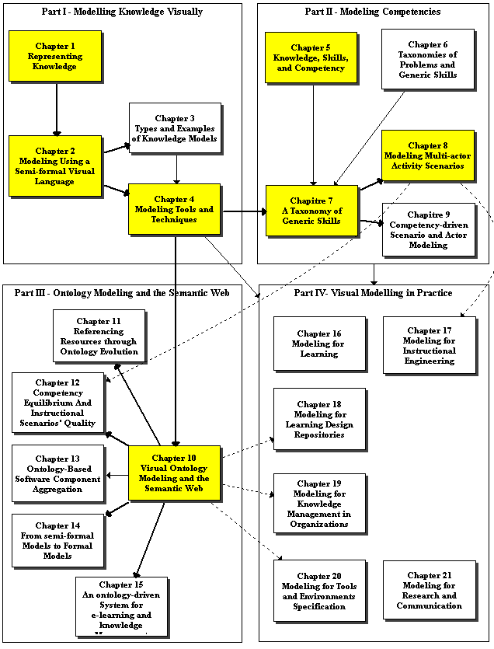
Structure of the Book
In section II, I start with an inventory of competency profiles to propose a structured concept of competency and discuss the notion of generic skill applied to domain knowledge as a basis for building competency profiles. From a number of previous proposals, I propose an integrated taxonomy of generic skills. Then I combine knowledge modeling and generic skills modeling to help build competency profiles. The last two chapters are applications of competency modeling, to guide the modeling of multi-actor activity scenarios, the modeling of a knowledge domain and the definition of actors’ models.
In section III, Ontology Modeling and the Semantic Web, I present a specialization of the visual language to MOT+OWL that support the representation of knowledge and competencies as ontologies, thus bringing the language at a formal and computational level. The other chapters are independent from one another. They address practical and actual issues about the use of ontologies for the semantic Web. The first one concerns the problem to maintain the referencing of resources using an ontology while it is evolving. The second addresses the quality of activity scenarios by referencing their components with ontologies and competency attachments. The third one uses ontology to guide the aggregation of software components. The fourth one presents a process to transform informal and semi-formal models, like the ones in sections I and II into ontologies. The TELOS ontology-driven system is then presented with its technical ontology that drives the system to produce Web-bases environments for learning and knowledge management.
Section IV, Visual Modelling in Practice, is composed of six chapters, independent from each others, that present applications and studies that have been conducted at the LICEF research centers. They exploit the concepts, tools and methods presented in section I and II. Three of the chapters (18, 19 and 20) also contain ontology modeling applications, relying on chapter 10. Each chapter covers a different type of use of visual knowledge modeling: for learning, for instructional engineering, for learning design repositories, for knowledge management in organizations, for tools and environments specification and for research processes.

Use of the Book for Various Readers
The preceding figure provides a concept map of the sections and chapters of the book. Strong links are essential prerequisites, light links are useful prerequisite and dotted links mean that only a part of the chapter is necessary to understand part of a following chapter.
Using these links, the reader will be able to decide on a learning path that corresponds to his/her needs. Here are some examples
- The reader who wants a good overview at a first reading can start with the “colored” rectangles that correspond to chapters 1, 2, 4, 5, 7, 8, 10, and one of the chapters in section IV.
- The reader interested mainly in ontologies and the Semantic Web, or the reader more technically inclined could read all the chapters of section I, chapter 8, and all the chapters in section III.
- The reader interested mainly in educational applications of visual modeling should read all nine chapters of section I and II, plus chapters 16, 17, 18 and 21.
- The reader interested mainly in knowledge management applications of visual modeling should read all nine chapters of section I and II, plus chapters 19, 20.

Contributions and Aknowledgement
Some of the chapters or sections have been first written by other researchers or doctoral students for which I consider they are the main authors. I have revised them, added some elements to facilitate their integration in the main thread of the book.
Here is a list of these chapters or sections and their prime authors.
Section 8.2 and 9.4 | Olga Marino
Chapter 11 | Délia Rogozan
Chapter 12 | Julien Contamines
Chapter 13 | Anis Masmoudi
Chapter 14 | Michel Héon
Chapter 16 and Section 19.2 | Josianne Basque and Béatrice Pudelko
Section 17.3 | Richard Hotte
Section 17.4 | Karin Lundgren-Cayrol and Diane Ruelland
Section 19.1 | Michel Léonard
Section 20.1 and 20.2 | Karin Lundgren-Cayrol
Section 20.3 | Diane Ruelland
Section 20.4 | Geneviève Habel and François Magnan

In conclusion, I would like to thank all the researchers and students at the LICEF research Center and the CICE Research Chair who have used the concepts, tools and methods presented here. Besides the above contributors, I would like to underline the early contribution of Claire Aubin, Françoise Crevier and Ileana De la Teja who made important contributions to the MISA method and still use the MOT editors in their professional practice. I must also mention the steady and insightful contribution of Michel Léonard who supports the use of the MOT modeling tools by giving training to partner organizations who wish to use it. All these persons, and also colleague researchers at TELUQ France Henri, Jacqueline Bourdeau and Hamadou Saliah-Hassane have contributed useful feedback from time to time.
Also many thanks to the computer architects, analysts and technicians who have produced versions of the visual modeling tools used in this book, in particular Eric Bleicher, Ioan Rosca, Alexis Miara, Frédéric Bergeron and François Magnan. Without their intelligent contribution, all these projects might have remained a theory instead of operational methods and tools.
Finally, I must recognize the financial support of the organizations who financed various versions of the tools: the DMR Group and the Centre de recherche informatique de Montréal (CRIM), the Social Sciences and Humanities Research Council (SSHRC), the Telelearning Network of Centers of Excellence (TL-NCE), the Canadian Defense Industrial Research Program (DIRP), Hydro-Quebec, Bell Canada the Natural Science and Engineering Research Council (NSERC) of Canada.

Gilbert Paquette, Montreal, May 2009

