A Digital Tool for Self-assessing Information Literacy Skills

Josianne Basque
LICEF Research Center
Télé-université, Université du Québec à Montréal
Montreal, Canada
basque.josianne@teluq.uqam.ca

Diane Ruelland
LICEF Research Center
Télé-université, Université du Québec à Montréal
Montreal, Canada
ruelland.diane@licef.teluq.uqam.ca

Marie-Claude Lavoie
LICEF Research Center
Télé-université, Université du Québec à Montréal
Montreal, Canada
marieclaude.lavoie@gmail.com

Abstract: To encourage students to recognize the value of information literacy skills and to improve these skills, we have developed an online tool called infoCompétences+. This tool allows users to assess their level of information literacy skills, consult an overview of their strengths and weaknesses as individuals and as part of a group, and obtain a list of resources to help them improve their skills. The development of this tool was funded by the Université du Québec and built on research projects carried out at the LICEF Research Center on the topic of competency management in training environments. In this paper, we describe the tool, as well as the results of usability tests conducted with the assistance of 35 university students. Major findings indicate that the students found the tool useful to complete their studies, to know more about themselves, as well as about the information literacy domain. Based on our initial work, a generic shell was recently developed to allow university professors to apply the tool in a variety of other knowledge fields.

1. Introduction
In this "Knowledge Society", students must be able to find, evaluate, and use information efficiently. They must be skilled information literate learners. Indeed, today’s dominant educational paradigms, including constructivism, socio-constructivism and situated learning, emphasize that students be involved in problem solving, critical and creative thinking, decision making and inquiry-based learning. All these activities require finely honed information literacy skills.
The Association of College and Research Libraries (ACRL, 2000) defines these skills as “a set of abilities requiring individuals to recognize when information is needed and have the ability to locate, evaluate, and use efficiently information” (p. 2). These abilities involve, in an every increasing way, the use of Information and Communication Technologies (ICTs), such as search engines, digital libraries and tools for managing bibliographies, representing and organizing information, taking notes, annotating, etc.
A recent study revealed that a large number of post-secondary students believe that they have all the skills needed to conduct information searches in learning environments (Loiselle, Basque, Fournier, & Chomienne, 2004). However, other studies indicate that university students actually have gaps in their ability to plan and organize the information search process, to use available computerized tools efficiently when searching for and organizing information, as well as to critically analyze, interpret and evaluate information (Beaufils, 1998; Land & Greene, 2000; Mittermeyer & Quirion, 2003; Pierce, 1998).
In many post-secondary institutions, information literacy competencies are implicitly considered as "prerequisite skills", more or less. Often, no formal training is offered to students pertaining to this domain and it
seems that they are solely responsible for improving their information skills in order to succeed in their academic studies.
In order to support post-secondary students to become aware of their own information literacy competencies and to self-improve these skills, we developed an online tool, called infoCompétences+. This project was part of a comprehensive Information Literacy Competencies Program funded by the Fonds de développement académique du réseau (FODAR) of the Université du Québec network, which supported projects conducted in ten different universities in the province of Quebec (Canada). Each team was responsible for the development of some resources for students, teachers or librarians (http://pdci.uquebec.ca/).

2. Main Conceptual Framework: Self-assessment and Metacognition
From the perspective of metacognition research, self-assessment is part of a reflexive process which aims to control an individual's own activities. It includes the following three steps: self-assessment, result analysis, and decision making in order to adjust one's actions (Brown, 1987; Noël, 1991). This process is also described as a learning strategy, which can be grasped and must be improved to enhance the learners’ autonomy (Ruelland, 2000). A continuous, formative self-evaluation process during learning can support learners in identifying their own training needs and self-adjust the learning strategies they use (Scallon, 2004).
Even though the learners might, at any time during learning, under- or over-estimate their competency level, some authors also argue that they are the ones who can identify the state of their competencies with the greatest precision (Allal, 1999). However, in order to properly support the self-assessment process during learning, it is important to inform the learners of the learning objectives, of the activities that can help them attain these objectives, of the work they will have to produce and submit to the teacher for summative evaluation, and the evaluation criteria that will be applied (St-Pierre, 2004).
These basic ideas found in literature on metacognition served as the framework to develop the online tool called infoCompétences+. We also considered that giving students the opportunity to anonymously compare their competencies with those of their peers would possibly help them reflect on their own performance in the domain and stimulate them to improve their skills. This prompted us to integrate this functionality in the tool.

3. Main Methodological Framework
The project is built largely upon research and development conducted for some years at the LICEF Research Center (Brisebois, Ruelland, & Paquette, 2005; Paquette, 2002; Ruelland & Brisebois, 2002). The project methodology included several concurrent steps and required the collaboration of specialists in various disciplines (cognitive sciences, library sciences, instructional design, programming, and graphic design). We report here briefly as to how we proceeded to identify the information literacy standards implemented in the tool as well as how the choice of a performance scale was arrived at, a resource repository created and the tool designed and developed.

3.1 Information Literacy Standards
In a self-assessment approach, it was necessary to propose a list of statements that would describe the targeted information literacy skills. Students would then be able to compare their own real-world experiences to each proposed statement.
We first compared the standards proposed by the Pilot Committee of the project (Comité de pilotage du Programme de développement des compétences informationnelles de l'Université du Québec, 2004), which were essentially based on the ACRL (2000) and the CAUL’s standards (CAUL, 2001), to eleven other lists of information literacy skills or procedural models found in the literature (e.g. (AASL, 1998; Eisenberg, Berkowitz, Jansen, & Berkowitz, 1999; Hill, 1999; Kuhlthau, 1993). This was done to evaluate the exhaustiveness of the Pilot Committee’s standards. We found that it was necessary to restate the list of skills in order to (1) make the statements more concrete for students, (2) eliminate redundancies between statements, (3) ensure that statements did not describe more than one skill (which makes self-assessment more difficult) and that statements were concise, (4) verify that the statements had a cohesive structure as a whole. More statements were added to cover some missing computer literacy skills, that is, those related to the use of ICT tools supporting information search and information processing tasks.
This work was validated by three university librarians and one professor. The final list contains seven "groups of competencies", including a total of twenty-three competencies, described more specifically with a total of eighty-four "competency statements" with which the students assess their levels of competency.

3.2 Performance Scale
Self-assessment in a learning context requires a scale which gives the students the criteria and levels of performance with which they will evaluate their own performance (St-Pierre 2004; Scallon 2004).
We reviewed fifteen existing self-assessment tools in various domains and found four types of performance scales used:
- Numeric scale (e.g. scale from zero to five);
- Generic binary qualitative ordinal scale based on a single criterion (e.g. yes/no; with/without help);
- Generic qualitative ordinal scale with multiple defined levels, each one defined by a combination of multiple criteria (e.g. Beginner – Intermediate – Advanced – Expert);
- Qualitative ordinal scale specific to each competency which describes the behavior of the person at each level of a competency.
The first two scales in the list seemed not enough informative in our case. The fourth type of scale is the most informative but is too time consuming to put in place. It would require too much effort from both the editors of the list of the eighty-four statements list and the students having to read the detailed descriptions of each level of each competency statement to complete the self-assessment activity. Therefore, we decided to use a generic qualitative ordinal scale, which is applied to the entire list of statements. The scale is adapted from the one proposed by (Paquette, 2002). It is composed of four levels (Beginner, Intermediate, Advanced and Expert), defined by a combination of five performance criteria (see Table 1).

Table 1 – Performance Scale (adapted from Paquette, 2002)
 | Performance Level
Criteria | Beginner | Intermediate | Advanced | Expert
Autonomy | With help | Without help | Without help |  | Without help
Persistence | Sometimes | Whenever necessary | Whenever necessary |  | Whenever necessary
Completeness | Partially | Partially | Entirely |  | Entirely
Complexity | Simple situations | Simple situations | Complex situations |  | Complex situations
Familiarity | Usual situations | Usual situations | Usual situations |  | New situations

3.3 Resource Repository
Digital resources which may help users develop information literacy skills were added to a repository by a librarian who analyzed them to identify the competency statements they represent. In the first version of the tool, 85 resources were metatagged in Palom@, a repository management system developed at the LICEF research center, in order to describe and identify the competencies to which they are linked. The goal was to have this initial repository linked to the infoCompétences+ tool, but to keep it independent from the tool, thus facilitating the updating of the resources metatagged in the repository. New resources, be it a text-based or multimedia document, an URL, a human resource or a learning unit, can be added to the repository at any time. Each time the students use the tool, new resources can then be dynamically proposed to them.

3.4 Tool Design and Programming
It was decided right from the start of the project that the tool would be available online and that it would require minimal maintenance.
The definition of the infoCompétences+ functionalities was essentially based on the self-management model designed for online learning proposed by (Brisebois et al., 2005). A rapid prototyping approach was used to design and develop the tool. Based on the analysis of the fifteen existing self-assessment tools that were reviewed, we selected and adapted the most critical functionalities to elaborate an initial Power Point storyboard, which was examined by four librarians and one instructor. An interactive prototype was subsequently developed to test the feasibility of the basic functionalities, the screen displays and the set of competencies on five students and three professors. The final prototype was created with the open source web application DotNetNuke and tested by thirty five students attending the Université du Québec. They were asked to fill out a questionnaire including both open-ended and close-ended questions after having explored all the functionalities of the tool on their own computers and at their own pace. Final revisions were then made to the tool, based on the test results.

4. A Brief Presentation of infoCompétences+
infoCompétences+ is an online tool which consists of three main modules, accessible through navigational tabs, comprised of the Self-assessment module, the Summary module, and the Action Plan module (see Fig. 1). The tool is accessible at the Information Literacy Competencies Program Website (http://pdci.uquebec.ca/infocompetences-allegee-teluq/ ).

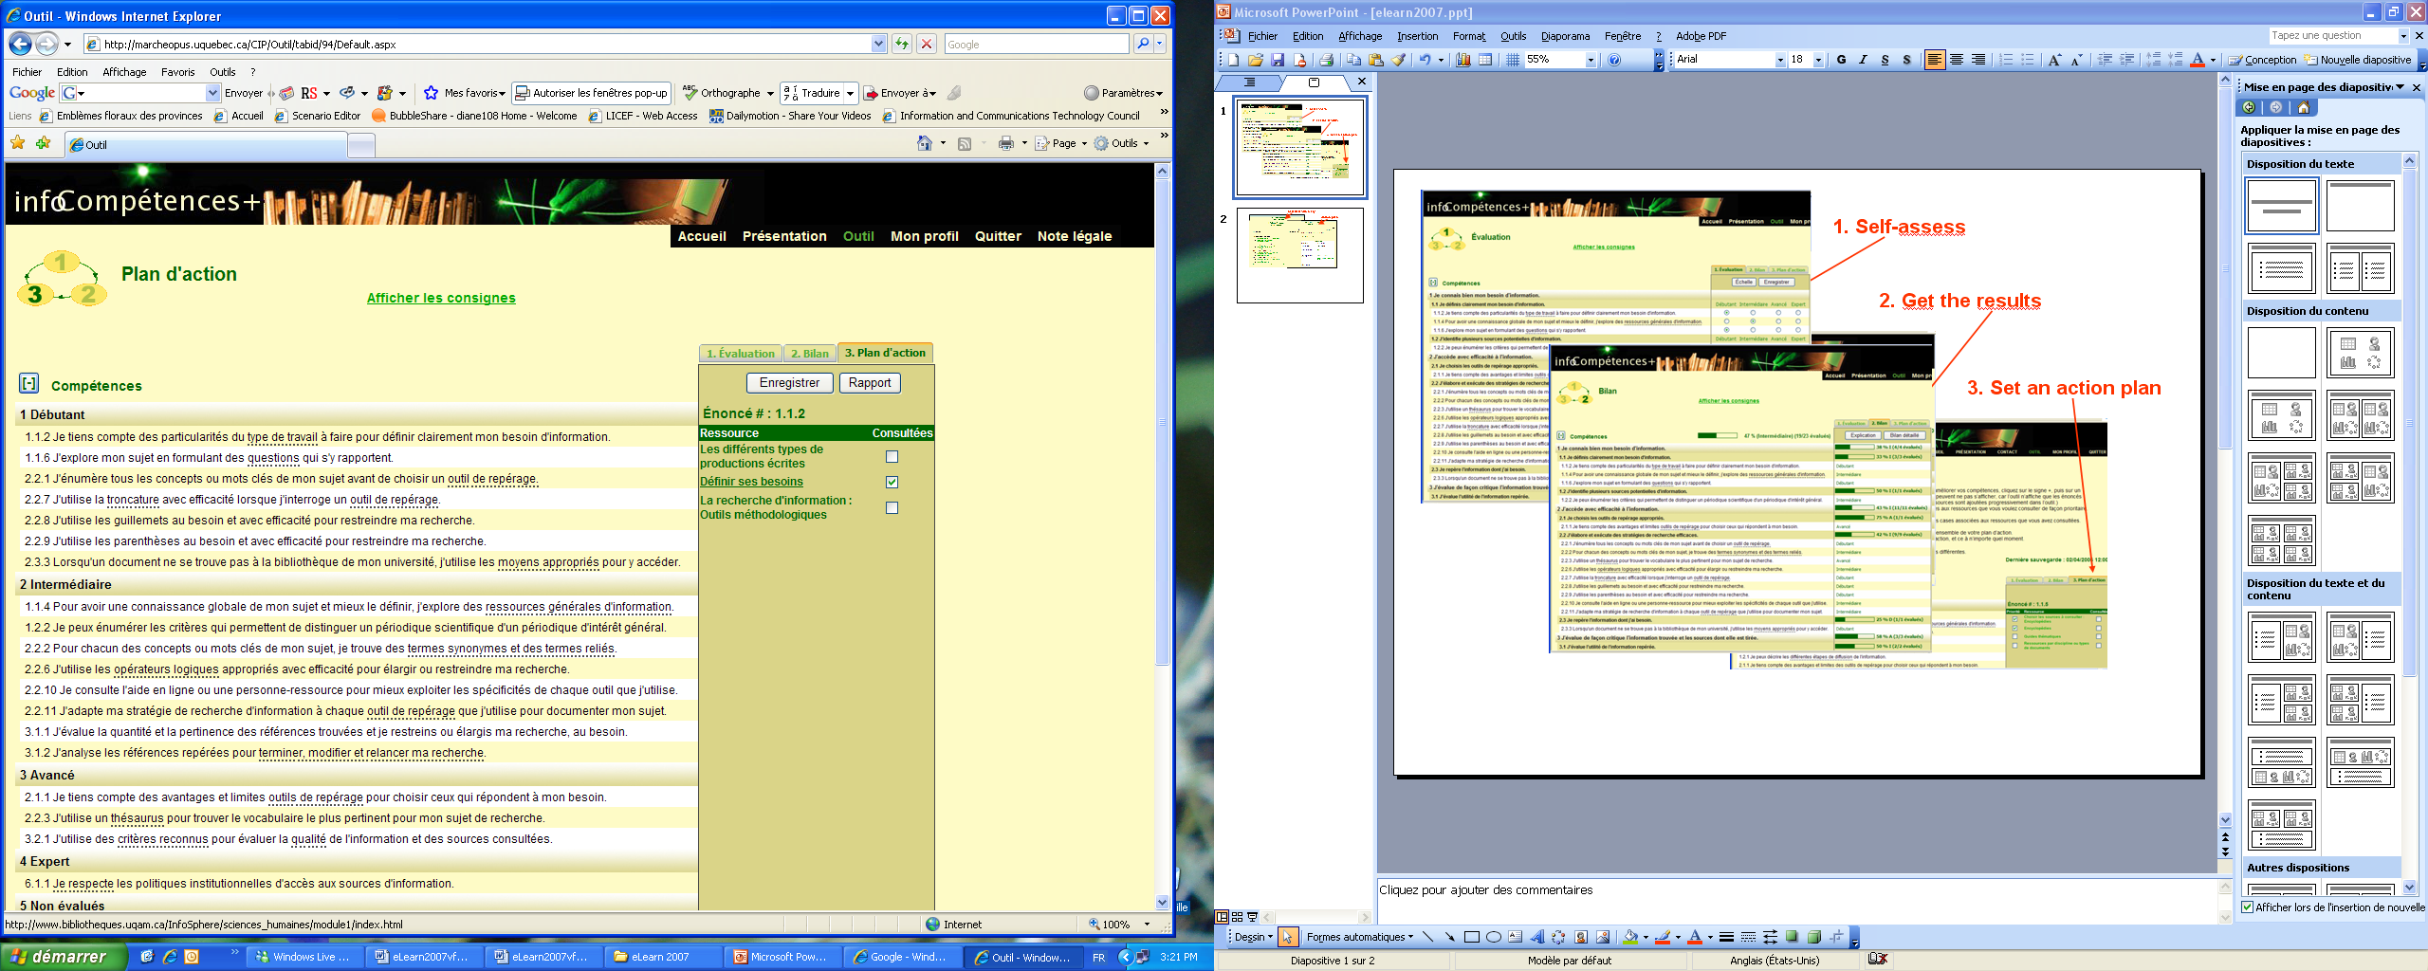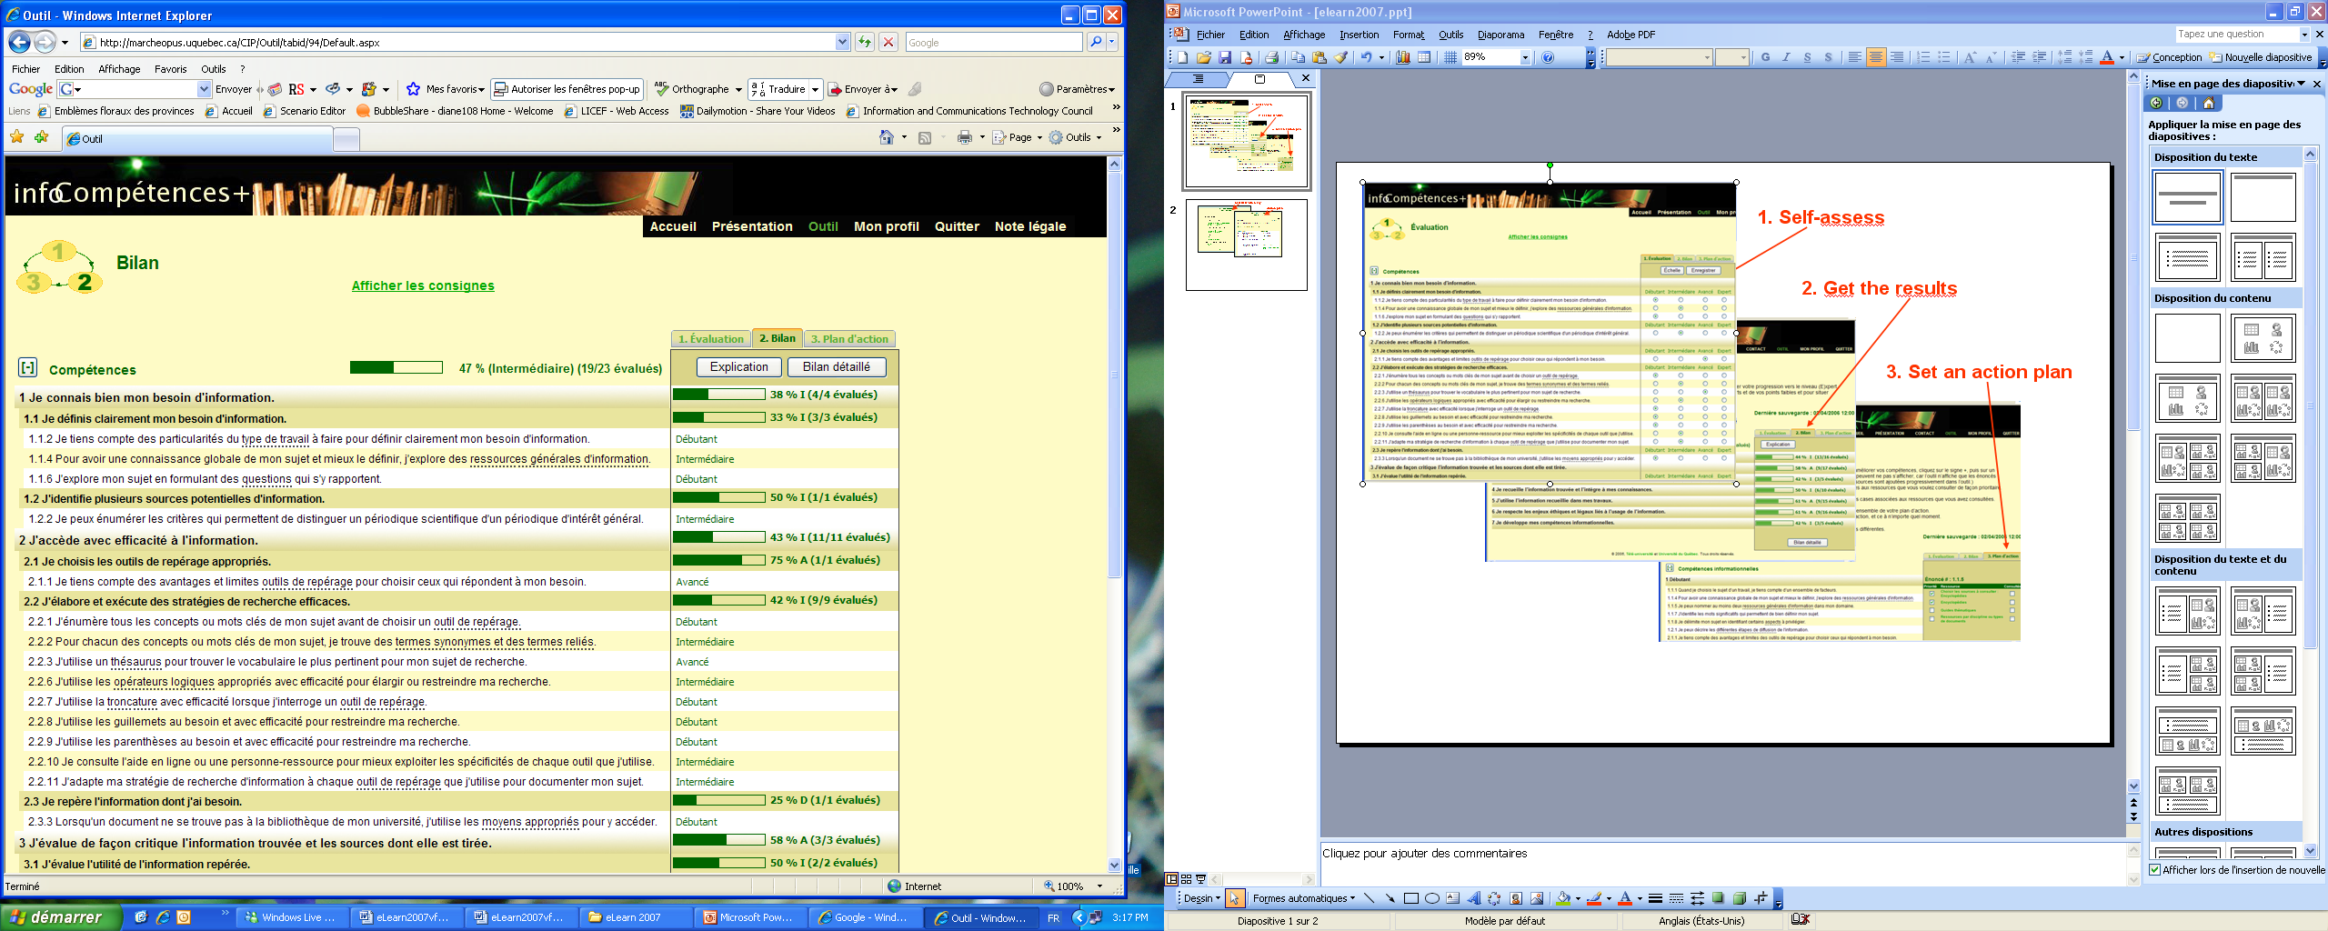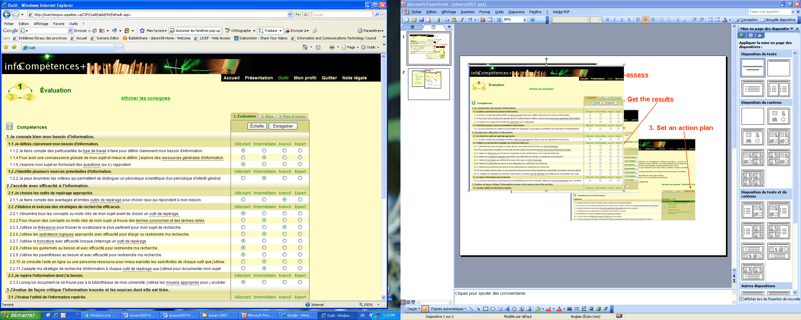
1. Self-Assessment Module
2. Summary module
3. Action Plan Module

Fig. 1 – Main module screenshots

From the Home Page, users can access a brief presentation of the tool. They are invited to use the tool at any time during their university studies, either to obtain a diagnosis before choosing or engaging in a learning unit, to validate their progress after completing a semester or even to review their information skills mastery before applying for a job.

4.1 Self-assessment Module
The Self-assessment module (see Figure 1) allows students to assess their competencies on the eighty-four competency statements by clicking on the performance level (Beginner, Intermediate, Advanced, Expert) that best represents what they believe to be most representative of their level. The dotted hyperlinks on various words in some statements open tooltips which provide elaborated definitions or additional contextual information. Users can also access a detailed description of the qualitative performance scale (see Table 1) at all times by clicking on the Scale (Échelle) button. Responses can also be modified one by one, all the answers reset, or portions of answers saved.

4.2 Summary Module
The Summary module (see Figure 1) displays progression bars which provide the user with a visual summary of her/his progress towards the "expert" performance level. One point is attributed to each level of the performance scale. Percentages are calculated for each competency and each group of competencies as well as for the overall performance (Beginner = 0-25 %; Intermediate = 26-50 %; Advanced = 51-75 %; Expert = 76-100 %).
From this module, the student can also access a detailed summary of her/his strong and weak competencies, and compare these results to the means of different groups to which she/he belongs (e.g. course groups, study program group, institution group). All results are displayed anonymously. They can also be viewed by professors or library specialists who created the groups in the system.

4.3 Action Plan Module
The Action Plan module (see Figure 1) displays a view of the competency statements classified by performance level as assessed by the student. The user can then click on a statement to display resources that can help him improve the targeted competency. These resources can be accessed by clicking on the hyperlinked titles. After a resource is consulted, the student can check off the resource checkbox to keep track of the progress of her/his activity in the tool.
The user can also obtain an Action Plan Report which provides a complete list of assessment results, helpful resources associated with each competency statement and resources consulted to date (see Figure 2). This report supports analysis and follow-up processes, in the hope that it will prompt the user to persist in her/his own competency development program.
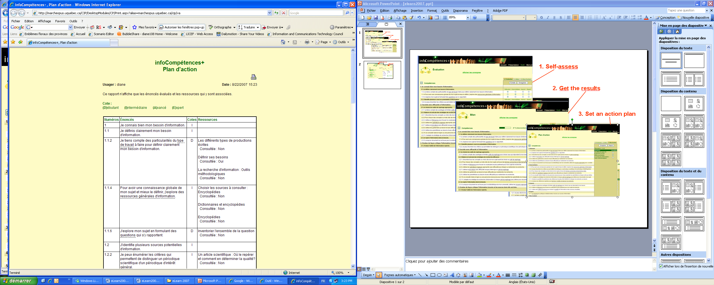
Resource Title
Consulted: Yes/No

Fig. 2 – Action Plan Report Screenshot

5. Results of Usability Tests
Overall, the results of the usability trials with thirty five students from the Université du Québec indicated that the students appreciated such a tool. Eighty percent of participants rated it four or five on a five-point Likert scale, in which one represents the lowest rating. More than half said that this tool could be useful in order to successfully complete their studies (57 %) and over 80 % said that such a tool would allow them to know more about themselves (83 %), as well as about the information literacy domain (83 %). Sixty percent indicated that the tool met their expectations (60 %) and the majority (74 %) declared that they would recommend it to peers and would use it again (66 %). The Evaluation module was deemed useful by 91 % of the students and efficient by 80 %. Another 80 % of the participants found that the Summary module was useful and 77 % indicated that they could easily identify their strengths and weaknesses; 91 % found it pertinent. As for the Action Plan module, over 80 % of participants found that the resources were useful, appropriate and easy to consult.
The ratings were lower when it came to certain navigational functions, technical manipulations, and the graphic interface and such critiques helped us improve the ultimate design of the tool.
Some students revealed that the use of the performance scale was difficult to apply and that they had problems judging which rating was appropriate for their skill level. Their comments indicated that they are not accustomed to self-assess their competencies by using such a systematic process, although the majority of them proceeded intuitively in various situations. The students had difficulties grasping that this process was not a test to objectively evaluate their performance but a tool to subjectively self-reflect on their own information literacy skills. It seems that they are in need of more practice in metacognitive thinking.
They also mentioned that they had difficulty understanding that the comparison of their results to those of different student groups, although done anonymously, is not a normalizing method but simply additional information which may help them reflect more accurately and formatively on their own competencies.

6. Conclusion and Future Work
This project was aimed at creating an online tool, connected to a resource repository applying standardized metatagging, to support the Université du Québec’s students in managing the development of their information literacy skills by (1) informing them on the information literacy competencies domain, (2) raising their awareness of their need to improve these competencies and (3) encouraging them to follow up with appropriate action. The usability tests proved the tool to be valuable to the students. It would be interesting in the future to collect data on how professors and librarians rate the tool in helping them diagnose students’ weaknesses in this domain.
Based on our initial work, a generic shell was recently developed at Télé-université, called Compétences+, to allow professors and instructors to apply the tool in various knowledge fields. Recently, the generic tool fueled the elaboration of three different learning scenarios based on competency self-management in three different knowledge domains implemented in both academic (Basque & Page-Lamarche, 2007; Hotte, 2007) and workplace learning (Ruelland & Lundgren, 2007). These emergent uses created new demands to improve the tool, including additional flexibility in setting variables (e.g. set the level of the performance scale), to better assist the student throughout the self-assessment process, to add functionalities for editing the competency profile and to facilitate repository maintenance. Over the longer term, there are plans to keep track of the students’ results so that it will be possible to display their progress on a timeline, to add comparison functionalities, including comparisons between professors’ assessments of information skills of their students and students’ self-assessment, and to integrate the tool into a portfolio approach.

References

Based at Télé-université, Montreal, Canada, the LICEF Research Center is a laboratory dedicated to cognitive informatics and training environments. For further details, refer to the LICEF website: http://www.licef.teluq.uquebec.ca
Palom@ is a resource management tool which applies the IEEE-LOM and NORMÉTIC (http://www.normetic.org/) referencing norms. For more information on Palom@: www.cogigraph.com

