CHAPTER THREE: CUED VS FREE RECALL FOR ASSESSING L2 VOCABULARY ACQUISITION
François Pichette

Introduction

Type of learning
Most linguists refer to morphemes as the smallest units of meaning (Mullany & Stockwell, 2010), while they tend to reserve the term word to refer to the smallest unit of speech that carries meaning and that can exist in isolation (e.g., Fasold & Connor-Linton, 2006; Katamba, 2005). Defined as such, words correspond to free morphemes, in contrast to bound morphemes such as affixes, which carry meaning but need to be attached to a lexical root. Words are complex constructs with various components related to their form (spelling, pronunciation, word parts), to their meaning (concept, referents, associations) and to their use (grammatical functions, collocation, constraints) (Nation, 2001).
The way new words are encountered and processed will determine how much attention will be allotted to the various facets of those words. The two facets that have received by far the most attention are form and meaning, since most researchers make a distinction between those two aspects, and it is a universally recognized fact that “in order to acquire vocabulary one must attend to both word form (pronunciation, spelling) and to whatever cues are available in input that can lead to identification of meaning” (Schmidt, 2010, p. 725). The connection between the two is also important, and it has been pointed out that “the most important component of word knowledge is the ability to establish the link between word form and word meaning” (Laufer & Goldstein, 2004, p. 409).
Several studies have thus compared various learning tasks in terms of the relative amount of attention, involvement or focus they direct at word forms and at word meanings. Among them, Barcroft (2002) mentions pleasantness ratings as a task where the focus is on the semantic properties of the word, since the examinee provides no word forms but thinks about the meaning and what it represents for him or for her. Copying, on the other hand, would be a task that focuses on word form, since it is possible to copy words for which the meaning is not known. Extensive reading has also been considered as an instance of meaning-based vocabulary learning, whereas looking up words in a dictionary is form-based (San Mateo Valdehíta, 2012) because the form of the word has to be kept active in one’s mind in order to be able to locate it.
Given the apparent superiority of writing tasks over reading tasks for vocabulary acquisition (Coombers, Ramstad, & Sheets, 1986; Pichette, de Serres, & Lafontaine, 2011), asking students to use newly encountered words in their writing becomes an interesting teaching method. When writing, the person’s cognitive resources are said to be directed mostly at the semantic properties of the word to be learned, thus decreasing the processing and learning of its structural properties (Barcroft, 2004).

Type of assessment
In research, methods for assessing vocabulary acquisition vary between studies. The tests that are used to assess recall will differ in the relative weight they put on the various word components (see Laufer & Goldstein, 2004; Morris, Bransford, & Frank, 1977; Nation, 2001; Pressley, Levin, Kuiper, Bryant, & Michener, 1982).
Some tests put more emphasis on word meanings. One such test would be definition recall, where the examinee has to handle word meanings in performing the task. Cued recall is another example of a test where the meaning of the word is provided to the person, either by means of a definition, an image, or an L1 equivalent if the word is in another language.
Other tests, such as free recall, put more emphasis on word forms. Free recall relies more on form, while meaning is supposedly not involved or involved to a small extent. The reasoning behind this is that in free recall the examinee may provide forms that he or she remembers seeing without being able to associate them to the right meaning. For example, if his name is René and one of the words was rana, that word is likely to be provided without the person remembering its meaning.

Type of learning vs type of assessment
Most researchers in cognitive psychology have also agreed for a long time that working memory capacity is limited and many argue that the amount of attention allocated to a language task such as word-form memorization will enhance performance on that task at the expense of other concurrent cognitive tasks (e.g., Bialystok, 1992; Fischler, 1998; Kahneman, 1973; Neely, 1977; Schneider & Shiffrin, 1977; Segalowitz, 2000, 2003). In other words, when facing new words, focusing more on their meaning will lead to better recall in a test based on word meanings than on word forms, and vice-versa. For example, Barcroft’s (2002) participants who were tested in their L1 showed better learning of new words when assessed via what the author uses as a form-oriented test (free recall of words) in which they focused on the meaning of target words (through pleasantness ratings) than when they focused on their form (through copying).
If, as was said earlier, writing is a more meaning-based task, writing activities would yield better recall on a meaning-oriented assessment task (e.g., cued recall) than on a task that is more form-oriented (e.g., free recall).
However, as far as vocabulary recall for L2 words is concerned, an important distinction needs to be made between concrete and abstract words. Concrete words are much more likely to have a meaning that is already known to the learner, due to the fact that they refer to objects that usually exist in all cultures and their meaning tends to be the same. Consequently, the type of word encountered may play an important role in recall (see Pichette et al. 2011). For concrete words, it may not be the learning task itself that best determines the relative amount of attention directed at form and meaning, but the nature of the items being processed. Concrete words refer to concepts whose meaning is already known to the readers, having been developed via their L1. They can also be expected to be clear, stable across languages, and readily accessible. For example, due to the nature of their referent, concrete words like screwdriver are less likely to show interlanguage differences in meaning than more abstract words such as marriage or politeness. In short, in the case of concrete words, “new words” in the L2 are not new words in the same sense as in the L1, but rather new word forms. Consequently, we can safely assume that not much focus is needed on meaning, and that resources should logically be directed more at the formal properties of the word in the formto-meaning association.
If the meaning of the item is already known, is stable (concrete) and is readily accessible, the focus would be on the word’s formal (or structural) properties no matter the task at hand. If, on the contrary, the new item is related to a meaning that is new to the learner, that is imprecise, or that is not readily accessible, the focus has to be on both form and meaning. This suggests that rates of vocabulary acquisition from a writing task would show up in a similar manner whether it be assessed by a form-focused or a meaning-focused test.

Writing as meaning based
The fact that writing is meaning-based is an intuitive hypothesis for cognitive processes that are difficult to quantify (Applebee, 2000; Lesgold, & Welch-Ross, 2012). In fact, writing may not be more meaning-based than form-based for the following two reasons:

- In writing, word forms have to be produced instead of simply processed as input. According to Swain’s (1985) Output Hypothesis, only language production tasks truly compel the learner to undertake full grammatical processing. Therefore, writing involves deep and extensive form processing.
- Word forms are also processed as input once produced. Word forms are not only processed as output, but they are subsequently processed as input, because we read what we write.

Research question
The goal of our research is to seek an answer to the following question: following a writing task, does cued recall yield higher L2 vocabulary scores than free recall?
Given that the participants in this study perform a meaning-focused task, a positive answer–as suggested by previous research–would suggest that writing is indeed more meaning based than form based. On the contrary, the expected negative answer based on the considerations above would suggest that writing is not more meaning-based than form-based.

Method

Participants
Participants were 106 French-speaking university students enrolled in classes of Spanish as a second language, of which 29 were males and 77 females. Their mean age was 24.8 years old. Their Spanish course level was as follows: Elementary 2: 67 participants; Intermediate 1: 25; Intermediate 2: 14. The other languages they knew and could read were English (n = 85), German (n = 4) and Arabic (n = 1), while 21 declared no other language.

Learning task
The word acquisition task is a meaning-focused task consisting of concrete words presented in isolation (accompanied by a picture) about which participants had to write sentences. A series of 12 nouns representing concrete concepts was established. Cognates with French or English were eliminated to avoid the addition of a cross-linguistic variable, since the participants would otherwise not be dealing with entirely “new” words, given that new words are incorporated through the detection and use of similarities between new and already stored information (e.g., Matz, Teschmer, & Weise, 1988). The items chosen were considered rare enough to be unknown to the participants, and they represented animals, objects, and food. As additional criteria, they had to be words for which singular and plural forms exist, and they had to be easy to represent visually in a clear an unambiguous way. In order to control for word length effects (see Pichette, 2002) all 12 words consisted of three syllables and seven letters: ardilla, cebolla, durazno, guanajo, helecho, lechuza, mapache, repollo, taladro, toronja, verdugo, zancudo.
A pilot test was conducted with five learners of Spanish matching our participants’ profiles. It indicated that 35 seconds could be an optimal amount of time for being able to write a L2 sentence while at the same time limiting post-production reading and mental rehearsals.
Each word was mounted on a PowerPoint slide accompanied by a colour picture. Each picture represented one typical item. Figure 3-1 shows a slide sample.

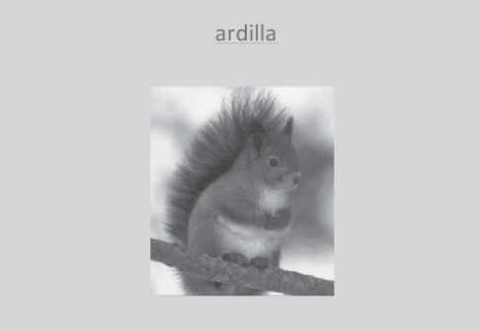

Figure 3-1: Slide sample.

Assessment tasks
Two tests are used in this study to assess vocabulary acquisition: one that is more form-oriented and one that is more meaning-oriented. As mentioned earlier, because it does not necessarily involve form-tomeaning mapping, free recall is more sensitive to the formal properties of word. Cued recall from a picture, on the other hand, is more sensitive to semantic properties (see also Webb, 2005). Both recall tests contained instructions asking the participants to circle words they had already encountered, in order to exclude such words from the analysis for not being new to them. A sample of both recall tasks is in the Appendix.
The form-focused test is a free-recall task where the participants are asked to remember and write as many Spanish words as they can from the presentation. The meaning-focused test is a cued-recall task where the same slides are presented to the participants, but with each picture presented without the corresponding Spanish word. Participants have to write down the Spanish word they remember on an answer sheet on a line next to the number that corresponds to the one on the slide.

Procedure
Testing took place during class time. The participants first signed an informed consent form and completed a background questionnaire aimed at gathering basic demographic and literacy information. They were also given verbal instructions on the nature, goal and procedure of the study. Each participant received two sheets with numbers corresponding to items to be learned, followed by lines for writing their sentences (see Appendix).
Slides representing the 12 new items were projected sequentially from a laptop computer onto a large screen at the front of the classroom. The order of presentation was randomized to avoid any primacy effects (Paivio, 1971). The duration of presentation for each slide was pre-set at six seconds (as in Pichette, 2002), with 35-second blank-screen intervals for writing a sentence, for an overall presentation time of about 8 minutes. About one minute was taken at the end of the task to collect the participants’ sheets.
The test for assessing vocabulary recall began at least one minute after the end of the presentation, since recall needs to be delayed by more than 30 seconds to reduce the recency effect (see Paivio, 1966). After performing the learning task, half the participants (52%) did the cued recall test, while the other half (48%) did the free recall test. Money was awarded post hoc as participation prizes in the form of a lottery.

Scoring
To compile the data provided by the participants on the cued recall, a syllable scoring system was used, whereby one point is awarded for each syllable correctly produced, for a maximum of three points per word. A right word associated to a wrong concept is only counted based on similarities in formal properties with the correct Spanish word.
For free recall, the same scoring method was used. In cases where it is not clear which word an item is to be associated with, the researcher and an independent scorer made a joint decision based on the set of answers provided by the participant
The words that participants claimed to know, or that the teacher declared having used with them, or for which a participant did not write a sentence, were eliminated.

Analysis
Mean scores and standard deviations (in parenthesis) were compared for each of the two types of vocabulary acquisition assessment: free recall and cued recall. The results are in Table 1.

Table 3-1. Compared means: Free recall vs cued recall.

 | Free recall (n = 51) | Cued recall (n = 55) | t test
Mean (SD) | 17.9 (13.0) | 18.4 (17.6) | -0.16 (p = 0.44)
w/o last (/33) | 15.5 (12.4) | 16.6 (17.8) | -0.38 (p = 0.35)

The first line on the table shows the mean score out of 36 for each recall test, with a t-test in the last column, which shows no statistical difference between the means. Although the items were randomized so as not to favour a specific item over the others, the means were also computed in the absence of the last item shown for each of the participant. The similar scores (out of 33 in this case) show that the delay before administering the recall task was sufficient to prevent recency effects.
The second line of the Table displays the means when the data for the last item shown to each participant were excluded from the analyses. The relative means–out of a total of 33 points–are similar to the ones obtained from all the items. This similarity confirms that our precaution to wait at least one minute before assessing recall did eliminate recency effects. Had recency effects come into play, our randomized presentations would have spread that influence over several items, but it was deemed preferable to avoid recency effects altogether. The t test associated with those means is also similar to that for the whole data set.

Discussion and conclusion
Various explanations can be suggested to explain the absence of a significant difference between free and cued recall. The first possibility is the one on which our predictions were based, i.e. that writing is not mostly meaning-based, so that it does not yield a higher score on the meaningbased recall test. This would lend credence to authors who go so far as to classify writing as being mostly form-based (e.g., San Mateo Valdehíta, 2012).
However, another explanation could be related to the nature of the recall tasks themselves. Tests are not either meaning-based or form-based, but they all involve both modes of processing at various degrees along a continuum. It remains possible that the difference in meaning involvement between cued recall and free recall is not sufficient to see a difference in scores obtained from types of recall tasks.
Evidently, those two possibilities are not mutually exclusive, and the absence of a difference between means could be due to a combination of learning-related and recall-related processes.
The research question that was posed and the data gathered only hold for concrete words. They underscore the need for future comparisons of concrete and abstract words. The higher meaning involvement that we can legitimately assume takes place for abstract words could translate into different score patterns, where cued recall would show higher scores than free recall.
Finally, these results have pedagogical implications that are related to language assessment. They suggest that teachers who want to assess vocabulary acquisition following a writing or a reading task need not worry about the test format to use, since meaning-based and form-based tests will reflect their students’ acquisition of new words equally well.

References
Applebee, A. N. (2000). Alternative models of writing development. In R. Indrisano and J. R. Squire (Eds.), Perspectives on writing: Research, theory, and practice (pp. 90-110). Newark, DE: Taylor & Francis.
Barcroft, J. (2002). Semantic and structural elaboration in L2 lexical acquisition. Language Learning, 52(2), 323-363.
—. (2004). Effects of sentence writing in second language lexical acquisition. Second Language Research, 20(4), 303-334.
Bialystok, E. (1992). Selective attention in cognitive processing: The bilingual edge. In R. J. Harris (Ed.), Cognitive processing in bilinguals (pp. 501-513). Amsterdam: Elsevier.
Coombers, J. E., Ramstad, D. A., & Sheets, D.R. (1986). Elaboration in vocabulary learning: A comparison of three rehearsal methods. Research in the Teaching of English 20, 281-293.
Fasold, R., & Connor-Linton, J., (2006). An introduction to language and linguistics. New York: Cambridge University Press.
Fischler, I. (1998). Attention and language. In R. Parasuraman (Ed.), The attentive brain (pp. 381-399). Cambridge, MA: MIT Press
Kahneman, D. (1973). Attention and effort. Englewood Cliffs, NJ: Prentice Hall.
Katamba, F. (2005). English words: Structure, history, usage. London:
Routledge.
Laufer, B., & Goldstein, Z. (2004). Testing vocabulary knowledge: Size, strength, and computer adaptiveness. Language Learning, 54(3), 399436.
Lesgold, A. M., & Welch-Ross, M. (Eds.) (2012). Improving adult literacy instruction: Options for practice and research. Washington, DC: National Academies Press.
Matz, K.-D., Teschmer, J., & Weise, G. (1988). Angewandte
Fremdssprachenpsychologie und ihr Beitrag für die Effektivierung des Lernens und Lehrens von Fremdsprachen [Applied foreign language psychology and its contribution for effective learning and instruction of foreign languages]. Deutsch als Fremdsprache, 4, 224-229.
Morris, C. D., Bransford, J. D., & Frank, J. J. (1977). Levels of processing vs. transfer appropriate processing. Journal of Verbal Learning and Verbal Behavior, 16, 519-533.
Mullany, L., & Stockwell, P. (2010). Introducing English language: A resource book for students. London/New York: Routledge.
Nation, I. S. P. (2001). Learning vocabulary in another language. New York: Cambridge University Press.
Neely, J. (1977). Semantic priming and retrieval from lexical memory: roles of inhibitionless spreading activation and limited capacity attention. Journal of Experimental Psychology: General, 106, 226-254.
Paivio, A. (1966). Latency of verbal associations and imagery to noun stimuli as a function of abstractness and generality. Journal of Verbal Learning and Verbal Behavior, 4, 32-38.
—. (1971). Imagery and verbal processes. New York: Holt, Rinehart, and Winston.
Pichette, F. (2002). Second-language vocabulary learning and the Additivity hypothesis. Canadian Journal of Applied Linguistics, 5, 117-130.
Pichette, F., de Serres, L., & Lafontaine, M. (2011). Sentence reading and writing for incidental second language vocabulary acquisition. Applied Linguistics, 32(4), 1-18.
Pressley, M., Levin, J. R., Kuiper, N. A., Bryant, S. L., & Michener, S. (1982). Mnemonic vs. non-mnemonic vocabulary learning strategies: additional comparisons. Journal of Educational Psychology, 74, 693707.
Robinson, P. (2003). Attention and memory during SLA. In C. Doughty & M. H. Long (Eds.), Handbook of second language acquisition (pp. 631-678). Oxford: Blackwell.
San Mateo Valdehíta, A. (2012). El efecto de tres actividades centradas en las formas (focus on forms, FonFs): La selección de definiciones, la selección de ejemplos y la escritura de oraciones, en el aprendizaje de vocabulario en segundas lenguas. Revista electrónica de lingüística aplicada, 12, 17-36.
Schmidt, R. (2010). Attention, awareness, and individual differences in language learning. In W. M. Chan et al. (Eds.), Proceedings of CLaSIC 2010 (pp. 721-737). Singapore: National University of Singapore, Centre for Language Studies.
Schneider, W., & Shiffrin, R. (1977). Controlled and automatic processing. I: Detection, search and attention. Psychological Review, 84, 1-64.
Segalowitz, N. (2000). Automaticity and attentional skill in fluent performance. In H. Riggenbach (Ed.), Perspectives on fluency (pp. 200-219). Ann Arbor, MI: University of Michigan Press.
—. (2003). Automaticity and second language learning. In C. Doughty & M. Long (Eds.), The handbook of second language acquisition (pp. 382-408). Oxford: Blackwell.
Swain, M. (1985). Communicative competence: Some roles of comprehensible input and comprehensible output in its development. In S. Gass and C. Madden (Eds.), Input in second language acquisition (pp. 235-253). Rowley, MA: Newbury House.
Webb, S. (2005). Receptive and productive vocabulary learning: The effects of reading and writing on word knowledge. Studies in Second Language Acquisition, 27(1), 33-52.

Appendices

Appendix 3-A: Sample of sentence writing sheet #1.

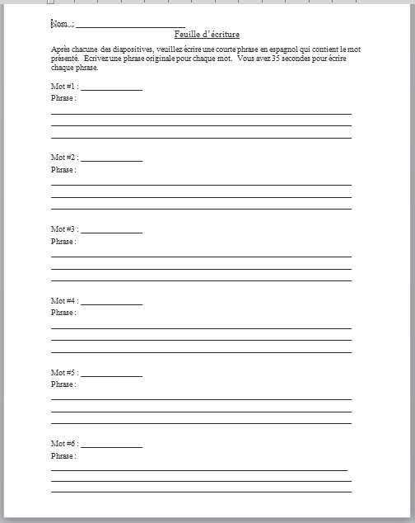

Appendix 3-B: Sample recall tests.

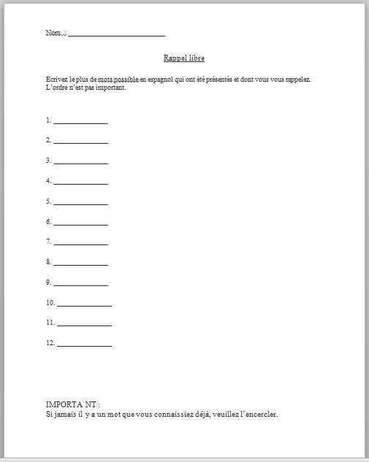

It must be kept in mind that in most cases, as stated by Laufer and Goldstein (2004), “A person who can retrieve the word form for a given concept is typically able to retrieve its meaning upon encountering the form” (p. 408).

